REVISED PROFORMA FOR ANNUAL REPORT 2013 (April 2012 to March 2013)

- GENERAL INFORMATION ABOUT THE KVK

1.1. Name and address of KVK with phone, fax and e-mail

Address | Telephone + FAX | E-mail
Darjeeling Krishi Vigyan Kendra,  Uttar Banga Krishi Viswavidyalaya  Kalimpong, Darjeeling, West Bengal - 734301 | 03552 256283  9378451457 | djkvk@yahoo.com

  - .Name and address of host organization with phone, fax and e-mail

Address | Telephone |  | E mail
Address | Office | FAX
Dr. Himadri Bhattacharya  Uttar Banga Krishi Viswavidyalaya  P.O Pundibari, Cooch Behar | 03582-270141/986 | 03582-270249/986 | cobkvk@yahoo.com

1.3. Name of the Programme Coordinator with phone & mobile No

Name | Telephone / Contact
 | Residence | Mobile | Email
Dr. Samuel Rai | 03552-257794 | 09434429175 | slg_drsamuel@sancharnet.in

1.4. Year of sanction of KVK: 15(22)/1 dated 1993

1.5. Staff Position (as on 1st April, 2013)

Sl.  No. | Sanctioned post | Name of the incumbent | Designation | Discipline | Pay  Scale with present basic | Date of joining | Permanent  /Temporary | Category (SC/ST/  OBC/  Others)
1 | Programme  Coordinator | Dr. S. Rai | Programme Coordinator  (In-charge) | Genetics & Plant Breeding | Salary from Univ | 20.09.2006 | Permanent | General
2 | Subject Matter  Specialist | Sri M. W. Moktan | Lecturer | Agril. Extension | PB-3  28490 | 10.12.2001 | Permanent | General
3 | Subject Matter  Specialist | Sri S. ALI | Lecturer | Plant Pathology | PB-3  27210 | 11.03.2003 | Permanent | General
4 | Subject Matter  Specialist | Dr. Rakesh Roy | Lecturer/sms | Animal Science | PB-3  27000 | 29.06.2011 | Permanent | SC
5 | Subject Matter  Specialist | Dr. T. K. Pandit | Lecturer/sms | Soil Science | PB-3  21600 | 14.06.2011 | Permanent | SC
6 | Subject Matter  Specialist | Sri Ramkrishna Sarkar | Lecturer/sms | Horticulture | PB-3  21600 | 30.08.2011 | Permanent | SC
7 | Programme Assistant | Sri B. D. Kharga | Programme Assistant | Agril. Extension | PB-2  15780 | 20.06.2007 | Permanent | General
8 | Computer  Programmer | Sri. Subrata Manna | Programme Assistant (Comp) | M.C.A | PB – 2  16260 | 30.01.2006 | Permanent | OBC
9 | Farm Manager | Akash Deep Thapa | Farm Manager | Agril. Extension | PB-2  15780 | 02.07.2007 | Permanent | OBC
10 | Accountant / Superintendent | Mr. Puspalal Chhetri | Assistant | B.Com | 6500 | 8.12.2011 | Consolidated | General
11 | Stenographer | Palash Das | Steno Gr-III | B.Com | PB – 1  11160 | 29.06.2006 | Permanent | General
12 | Driver | Ashok Tamang  Driver | Driver | HS | PB – 1  8710 | 12.09.2007 | Permanent | ST
13 | Driver | Nirmal Bagdas | Sr. Driver | VIII | PB – 1  13770 | 23.08.1996 | Permanent | SC
14 | Supporting staff | Sri. N. Sharma | Lab Attendant | M.P | PB – 1  9660 | 05.04.1999 | Permanent | General
15 | Supporting staff | Sri. D.Tamang | Cook | VIII | PB – 1  9660 | 05.04.1999 | Permanent | ST

1.6. Total land with KVK (in ha) : 22.4 ha

S. No. | Item | Area (ha)
1 | Under Buildings | 0.25
2. | Under Demonstration Units | 1.00
3. | Under Crops | 2.50
4. | Orchard/Agro-forestry | 1.88
5. | Others | 16.77

1.7. Infrastructure Development:
A) Buildings
S. No. | Name of building | Not yet started | Completed up to plinth level | Completed up to lintel level | Completed up to roof level | Totally completed | Plinth area (Sq.m) | Source of funding
 | Administrative  Building |  |  |  |  | April 2004 | 293 | ICAR
2. | Farmers Hostel |  |  |  |  | 31/03/2006 | 293 | ICAR
3. | Staff Quarters (6) |  |  |  |  | 31/03/2009 | 400 | ICAR
4. | Demonstration Units (2) |  |  |  |  | 2006-07 |  | ICAR
5 | Fencing |  |  |  |  | 2006-07 |  | ICAR
6 | Rain Water harvesting structure |  |  |  |  | 2005-06 |  | ICAR
7 | Threshing floor |  |  |  |  | 2010- 12 | 400 sq ft | ICAR
8 | Farm godown |  |  |  |  | 2010- 12 | 400 sq ft | ICAR
9. | Others |  |  |  |  |  |  | ICAR

B) Vehicles

Type of vehicle | Year of purchase | Cost (Rs.) | Total kms. Run | Present status
Jeep Four wheeler | 2006 | 5.0 lakhs | 1,10,067 | Good

C) Equipment & AV aids

Name of the equipment | Year of purchase | Cost | Present Status
Over Head Projector | 1995 | 9042 | Not good
Television | 2004 | 13500 | Good
DVD | 2006 | 4050 | Good
Camera | 1994 | 2350 | Not good
Digital Camera Sony F217 | 2004 | 64990 | Not good
LCD Projector | 2008 | 78000 | Good
LCD Projector | 2009 | 56000 | Good
Nikon SLR Camera | 2009 | 30000 | Good
Handy Cam | 2009 | 25000 | Good
Laptop | 2009 | 30000 | outdated
Laptop | 2011 | 30000 | Not Good
Netbook | 2011 | 25000 | Good
Ahuja Sound system for Conference Hall |  |  | Good
Canon Photo copier |  |  | Good
FAX Machine |  |  | Good
Laptop | 2011 | 44780 | Working
Desktop | 2011 | 40980 | Working
LCD Projector | 2011 | 54000 | Working
Printer | 2011 | 10900 | Working
UPS | 2011 | 1750 | working

D) Farm Implements
Sl. No. | Name of the equipment | Year of purchase | Cost (Rs.) | Present status | Source of fund
1 | Power tiller | (2 nos) one from RRS, Hill Zone & another from Khoribari |  | One is in working condition another working but need some repairing
2 | Rotary power tiller | 2011 | 68500 | working | RKVY
3 | Weed cutter | 2011 | 32800 | Working | RKVY
4 | Mobile sprayer | 2011 | 32600 | Working | RKVY
5 | Rocker sprayer | 2011 | 4800 | Working | RKVY
6 | Branch cutter | 2011 | 61000 (2nos) | Working | RKVY
7 | Paddy cutter | 2011 | 36000 | working | RKVY
8 | Weigh machine | 2011 | 16640(2nos) | Working | RKVY
9 | P.A. System | 2011 | 2860 | working | RKVY

1.8. A). Details SAC meeting* conducted in the year: 2011-12 SAC meet in the last year could not be held due to political disturbance.
Sl.No. | Date | Number of Participants | Salient Recommendations | Action taken | If not conducted, state reason
1. | 07/03/2011 | 38 | Number of treatments in OFTs are too large. | We have designed our OFTs with maximum of 3-4 treatments in farmers field
 |  |  | To undertake OFT on Boro rice during kharif as cultivation of Boro paddy is very meager. Incorporation of one recommended practice while conducting SRI trial was suggested. | Action taken
 |  |  | In hybrid maize low B:C ratio was observed with cob tips of the variety Nath 1133 were open at maturity. It was suggested to conduct trials with varieties suited for hills. Varieties bred in NE region rather than NW areas are better suited to this region like RCM1-1 and RCM1-3 bred at Barapani, Meghalaya which are performing exceeding well in this region. | This point has been taken care off and RCM-1 is being used in FLD programme.
 |  |  | Brown manuring in kharif rice: Results are not very remarkable. DEE suggested repeatation of the trial on the same field/plot for at least 2-3 | This OFT is being continued this year also
 |  |  | Regarding cardamom, Asst Director of Spice Board suggested phytosanitary measures for the control of disease. Mr. J.B.Rai suggested identification of local trichoderma. Mr. T.R.Rai suggested that the farmers should inform the scientists or Agril. officers the outbreak/occurrence of the disease immediately | Not done
 |  |  | One representative from KKS informed communication problem regarding newer varieties and suggested for having a Krishak Call Centre to which PC informed that mobile service will start very soon. Dr. S.K.Roy stated that the program is under progress | Action taken and SMS service is in full functional
 |  |  | The Vice Chancellor enquired about Collaboration with RRS on medicinal plants. | Could not be initiated
 |  |  | Community radio station is being set up in many KVKs in this zone, it was enquired about the present status of this KVK. | The work is pending with Ministry of Information & Broadcasting
 |  |  | KVK has to record the analysis of technology adaptation by the farmer after conducting any of the programmes like training, FLD and OFTs | It has been considered and documented the information in the form of Video.
 |  |  | In all FLDs economics analysis should be there with B:C ratio | This point has been taken care of.
 |  |  | Monitoring should be done after installation of farm information unit. Status and mode of information will be displayed in the next SAC meeting | Action taken and 5 more FIUs has been established.
 |  |  | It was requested to collaborate with Spices Board on analytical work | Worked together on Dolley Khorsany.

Remarks by Prof. B.C. Saha (DEE)
- Plan year of KVK is April to March.
- 2nd SAC meeting is basically based on results
- Re-look on conducting SRI trial, which will be adoptable in boro or kharif. One recommended practice should be taken up into consideration.
- No. of treatments should be restricted to 3-4 (Technology options) in the OFTs.
- In all FLDs economics analysis should be there as was also suggested by VC. B:C ratio should be given due consideration.
- Selection of varieties under FLDs should be based on performance, local acceptance etc. as suggested by Dr. Ghimiray.
- Monitoring should be done after installation of farm information unit. Status and mode of information will be displayed in the next SAC meeting.
- Integrated management approach to be developed by KVK to combat the disease of large cardamom.
- Regarding increasing representative from the farming community, DEE informed that SAC meeting is done as per ICAR guidelines and the composition is clearly worked out and more cannot be accommodated.
- Comprehensive selections of farmers to cover a larger area have to be done.
- Conduct different kind of training programmes.
- Summing up by Director, Directorate of Extension Education, UBKV, Pundibari, Cooch Behar.
- Few words about plant health clinic & soil testing laboratory and farmer’s training hall (By PC)
- Vote of thanks by Dr.B.R.Sharma

2. DETAILS OF DISTRICT (2012-13)

2.1 Major farming systems/enterprises (based on the analysis made by the KVK)

S. No | Farming system/enterprise
1 | Hill and mountain farming system with horticulture base crop enterprise

2.2 Description of Agro-climatic Zone & major agro ecological situations (based on soil and topography)
S. No | Agro-climatic Zone | Characteristics
1 | Hill Zone | - Sloppy land – high soil erosion, shallow depth  - Acidity problem  - Low soil fertility – due to NPK and micro nutrient  - Low Nitrogen release from organic mater due to soil acidity and low temperature
2 | Tarai Zone | - High leaching loss of nutrient due to light texture soil  - Low availability of P due to soil acidity  - Bo and Mo deficiency
S. No | Agro-Ecological Situation |  | Characteristics
1 | Eastern Himalayan |  | - Due to sub-humid climate organic matter content moderate to high (2%) but decrease with depth  - The eastern Himalayan region acidic to neutral range pH found

2.3 Soil type/s
S. No | Soil type | Characteristics | Area in ha
1 | Brown forest soil | - Slow release nutrients from organic matter due to acidity and low temperature  - Micro nutrient deficiency  - Leaching loss of nutrients due to high rainfall | 160471

2.4. Area, Production and Productivity of major crops cultivated in the district
S. No | Crop | Area (ha) | Production (q) | Productivity (q/ha)
1. | Rice | 34500 | 586000 | 16.98
2. | Wheat | 2200 | 29000 | 13.18
3. | Maize | 14400 | 294000 | 20.42
4. | Gram | 46 | 490 | 10.65
5. | Other Pulses | 2100 | 13000 | 6.19
6. | Mustard | 100 | 301 | 3.01
7. | Linseed | 100 | 205 | 2.05
8. | Potato | 6600 | 1085000 | 164.40
9. | Tea | 37000 | 699000 | 18.89
10. | Chilli (dry) | 400 | 3000 | 7.5
11. | Ginger | 200 | 7000 | 35
12. | Mandarin Orange | 3490 | 321100 | 92
13. | Tomato | 890 | 143100 | 160.79
14. | Cabbage | 970 | 330000 | 340.21
15. | Cauliflower | 760 | 261100 | 343.55
16. | Radish | 1010 | 136400 | 135.04
17. | Gladiolus | 1194 | 17.52 crore spikes | 146733 spikes

2.5. Weather data 2012 -13 (Source IMD, RRS(Hill Zone), UBKV, Kalimpong

Month | Rainfall (mm) | Temperature ⁰ C |  | Relative Humidity (%)
Month | Rainfall (mm) | Maximum | Minimum | Relative Humidity (%)
April 12 | 11.0 | 23.5 | 21.4 | 90
May 12 | 23.1 | 26.6 | 23.8 | 91
June 12 | 298.4 | 21.3 | 19.9 | 96
July 12 | 478.3 | 22.3 | 21.5 | 97
Aug 12 | 463.0 | 22.4 | 21.7 | 94
Sept 12 | 488.0 | 21.7 | 20.3 | 91
Oct 12 | 38.0 | 18.5 | 15.5 | 86
Nov 12 | 6.5 | 16.3 | 15.3 | 79
Dec 12 | 0 | 12.1 | 8.9 | 73
Jan 13 | 7.5 | 9.3 | 7.2 | 83
Feb 13 | 4.0 | 11.2 | 9.1 | 71
Mar13 | 6.0 | 17.7 | 16.5 | 62

  - Production and productivity of livestock, poultry, fisheries etc. in the district

Category | Population | Production | Productivity
Cattle
Crossbred | 277057
Indigenous
Buffalo | 5520
Sheep
Crossbred | 2649
Indigenous
Goats | 187975
Pigs | 53875
Crossbred
Indigenous
Rabbits
Poultry 673026
Hen
Desi
Improved
Duck
others | 71593

2.7 Details of operational area / villages (2012- 13)

Sl.No. | Taluk | Name of the block | Name of the village | Major crops & enterprises | Major problem identified | Identified Thrust Areas
1 | Kalimpong | Kalimpong I | Bong Busty | Paddy, Vegetables, Maize, Ginger | Ginger Rhizome rot, low productivity of paddy and vegetables | Rhizome rot disease of ginger
2 |  |  | Chakhol | Large Cardamom, Maize Potato Vegetables | Blight in Large cardamom, potato, low market price for vegetables | Blight in Large cardamom
3 |  | Algarah | Sangsey | Ginger, Maize, Vegetables, Darjeeling Orange | Fruit drop in orange, Rhizome rot in ginger | Fruit drop in orange, Rhizome rot in ginger
4 |  |  | Sakyong | Ginger, Maize, Vegetables, Darjeeling Orange | Fruit drop in orange, Rhizome rot in ginger | Fruit drop in orange, Rhizome rot in ginger
5 | Kurseong | Mirik | Manju | Ginger, Darjeeling Orange, Vegetables | Rhizome rot in ginger, fruit drop and trunk borer in orange and low market rate for vegetables | Fruit drop in orange, Rhizome rot in ginger
6 |  |  | Bungkulung | Darjeeling orange, ginger, Maize, Rice, Vegetable | Rhizome rot in ginger, fruit drop and trunk borer in orange and low market rate for vegetables | Fruit drop in orange, Rhizome rot in ginger
7 | Darjeeling | Darjeeling Pul Bazar | Lower Kizom | Ginger, Maize, Vegetable and Rice | Rhizome rot in ginger, low productivity of vegetables | Rhizome rot of ginger

2.8 Priority thrust areas

1. Management of declination of Darjeeling Mandarin orange.
2. Mulching in Citrus orchard (to conserve soil moisture).
3. Management of Gladiolus (cut flowers) & Marigold
4. Production management of Rice.
5. Production management of Potato.
6. Promotion of I.P.M. in Rice and Potato.
7. Introduction of off season vegetables.
8. Socio-Economic empowerment of women through Preservation, Mushroom production, Backyard Poultry and Goatery.
9. Entrepreneurship development of rural youth through floriculture, small scale piggery and production of vermi compost.
10. Production & Management of Large Cardamom.
11. Production & Management of Maize.

3. TECHNICAL ACHIEVEMENTS

3. A. Details of target and achievement of mandatory activities by KVK during 2012- 13
OFT |  |  |  |  |  |  | FLD
1 |  |  |  |  |  |  | 2
Number of OFTs |  |  |  | Number of farmers |  |  | Number of FLDs |  |  |  | Number of farmers
Target |  | Achievement |  | Target |  | Achievement | Target |  | Achievement |  | Target |  | Achievement
2 |  | 2 |  |  |  |  | 2 |  | 2
2 |  | 1 |  |  |  |  | 1 |  | 1
2 |  | 1 |  |  |  |  | 2 |  | 2
2 |  | 2
Training |  |  |  |  |  |  | Extension activities
3 |  |  |  |  |  |  | 4
Number of Courses |  |  | Number of Participants |  |  |  | Number of activities |  |  | Number of participants
Target | Achievement |  | Target |  | Achievement |  | Target | Achievement |  | Target |  | Achievement

Seed production (q) |  | Planting material (Nos.) / q
5 |  | 6
Target | Achievement | Target | Achievement
Maize (Advanta) 2q | 4.31 q | Darjeeling Orange (500) | 100
Rice (Adday) 3q | 4.25 q | Potato  (Darjeeling Red round) | 28 q
Mustard (B-9) 0.5q | 0.28q | Turmeric 0.15 q | 0.14q
Soybean (Local) 1.5q | 2.85 q | Ginger (Gorubathaney) 5q | 1.0 q

3.1 Achievements on technologies assessed and refined

A. Details of each On Farm Trial to be furnished in the following format
OFT – 1
1 | Title of the OFT | Assessment of bio-primed seedling on crop management of round chilli
2. | Problem diagnose | Assessment of bio-primed seedlings in crop management of round chilli
3. | Details of technologices selected for assessment /refinement | Tech. option I: Farmers’ practice – no use of any bio-agents and PGPR  Tech. option II: Bio-primed seedling with Trichoderma harzianum followed soil application Tech.  Tech. Option-III: Bio-primed seedling with Pseudomonas fluorescens followed soil application  Tech. option III: Bio-primed seedling with PSB followed soil application
4. | Source of Technology | Dept. of Plant Pathology, UBKV
5. | Production system and thematic area | Vegetable based cropping system.
6. | Performance of the Technology with performance indicators | Bio-priming with three bio-agents were used separately to assess its effect on crop improvement of round chilli and it was found that all the bio-agents performed positively. But as far as general crop management was concerned PSB gave good results and Pseudomonas fluorescens found effective against bacterial wilt.
7. | Final recommendation for micro level situation | Bio-priming with Pseudomonas fluorescens can be used to manage bacterial wilt caused by Ralstonia solanacearum. Whereas bio-primed with PSB can be used to increase general crop vigour
8 | constraints identified and feedback for research | Availability of effective bio-agents.
9. | Process of farmaers participation and their reaction | Concerned farmers participated actively through phone calls, personal contacts, krishi Mela, field days, etc. they were also connected through block level officer of the Department of Agriculture. Farmers were highly satisfied and interested to use bio-primed seedlings.

Treatment | Crop stand | Shoot length (cm) | Root length (cm) | Bacterial wilt  (%) | Anthracnose  (PDI) | Yield  (kg/plant)
Farmers  Practice | 75.6  (60.36) | 118.7 | 6.9 | 32.60  (34.81) | 22.1  (28.04) | 0.74
T0₁ | 82.4  (65.17) | 127.1 | 6.7 | 25.40  (30.26) | 28.4  (32.2) | 0.97
T0₂ | 85.5  (15.33) | 153.3 | 8.2 | 18.50  (25.47) | 26.2  (30.78) | 1.45
T0₃ | 91.4  (16.5) | 165.4 | 9.4 | 23.60  (29.06) | 24.1  (29.4) | 1.52
SEd | 2.6681 | 1.0707 | 0.6472 | 1.361 |  | 0.124
LSD(P=0.05) | 6.5289 | 2.6199 | 1.5838 | 3.3324 | NS | 0.3035
CV % | 4.82 | 9.31 | 10.16 | 5.6 |  | 12.95

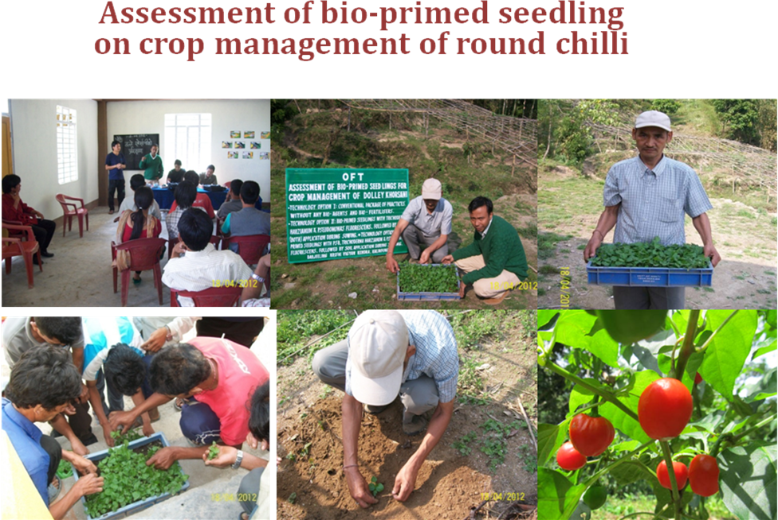

OFT – 2
Refinement of mulching methods for conserving soil moisture during dry period in Orange Orchard

Title of the OFT | Refinement of mulching methods for conserving soil moisture during dry period in Orange Orchard
Problem diagnose | During dry period, it’s difficult to get life saving irrigation in hill situation. So, save the soil moisture during dry period from being lost through evaporation in the month of January to April.
Treatment details | Farmer’s practice: Use of dry leaves, green leaves and hay as mulching materials  Tech. Option I:Use of only polythene mulching  Tech. Option II:Dry leaves and green as mulching materials and cover the same with polythene on top  Tech. Option III:Hay as mulching materials and cover the same with polythene on top
Source of Technology | UBKV, Pundibari
Production system and thematic area | Fruit crop based cropping system
Performance of the technology with performance indicators | To save soil moisture during dry period from lost through evaporation different mulching materials was used. The technology Option-II was found to be significant followed by Technology option I and III.
Final recommendation for micro level situation | Among the different mulching materials, technology Option-II was recommended but further trail also needed against the farmers practice using both dry leaves and polythene as a mulching materials.
Constraints identified and feedback for research | Lack of awareness about the mulching materials about polythene use as mulching materials. That’s why further research and training programmes have to be conducted to standardize the polythene and dry leaves use as mulching materials to save the soil moisture during dry period from being lost through evaporation.
Process of farmers participation and their reaction | Farmers participated actively through phone calls, personal contacts, krishi Mela, field days, etc. Farmers participated in this programme were highly interested save the soil moisture during dry period to use mulching materials.

Results:

Technology option | After 15 day Moisture (%) | After 30 day Moisture (%) | After 45 day Moisture (%) | After 60 day Moisture (%) | Yield/  Plant | Yiield increased (%) | Gross cost  (Rs/plant) | Gross Return  (Rs/plant) | B:C ratio
Farmers' practice : Use of dry leaves, green leaves and hay as mulching materials | 33 | 28 | 24 | 22 | 595 | - | 430 | 1042 | 1:2.42
Technology Option I : Use of only polythene mulching | 35 | 30 | 26 | 23 | 646 | 8.6 | 455 | 1130 | 1:2.48
Technology Option II : Dry leaves and green as mulching materials and cover the same with polythene on top | 42 | 38 | 35 | 30 | 702 | 17.9 | 465 | 1230 | 1:2.64
Technology Option III: Hay asmulching materials and cover the same with polythene on top | 39 | 32 | 27 | 25 | 678 | 13.9 | 460 | 1186 | 1:2.58

Calculation: W₁-W₂
Air dry Moisture(%) = X100
W₂

Where, W₁= Weight of air dry soil
W₂= Weight of oven dry soil

Soil sample analysis Results:
Nutrient content | Initial soil test result | After fruit harvest
OC (%) | 1.82 | 1.95
pH | 4.92 | 5.40
Available N Kg ha⁻¹ | 270 | 295
Available P₂O₅Kg ha⁻¹ | 50 | 57
Available K₂OKg ha⁻¹ | 220 | 245

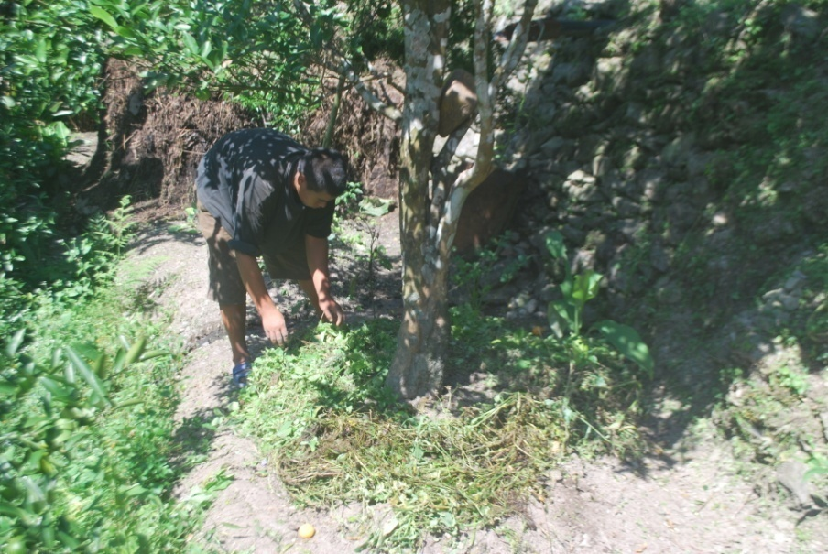
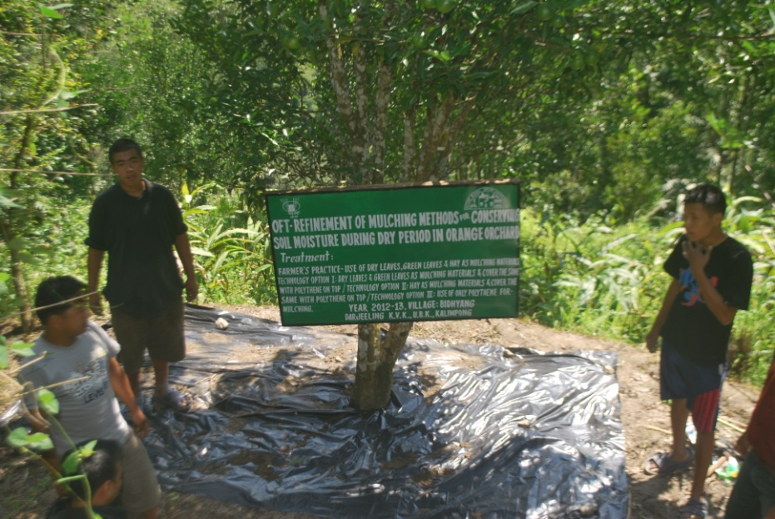
Mulching with polythene sheet Mulching with dry and green leaves
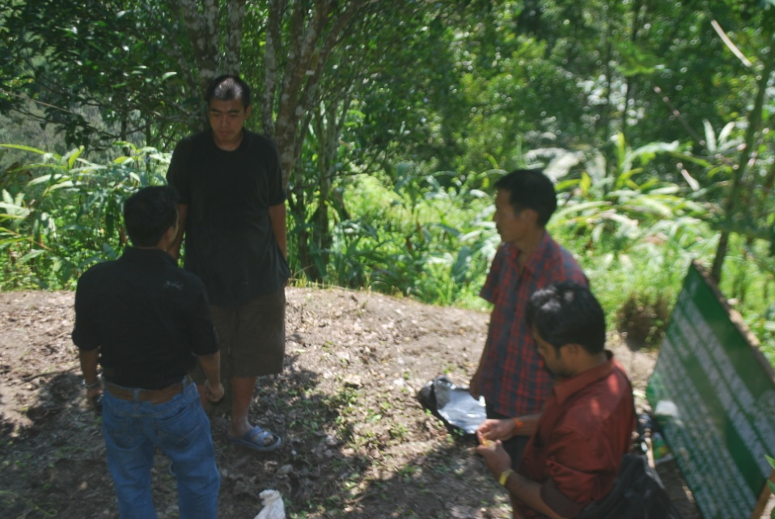
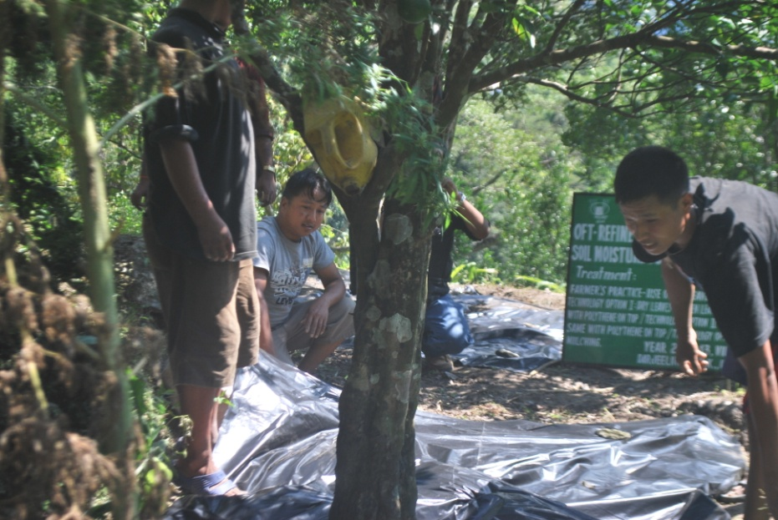
Mulching with hay & polythene sheet

OFT – 3
1. | Title of the OFT | Performance of TPS varieties under Hill Agro-climatic situation
2. | Problem diagnose | Poor quality potato tuber yields and high cost of cultivation. Non-availability of quality seed tubers, high seed cost, virus infiltration of seed tubers causing degeneration of seed stocks.
3. | Details of technologies selected for assessment/refinement | Tech. option I: Farmers’ practice - use of seed tubers (Darjeeling Red Round) with FYM 5 tonnes/ha  Tech. option II: Cultivation of H.P.S. I/13 with FYM @ 20 tonnes/ha and NPK @ 150:100:150 kg/ha  Tech. option III: Cultivation of H.P.S. II/13 with FYM @ 20 tonnes/ha and NPK @ 150:100:150 kg/ha  Tech. option IV: Cultivation of H.P.S. II/67 with FYM @ 20 tonnes/ha and NPK @ 150:100:150 kg/ha
4. | Source of Technology | Horticultural Research Complex, Nagicherra, West Tripura
5. | Production system and thematic area | Vegetable based cropping systems
6. | Performance of the Technology with performance indicators | Based on the tuber yield and benefit: cost ratio of TPS progenies compared to locally available variety, Darjeeling Red Round, the Technology Option IV (HPS II/67) was found to be significant followed by Tech. option II (HPS I/13).
7. | Final recommendation for micro level situation | Among the different TPS progenies, the Technology option IV (HPS II/67) was recommended but further trial on commercial production against the farmers’ practices using both these seed tubers and TPS seedlings have to be conducted next year.
8. | Constraints identified and feedback for research | Non-availability of TPS seed materials and lack of awareness about the TPS production technology. That’s why further research and training programmes have to be conducted to standardize the TPS production technology.
9. | Process of farmers participation and their reaction | Farmers participated actively through phone calls, personal contacts, field days, etc. Farmers participated in this programme were highly interested in raising crops from TPS and demanded a larger quantity and a regular supply of TPS for potato production

Results:

Crop/  Variety | Data on parameter in relation to Technology demonstrated (OFT 1)
Crop/  Variety | Technology | Tuber yield (t/ha) | Gross cost (Rs./ha) | Gross return (Rs./ha) | Net return (Rs./ha) | B : C
Potato | Tech. option I: Farmers’ practice | 11.42 | 52413 | 91360 | 38947 | 1.74
Potato | Tech. option II:  HPS I/13 | 15.61 | 58952 | 124880 | 65928 | 2.12
Potato | Tech. option III:  HPS II/13 | 14.94 | 58815 | 119520 | 60705 | 2.03
Potato | Tech. option IV:  HPS II/67 | 16.73 | 59132 | 133840 | 74708 | 2.26

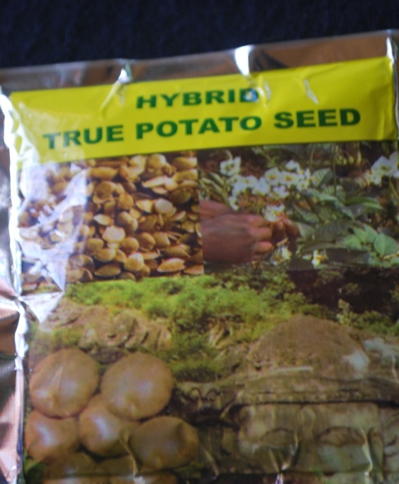
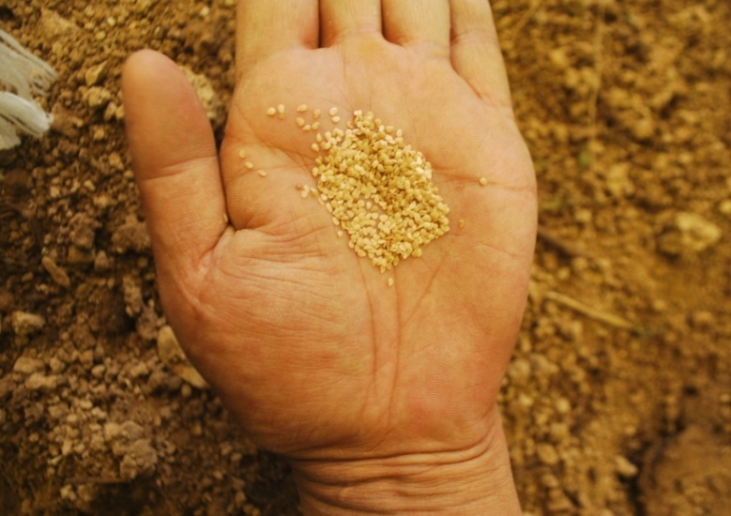

TPS packet True Potato Seed
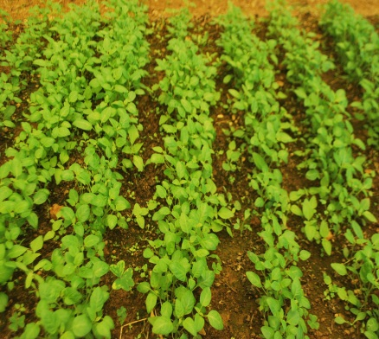
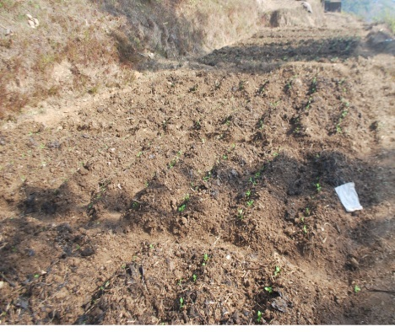

TPS seedlings True Potato Seed field
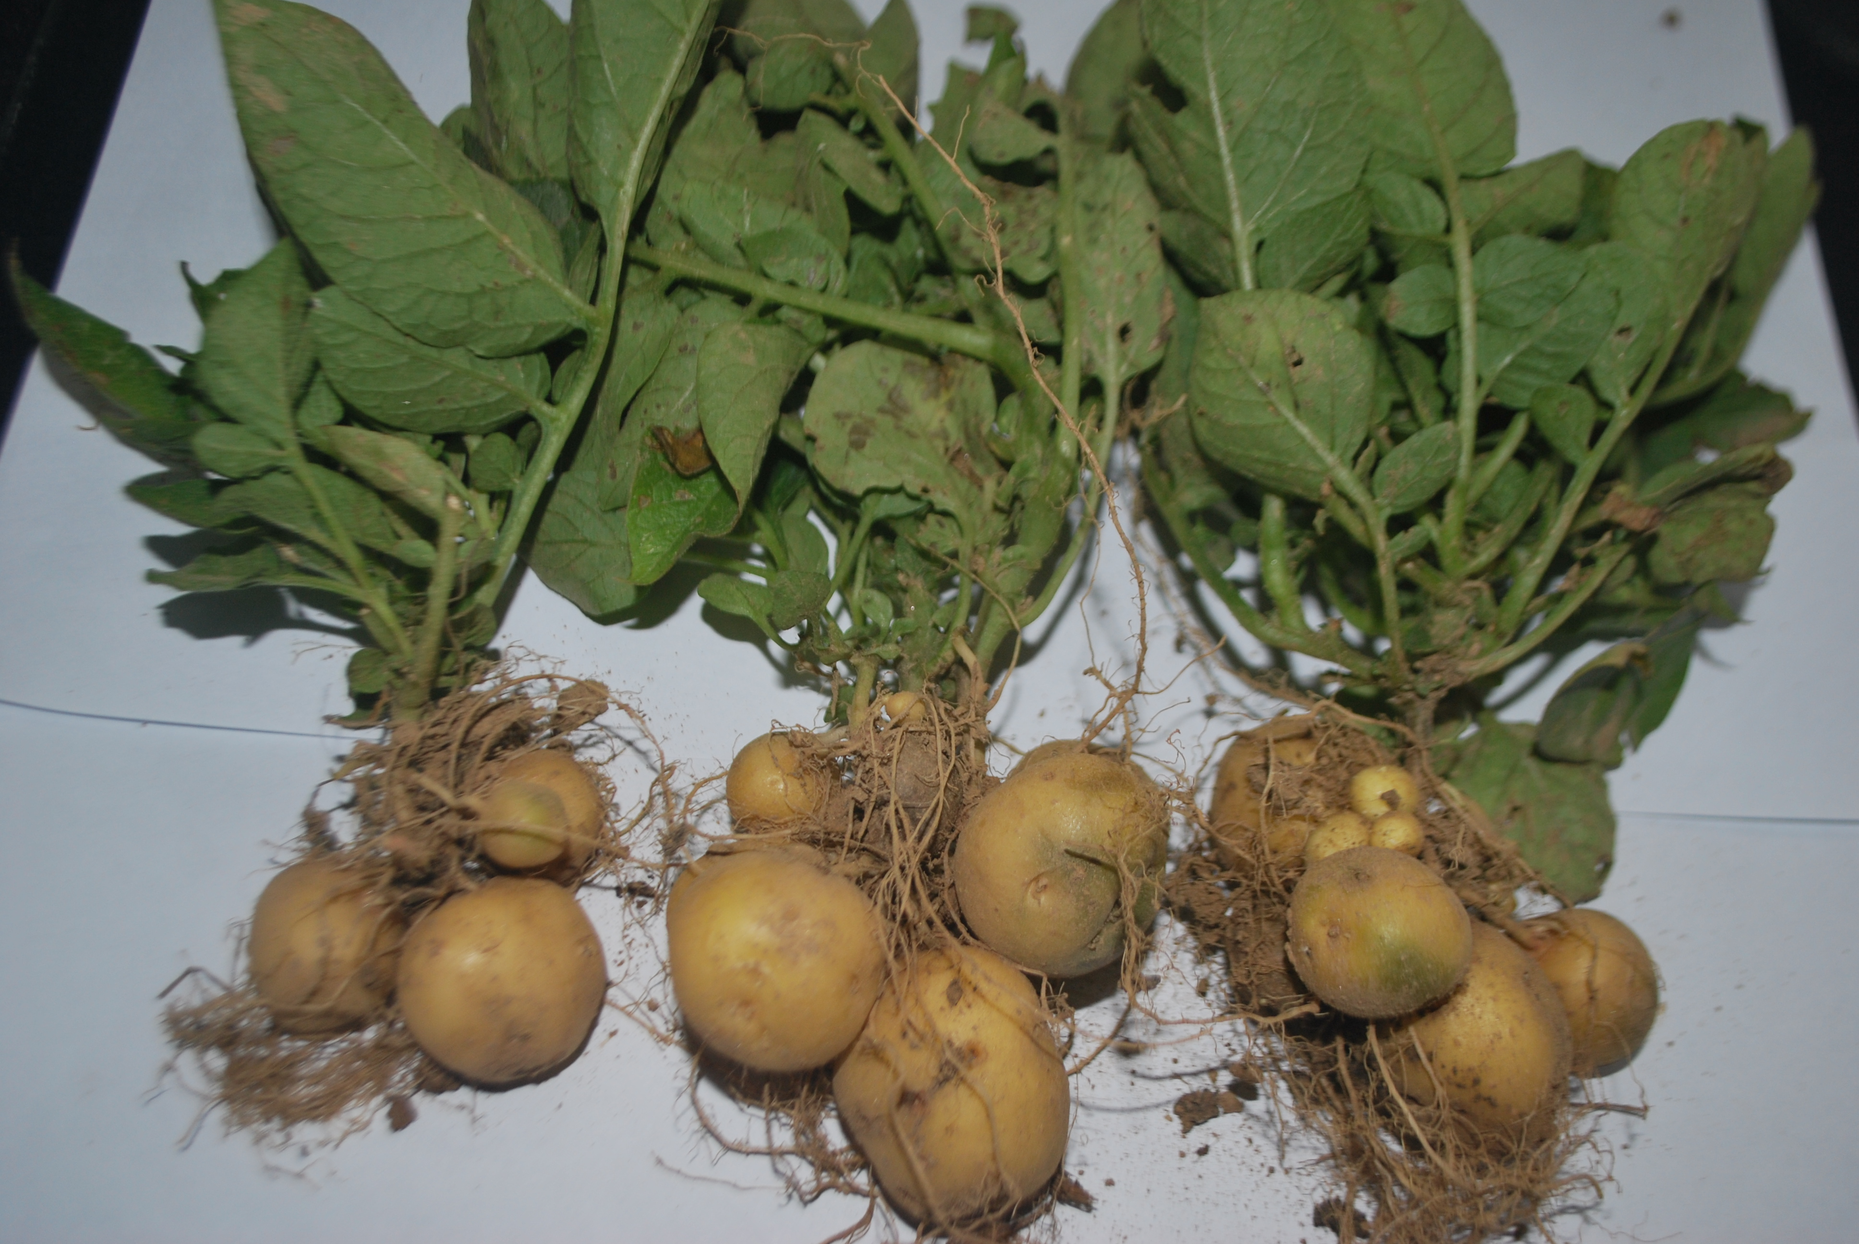
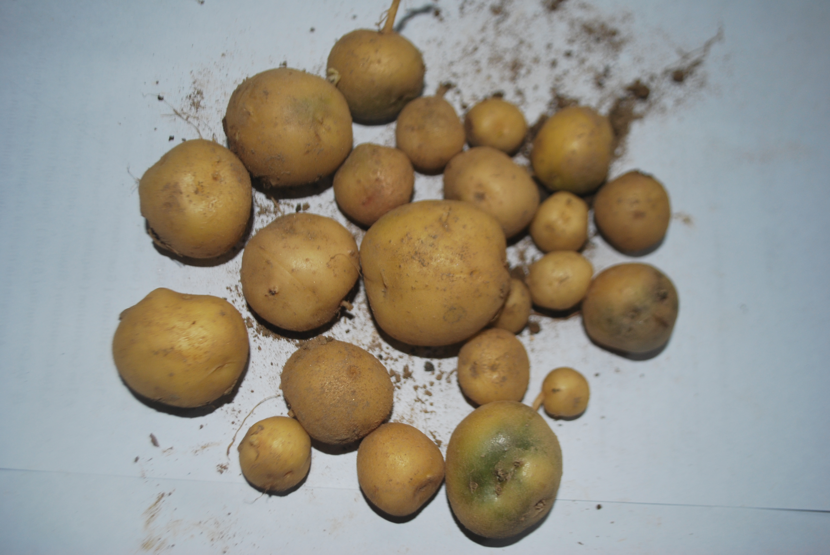

TPS plants with tubers TPS tubers

OFT - 4

1. | Title of the OFT | Assessing the performance of onion (Allium cepa) varieties
2. | Problem diagnose | Poor bulb yield due to repeated use of same local cultivar which causes low bulb yield and occurrence of more disease and pest infestation.
3. | Details of technologies selected for assessment/refinement | Tech. Option I: Farmers’ practice - cultivation of local variety with FYM @ 5 tonnes/ha and no chemical fertilizer application  Tech. Option II: Cultivation of Nasik Red (N-53) variety with FYM @ 10 tonnes/ha, 50% NPK of RDF (100:50:100 kg/ha) and vermicompost @ 2.5 t/ha  Tech. Option III: Cultivation of Mathahari variety with FYM @ 10 tonnes/ha, 50% NPK of RDF (100:50:100 kg/ha) and vermicompost @ 2.5 t/ha  Tech. Option IV: Cultivation of Luciffer variety with FYM @ 10 tonnes/ha, 50% NPK of RDF (100:50:100 kg/ha) and vermicompost @ 2.5 t/ha
4. | Source of Technology | Regional Research Station (Hill Zone), UBKV, Kalimpong
5. | Production system and thematic area | Vegetable based cropping systems
6. | Performance of the Technology with performance indicators | Based on the bulb yield and benefit: cost ratio, the Technology option III i.e. Mathahari variety with FYM @ 10 tonnes/ha, 50% NPK of RDF (100:50:100 kg/ha) and vermicompost @ 2.5 t/hawas found to be best against all other remaining technologies followed by Technology option IV.
7. | Final recommendation for micro level situation | The Technology option III Mathahari variety with FYM @ 10 tonnes/ha, 50% NPK of RDF (100:50:100 kg/ha) and vermicompost @ 2.5 t/hawas recommended for higher bulb yield and profit of farmers but it may be repeated next year.
8. | Constraints identified and feedback for research | Non-availability quality seed materials and vermicompost and also their cost is high. Therefore, training programmes for vermicompost preparation are needed using locally available kitchen wastes, crop residues, etc.
9. | Process of farmers participation and their reaction | Farmers participated actively through phone calls, personal contacts, field days, etc. They were satisfied and impressed about the best technology demonstrated through their participation during the whole trial period and expressed their views for further research and training programmes.

Results:
Crop/ Variety | Data on parameter in relation to Technology demonstrated (OFT 2)
Crop/ Variety | Technology | Bulb yield (t/ha) | Gross cost(Rs./ha) | Gross return (Rs./ha) | Net return (Rs./ha) | B : C
Onion | Tech. option I: Farmers’ practice | 7.10 | 21195 | 35500 | 14305 | 1:1.68
Onion | Tech. option II: Nasik Red | 12.52 | 55185 | 112680 | 57495 | 1:2.05
Onion | Tech. option III: Mathahari | 16.73 | 57076 | 150570 | 93494 | 1:2.64
Onion | Tech. option IV: Luciffer | 14.25 | 56255 | 128250 | 71995 | 1:2.28
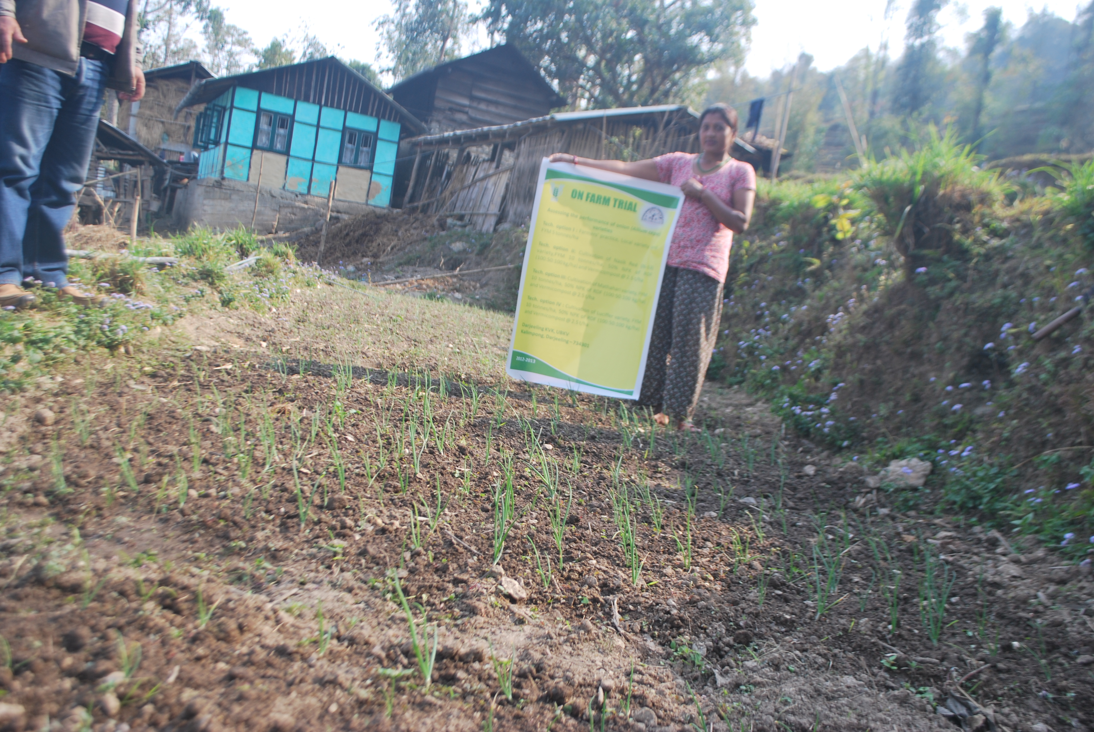
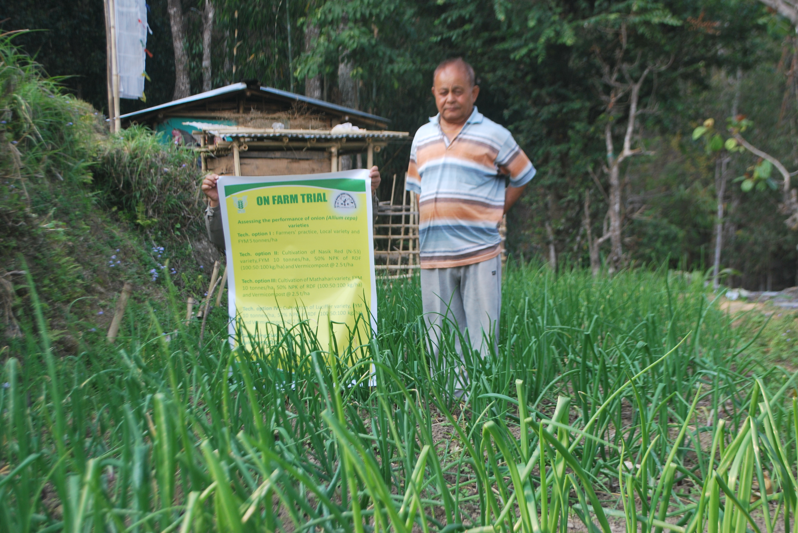
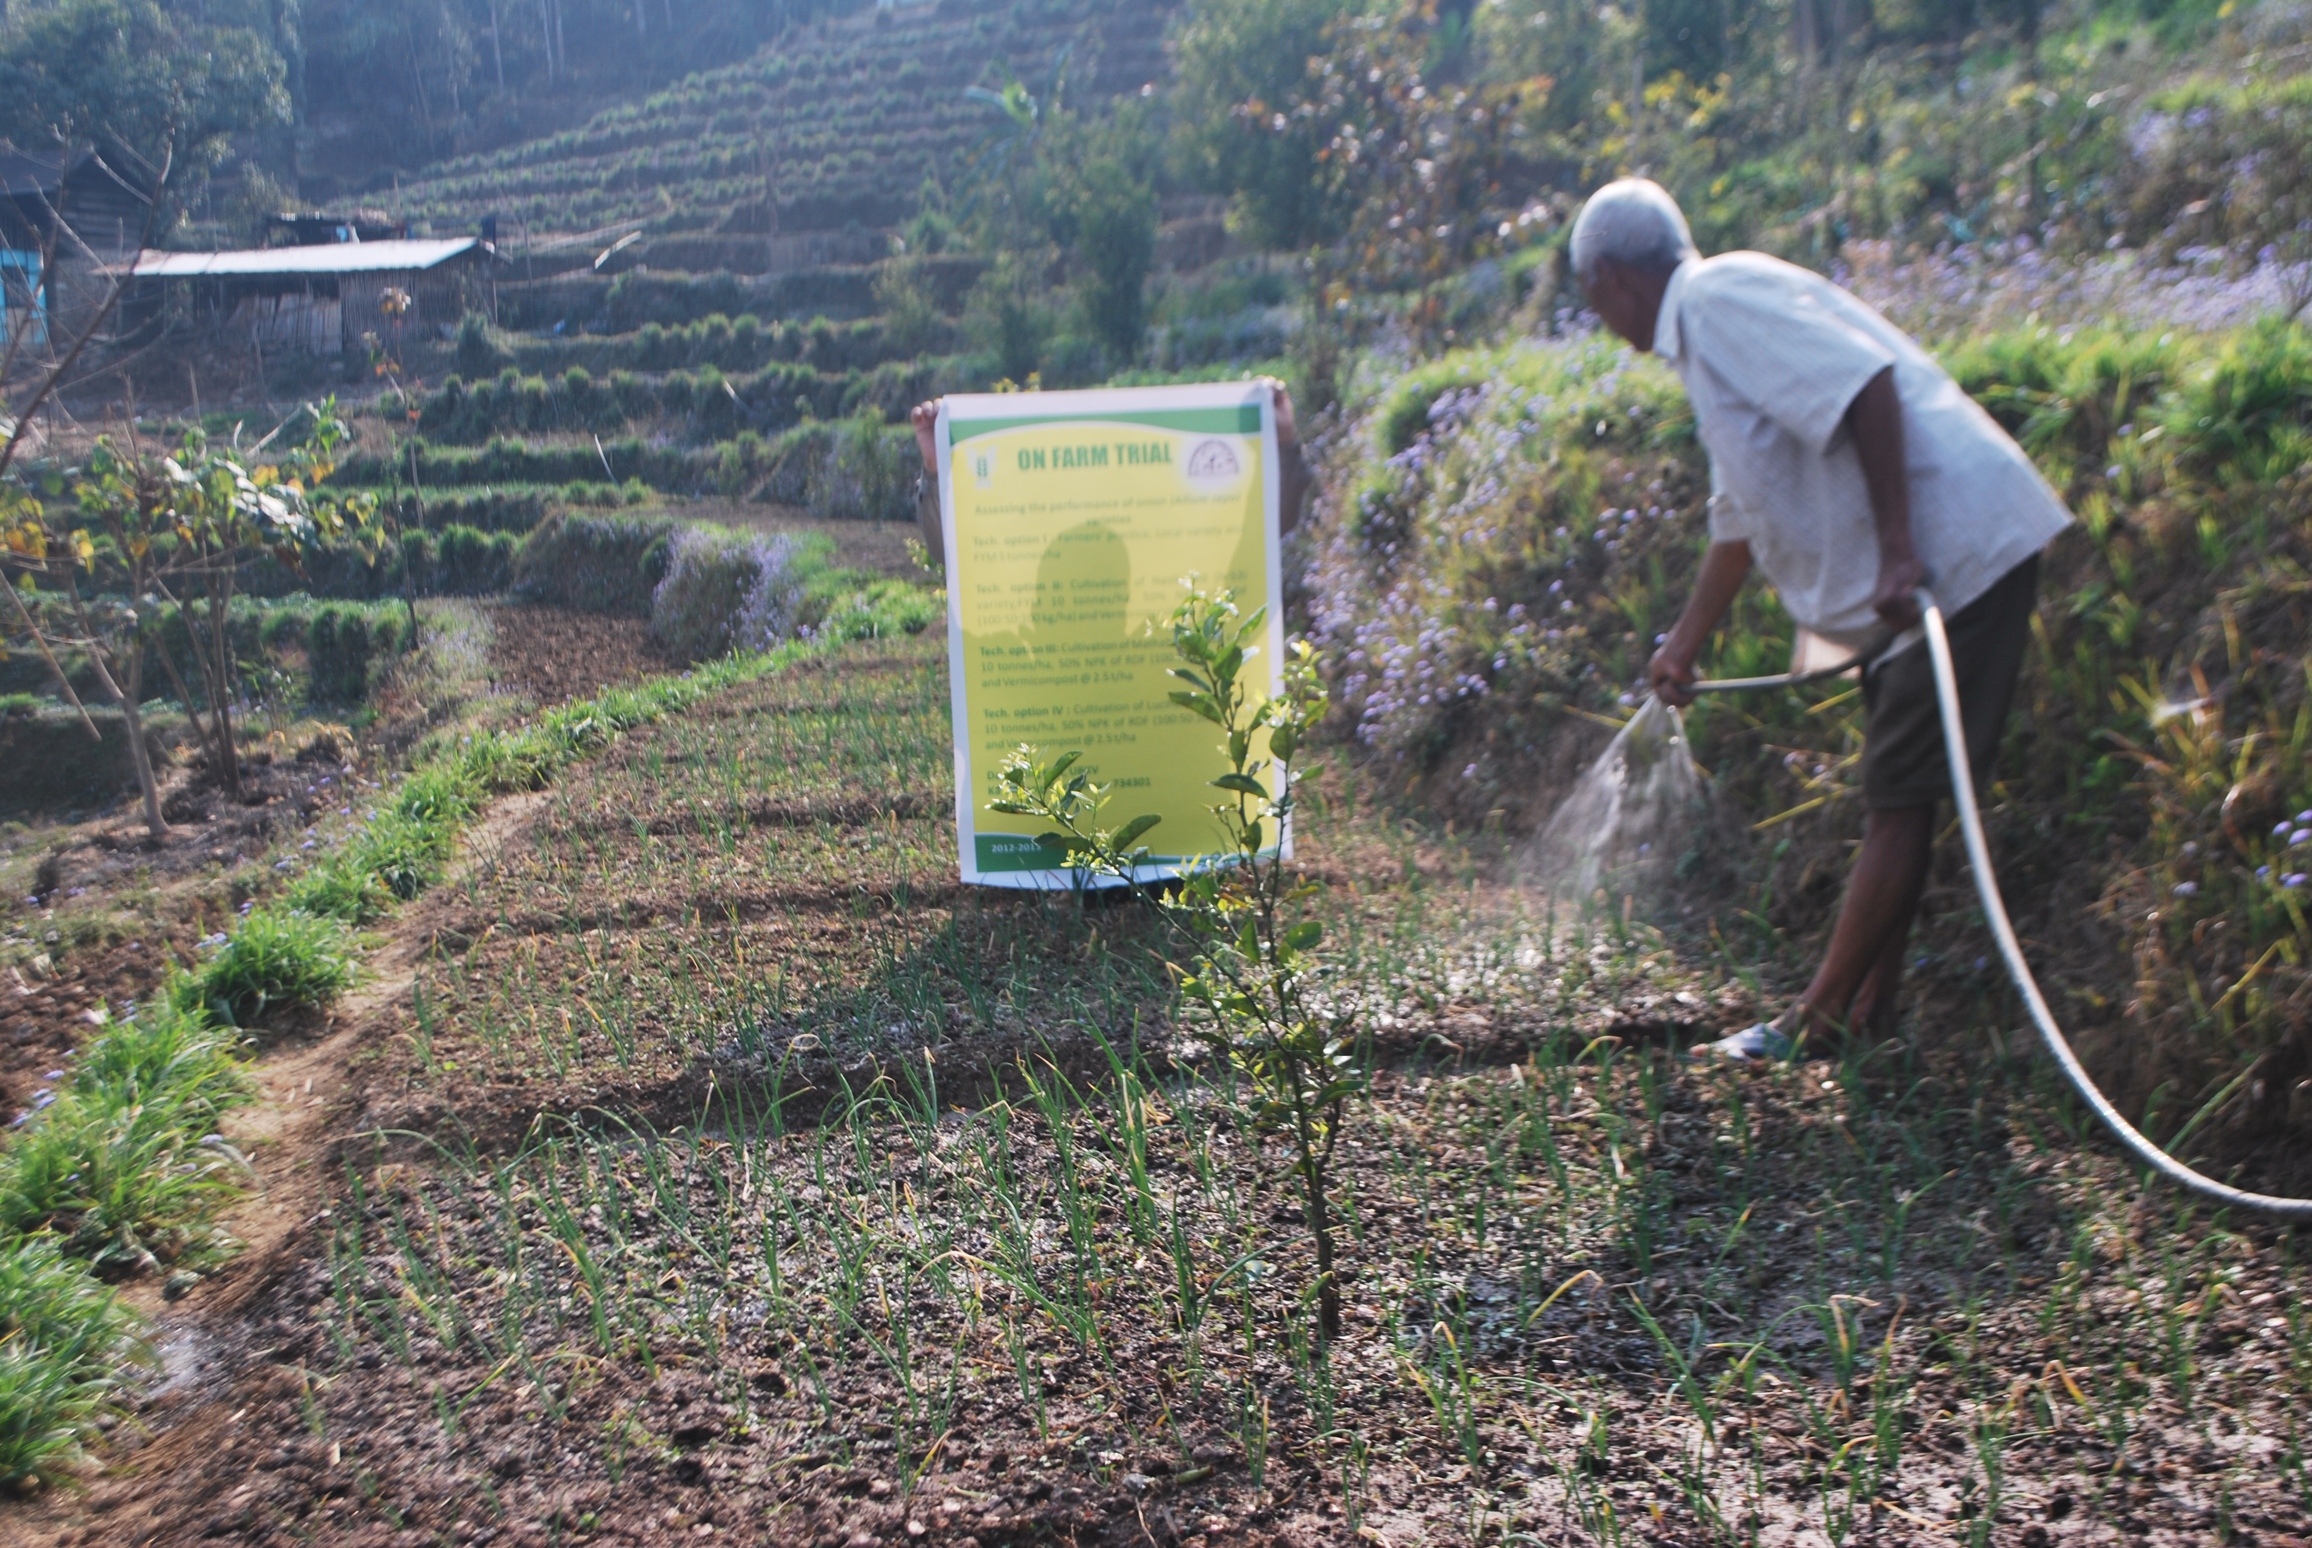
Onion field

OFT -5

Assessment of Vanaraja and RIR (Rhode Island Red) breed of fowl under backyard poultry farming system

1. | Title of the OFT | Assessment of production performance of Vanaraja and RIR (Rhode Island Red) breed of fowl under backyard poultry farming system
2. | Problem diagnose | Low productivity of poultry due to poor genetic makeup
3. | Details of technologies selected for assessment/refinement | Tech Option-1: Indigenous breed in backyard farming system  Tech Option-2: Vanaraja poultry breed in backyard farming system  Tech Option-3: RIR (Rhode Island Red) poultry breed in backyard farming system
4. | Source of Technology
5. | Production system and thematic area
6. | Performance of the Technology with performance indicators | T₂ is best treatment over T₁ & T₃, as there was increase in egg production than other options. There were more egg lay and weight of egg in vanaraja breed.
7. | Final recommendation for micro level situation | T₂ is best treatment over T₁ & T₃, as there was increase in egg production than other options. There were more egg lay and weight of egg in vanaraja breed.
8. | Constraints identified and feedback for research | Substantial increase in egg lay within backyard poultry farming
9. | Process of farmers participation and their reaction | Farmers participated actively through phone calls, personal contacts, field days, etc. Farmers participated in this programme were highly interested in raising crops from TPS and demanded a larger quantity and a regular supply of TPS for potato production.

Monitoring Indicator
Technology | Weight  (at 12 week) | Week of maturity | Weight at maturity | No. of egg  (upto 32 weeks/ hen) | Weight/egg (gm) | Avg. Gross Return (Income) Rs./in 32wks/unit | Avg. Net Return (Profit) Rs./in 32wks/unit | BC Ratio
Tech. Opt -1 | 0.30 kg | 25 | 1.55 kg | 14 | 52 gm | 560 | 410 | 2.73:1
Tech. Opt -2 | 0.45 kg | 20 | 2.35 kg | 78 | 58 gm | 4680 | 4180 | 8.36:1
Tech. Opt -3 | 0.46 kg | 20 | 2.40 kg | 74 | 56 gm | 4440 | 3980 | 7.96:1

Result:
Results of assessment | Feedback from the farmer
T₂ is best treatment over T₁ & T₃, as there was increase in egg production than other options. There were more egg lay and weight of egg in vanaraja breed. | Substantial increase in egg lay within backyard poultry farming

OFT -6
1. | Title of the OFT | Assessment on feeding of feed additives to lactating dairy cattle
2. | Problem diagnose | Low productivity of Dairy animal due to non adoption of deworming practices and imbalanced & deficient concentrate feeding practices
3. | Details of technologies selected for assessment/refinement | Tech Option-1: Farmers practice  (Livestock management with traditional feeding practices)  Tech Option-2: T1 + Green Fodder + Albendazole  Tech Option-3: T2 + Mineral mixture (20gm) + Himalayan Batisa (20gm) + Salt (20gm) cattle /day
4. | Source of Technology | WBSAFS
5. | Production system and thematic area
6. | Performance of the Technology with performance indicators | T₃ is best treatment over T₁ & T₂, as there was increase in yield than other two treatments. Milk yield has been increased substantially by feeding green fodder and anthelmentics with mineral mixture, Himalayan batisa, and salt over farmers' practice and feeding of only green fodder and anthelmentics
7. | Final recommendation for micro level situation | T₃ is best treatment over T₁ & T₂, as there was increase in yield than other two treatments. Milk yield has been increased substantially by feeding green fodder and anthelmentics with mineral mixture, Himalayan batisa, and salt over farmers' practice and feeding of only green fodder and anthelmentics
8. | Constraints identified and feedback for research | Feeding of feed additives increases the total yield in dairy cattle and there is also reduces in disease incidence and good body condition.
9. | Process of farmers participation and their reaction | Farmers participated actively through phone calls, personal contacts, field days, etc. Farmers participated in this programme were highly interested in raising crops from TPS and demanded a larger quantity and a regular supply of TPS for potato production.

Results:
Results of assessment | Feedback from the farmer
T₃ is best treatment over T₁ & T₂, as there was increase in yield than other two treatments. Milk yield has been increased substantially by feeding green fodder and anthelmentics with mineral mixture, Himalayan batisa, and salt over farmers' practice and feeding of only green fodder and anthelmentics. | Feeding of feed additives increases the total yield in dairy cattle and there is also reduces in disease incidence and good body condition.

Results of On Farm Trials

Crop/ enterprise | Farming situation | Problem Diagnosed | Title of OFT | No. of trials* | Technology Assessed | Parameters of assessment | Data on the parameter | Results of assessment | Feedback from the farmer | Any refinement done | Justification for refinement
1 | 2 | 3 | 4 | 5 | 6 | 7 | 8 | 9 | 10 | 11 | 12
Round Chilli | Rain fed medium to low hill farming situation | Poor yield of round chilli due to pest & diseases. | Assessment of bio-primed seedlings in crop management of round chilli | 8 | Bio-control | Root length, shoot length, disease incidence, yield | *OFT1 | Bio-priming with three bio-agents were used separately to assess its effect on crop improvement of round chilli and it was found that all the bio-agents performed positively. But as far as general crop management was concerned PSB gave good results and Pseudomonas fluorescens found effective against bacterial wilt
Darjeeling Mandarin Orange | Rain fed medium to low hill farming situation | During dry period, it’s difficult to get life saving irrigation in hill situation. So, save the soil moisture during dry period from being lost through evaporation in the month of January to April. | Refinement of mulching methods for conserving soil moisture during dry period in Orange Orchard | 7 | Conserving soil moisture during dry period | Fruit yield, Comparative economics | *OFT2 | Among the different mulching materials, technology Option-II was recommended but further trail also needed against the farmers practice using both dry leaves and polythene as a mulching materials.
Potato | Vegetable based cropping systems | Poor quality potato tuber yields and high cost of cultivation. Non-availability of quality seed tubers, high seed cost, virus infiltration of seed tubers causing degeneration of seed stocks. | Performance of TPS varieties under Hill Agro-climatic situation | 6 | Performance of TPS varieties | Yield, Comparative economics | *OFT 3 | Based on the tuber yield and benefit: cost ratio of TPS progenies compared to locally available variety, Darjeeling Red Round, the Technology Option IV (HPS II/67) was found to be significant followed by Tech. option II (HPS I/13).
Onion | Vegetable based cropping systems | Poor bulb yield due to repeated use of same local cultivar which causes low bulb yield and occurrence of more disease and pest infestation. | Assessing the performance of onion (Allium cepa) varieties |  | Performance of onion varieties | Yield, Comparative economics | *OFT 4 | Based on the bulb yield and benefit: cost ratio, the Technology option III i.e. Mathahari variety with FYM @ 10 tonnes/ha, 50% NPK of RDF (100:50:100 kg/ha) and vermicompost @ 2.5 t/hawas found to be best against all other remaining technologies followed by Technology option IV.
Poultry |  | Low productivity of poultry due to poor genetic makeup | Assessment of production performance of Vanaraja and RIR (Rhode Island Red) breed of fowl under backyard poultry farming system |  | Production performance of Vanaraja and RIR | Egg production, weight of egg | *OFT 5 | T₂ is best treatment over T₁ & T₃, as there was increase in egg production than other options. There were more egg lay and weight of egg in vanaraja breed.
Cattle |  | Low productivity of Dairy animal due to non adoption of deworming practices and imbalanced & deficient concentrate feeding practices | Assessment on feeding of feed additives to lactating dairy cattle |  | Feeding of feed additives to lactating dairy cattle | Yield in dairy cattle, disease incidence and body condition | *OFT 6 | T₃ is best treatment over T₁ & T₂, as there was increase in yield than other two treatments. Milk yield has been increased substantially by feeding green fodder and anthelmentics with mineral mixture, Himalayan batisa, and salt over farmers' practice and feeding of only green fodder and anthelmentics.

3.2 Achievements of Frontline Demonstrations

A.. Details of FLDs implemented during 2011-12 (Information is to be furnished in the following three tables for each category i.e. cereals, horticultural crops, oilseeds, pulses, cotton and commercial crops.)

Sl.  No. | Crop | Thematic area | Technology Demonstrated | Season and year | Area (ha) |  | No. of farmers/  demonstration |  |  | Reasons for shortfall in achievement
 |  |  |  |  | Proposed | Actual | SC/ST | Others | Total
1 | Hybrid  Maize | Integrated Farming | Variety- Kaveri | Kharif 2012-13 | 10 | 5 | 15 | 17 | 32
2 | Tomato | Integrated Farming | Hybrid variety | Pre- kharif | 1 | 1 | 4 | 5 | 9
3 | Pea | Integrated Farming | Composite variety | Rabi | 3 | 3 | 6 | 12 | 18
4 | Mandarin  Orange | Fruit fly Management | Fruit fly trap | Kharif | 3 | 3 | 2 | 7 | 9
5 | Large  Cardamom | Soil amendment | Lime  application | Kharif | 1 | 1 | 3 | 5 | 8

Details of farming situation

Crop | Season | Farming situation (RF/Irrigated) | Soil type | Status of soil  Kg/ha |  |  | Previous crop | Sowing date | Harvest date | Seasonal rainfall (mm) | No. of rainy days
 |  |  |  | Av.N | Av. P₂O₅ | Av. K₂O
Maize | Pre-Kharif 2012 | Variety- Kaveri | Sandy loam | 270 | 34 | 349 | Vegetables | 26/02/2012 | 18/06/2012
Tomato | Pre- kharif 12 | Romeo | ,, | 360 | 40 | 195 | Potato | 16.02.12 | 10.04.12
Pea | Rabi | Azadkranti | ,, | 310 | 37 | 290 | Paddy | 12.10.12 | 18.01.13
Mandarin Orange | Kharif  12 | Darjeeling Manderin | ,, | 378 | 50 | 220 | Perennial |  | 22.11.12
Large Cardamom | Kharif  12 |  | ,, | 395 | 42 | 280 | Perennial |  | 12.09.12

Performance of FLD

Oilseeds:
Frontline demonstrations on oilseed crops

Crop | Thematic Area | Name of the technology demonstrated | No. of Farmers | Area  (ha) | Yield (q/ha) |  | % Increase | *Economics of demonstration (Rs./ha) |  |  |  | *Economics of check  (Rs./ha)
 |  |  |  |  | Demo | Check | % Increase | Gross  Cost | Gross  Return | Net Return | **  BCR | Gross  Cost | Gross  Return | Net Return | **  BCR
* Economics to be worked out based total cost of production per unit area and not on critical inputs alone.
** BCR= GROSS RETURN/GROSS COST

Pulses

Frontline demonstration on pulse crops
^{Crop} | ^{Thematic Area} | Name of the technology demonstrated | ^{No. of Farmers} | ^{Area}  ^{(ha)} | ^{Yield (q/ha)} |  | ^{% Increase} | *Economics of demonstration (Rs./ha) |  |  |  | ^{*Economics of check}  ^{(Rs./ha)}
 |  |  |  |  | ^{Demo} | ^{Check} | ^{% Increase} | ^{Gross}  ^{Cost} | ^{Gross}  ^{Return} | ^{Net Return} | **  ^{BCR} | ^{Gross}  ^{Cost} | ^{Gross}  ^{Return} | ^{Net Return} | **  ^{BCR}

* Economics to be worked out based total cost of production per unit area and not on critical inputs alone.
** BCR= GROSS RETURN/GROSS COST

Maize, cotton and lentil as special programme

Frontline demonstration on Maize

Crop | Thematic Area | Name of the technology demonstrated | No. of Farmers | Area  (ha) | Yield (q/ha) |  | % Increase | *Economics of demonstration (Rs./ha) |  |  |  | *Economics of check  (Rs./ha)
 |  |  |  |  | Demo | Check | % Increase | Gross  Cost | Gross  Return | Net Return | **  BCR | Gross  Cost | Gross  Return | Net Return | **  BCR
Maize | ^{Integrated farming} | ^{Hybrid Variety} | 35 | 5 | 36.4 | 28.2 | 29.07 | 8360 | 29120 | 18760 | 1:3.1 | 7890 | 18740 | 11850 | 1:2.5
Total |  |  | 35 | 5 | 36.4 | 28.2 | 29.07 | 8360 | 29120 | 18760 | 1:3.1 | 7890 | 18740 | 11850 | 1:2.5
* Economics to be worked out based total cost of production per unit area and not on critical inputs alone.
** BCR= GROSS RETURN/GROSS COST

Other crops
Category and Crop | Thematic area | Name of the technology demonstrated | No. of Farmer | Area  (ha) | Yield (q/ha) |  | % change in yield | Other parameters |  | *Economics of demonstration (Rs./ha) |  |  |  | *Economics of check  (Rs./ha)
 |  |  |  |  | Demons  ration | Check | % change in yield | Demo | Check | Gross  Cost | Gross  Return | Net Return | **  BCR | Gross  Cost | Gross  Return | Net Return | **  BCR
Cereals
Millets
Vegetable crops
Tomato | Integrated Farming | Hybrid variety | 10 | 1 | 28.2 | 24.8 | 13.7 |  |  | 8470 | 25380 | 16910 | 1:3 | 5980 | 17360 | 11380 | 1:2.9
Pea | Integrated Farming | Composite variety | 21 | 3 | 18.2 | 15.8 | 15.2 |  |  | 13000 | 27300 | 14300 | 1:2.1 | 11320 | 18565 | 7245 | 1:1.64
Flower crops
Ornamental crops
Fruit crops
Mandarin Orange | Fruit Fly Management | Fruit Fly Trap | 14 | 3.0 | 185170 | 173340 | 11.10 |  |  | 185170 | 514420 | 329250 | 1:2.77 | 173340 | 463018 | 289678 | 1:2.67
Spices and condiments
Large Cardamom | Soil amendment | Lime application | 10 | 1 | 2.76 | 2.40 | 15.0 |  |  | 57850 | 218592 | 160742 | 1:3.7 | 55972 | 178800 | 122828 | 1:3.2
Commercial crops
Medicinal and aromatic plants
Fodder crops
Plantation crops
Fibre crops
Green manuaring
On Rice
 | Total
* Economics to be worked out based total cost of production per unit area and not on critical inputs alone.
** BCR= GROSS RETURN/GROSS COST

Soil test Result of FLD on Large Cardamom

Nutrient content | Initial soil test result | After Harvest
OC (%) | 1.42 | 1.51
pH | 4.35 | 4.92
Available N Kg ha⁻¹ | 266 | 290
Available P₂O₅Kg ha⁻¹ | 42 | 50
Available K₂O Kg ha⁻¹ | 220 | 245

Result of Front Line Demonstrations
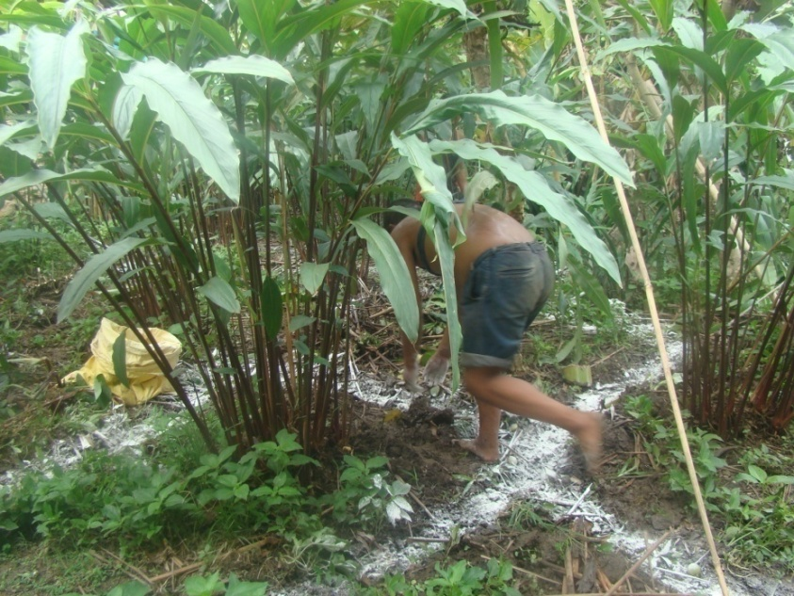
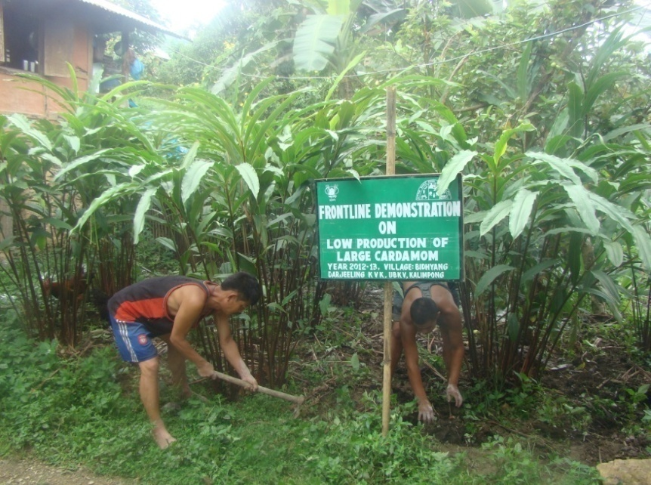

Limning Application of Vermi Compost

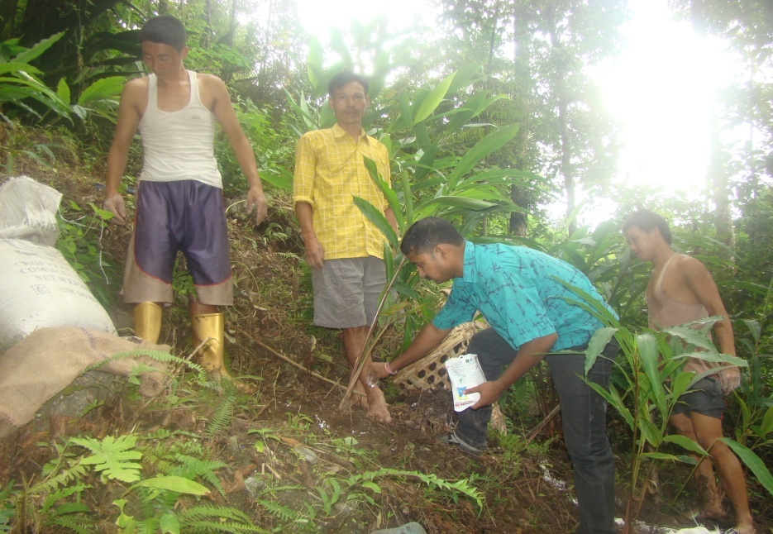
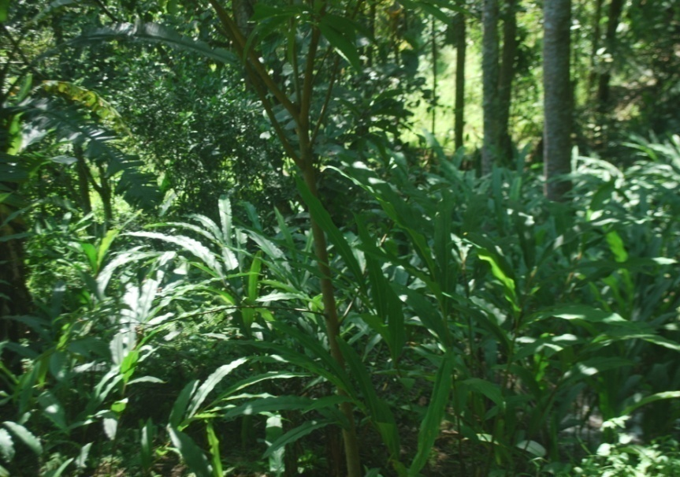

Application of Boron Healthy field

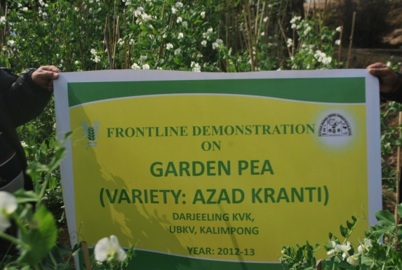
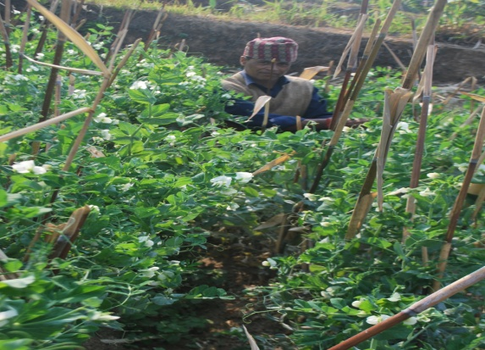

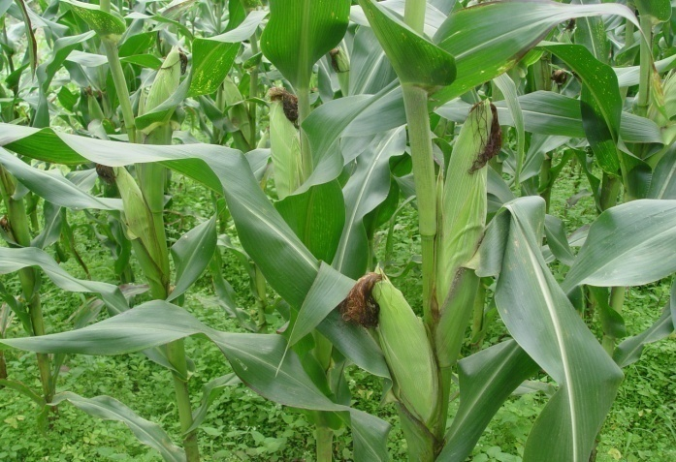
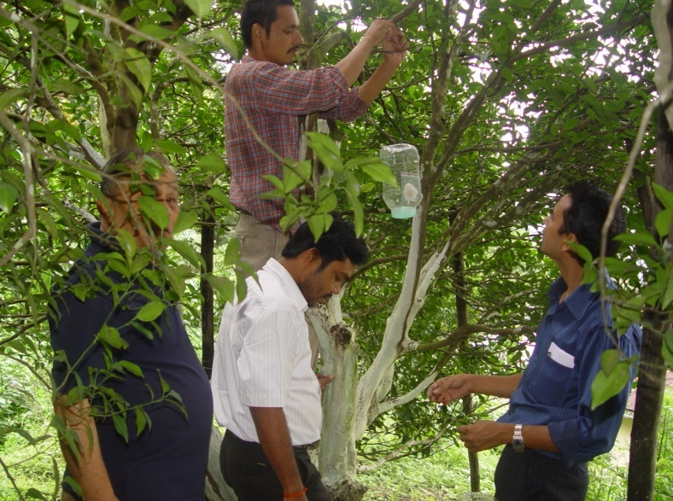
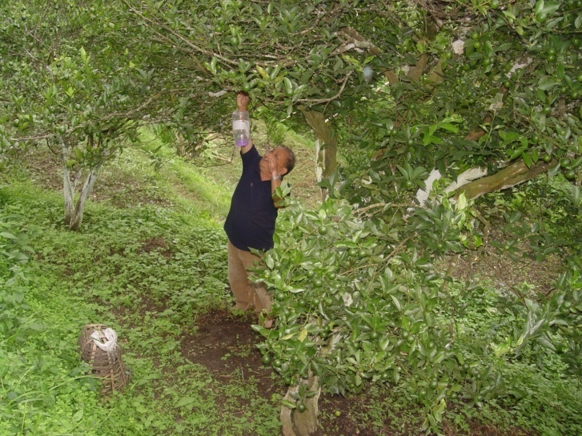
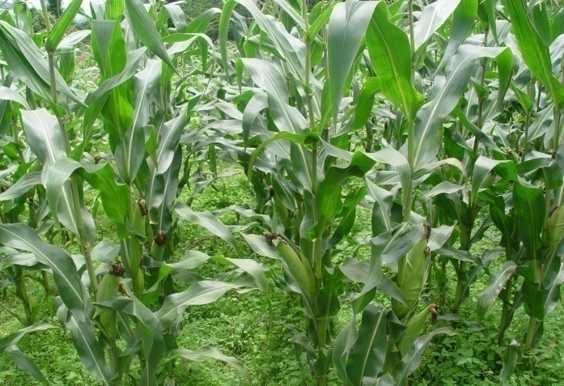

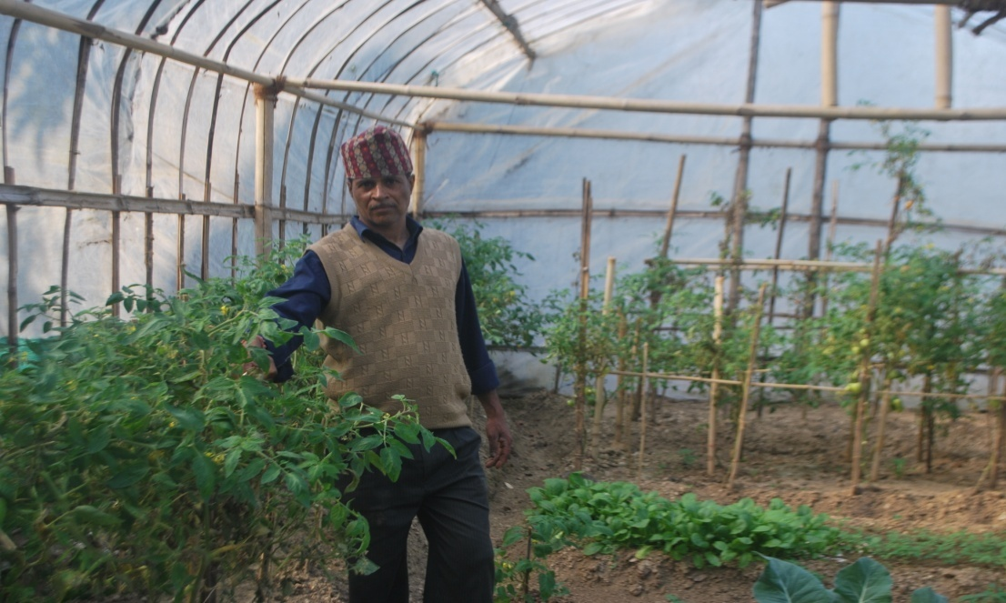
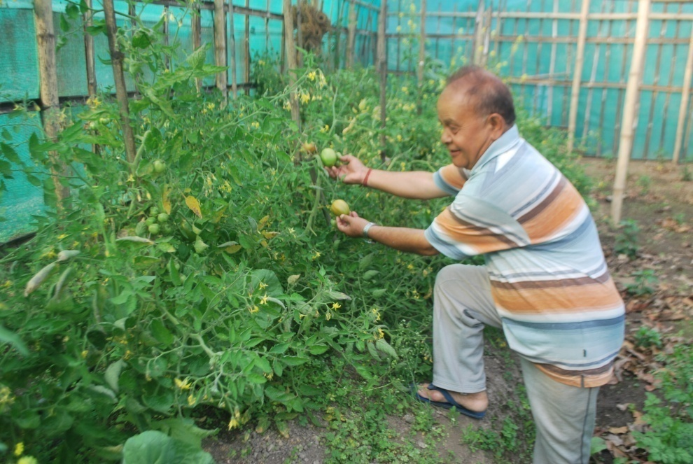
Photographs of FLD (other than Pulses and Oilseed)
Livestock

Category | Thematic area | Name of the technology demonstrated | No. of Farmer | No.of units | Major parameters |  | % change in major parameter | Other parameter |  | *Economics of demonstration (Rs.) |  |  |  | *Economics of check  (Rs.)
 |  |  |  |  | Demons  ration | Check | % change in major parameter | Demons  ration | Check | Gross  Cost | Gross  Return | Net Return | **  BCR | Gross  Cost | Gross  Return | Net Return | **  BCR
Dairy
Cow
Buffalo
Poultry
Rabbitry
Pigerry
Sheep and goat
Duckery
Others (pl.specify)
Total
* Economics to be worked out based total cost of production per unit area and not on critical inputs alone.
** BCR= GROSS RETURN/GROSS COST

Fisheries

Category | Thematic area |  | Name of the technology demonstrated | No. of Farmer | No.of units | Major parameters |  | % change in major parameter | Other parameter |  | *Economics of demonstration (Rs.) |  |  |  | *Economics of check  (Rs.)
 |  |  |  |  |  | Demons  ration | Check | % change in major parameter | Demons  ration | Check | Gross  Cost | Gross  Return | Net Return | **  BCR | Gross  Cost | Gross  Return | Net Return | **  BCR
Common carps
Mussels
Ornamental fishes
Others (pl.specify)
 |  | Total

* Economics to be worked out based total cost of production per unit area and not on critical inputs alone.
** BCR= GROSS RETURN/GROSS COST

Other enterprises

Category | Name of the technology demonstrated | No. of Farmer | No.of units | Major parameters |  | % change in major parameter | Other parameter |  | *Economics of demonstration (Rs.) or Rs./unit |  |  |  | *Economics of check  (Rs.) or Rs./unit
 |  |  |  | Demons  ration | Check | % change in major parameter | Demons  ration | Check | Gross  Cost | Gross  Return | Net Return | **  BCR | Gross  Cost | Gross  Return | Net Return | **  BCR
Oyster mushroom
Button mushroom
Vermicompost
Sericulture
Apiculture
Horticulture | Fruit Fly Trap | 9 | 9 | Fruit drop checked by 23% of total loss due to fruit fly | 41% Fruit drop due to fruit fly | 23 % increased in yield |  |  | Rs. 70 per plant | Rs. 230 | Rs. 160 | 1:2.28 | -- | -- | -- | --
Total
* Economics to be worked out based total cost of production per unit area and not on critical inputs alone.
** BCR= GROSS RETURN/GROSS COST

Women empowerment

Category | Name of technology | No. of KVKs | No. of demonstrations | Name of observations | Demonstration | Check
Women
Pregnant women
Adolescent Girl
Other women
Children
Neonats
Infants
Children

Farm implements and machinery
Name of the implement | Crop | Name of the technology demonstrated | No. of KVKs | No. of Farmer | Area (ha) | Filed observation (output/man hour) |  | % change in major parameter | Labor reduction (man days) |  |  |  | Cost reduction (Rs./ha or Rs./Unit ect.)
 |  |  |  |  |  | Demons  ration | Check | % change in major parameter

* Economics to be worked out based total cost of production per unit area and not on critical inputs alone.
** BCR= GROSS RETURN/GROSS COST

Demonstration details on crop hybrids
Crop | Name of the Hybrid | No. of  farmers | Area  (ha) | Yield (kg/ha) / major parameter |  |  | Economics (Rs./ha)
 |  |  |  | Demo | Local check | % change | Gross  Cost | Gross  Return | Net  Return | BCR
Cereals
Bajra
Maize | Kavari | 32 | 5 | 36.4 | 28.2 | 29.07 | 8360 | 29120 | 18760 | 1:3:1
Paddy
Sorghum
Wheat
Others (pl.specify)

Total
Oilseeds
Castor
Mustard
Safflower
Sesame
Sunflower
Groundnut
Soybean
Others (pl.specify)
Total
Pulses
Greengram
Blackgram
Bengalgram
Redgram
Others (pl.specify)

Total
Vegetable crops
Bottle gourd
Capsicum
Cucumber
Tomato | Romeo | 10 | 1 | 28.2 | 24.8 | 13.7 | 8470 | 25380 | 16910 | 1:3
Brinjal
Okra
Onion
Potato
Field Pea | Azad Kranti | 21 | 3 | 18.2 | 15.8 | 15.2 | 13000 | 27300 | 14300 | 1:2.1
Others (pl.specify)
Total |  | 31 | 4
Commercial crops
Cotton
Coconut
Mandarin Orange | Fruit fly trap | 14 | 3 | 185170 | 173340 | 11.10 | 185170 | 514420 | 329250 | 1:2.77
Large Cardamom | Soil amendment | 10 | 1 | 2.76 | 2.40 | 15..0 | 57850 | 218592 | 160742 | 1:3.7
Total |  | 24 | 4
Fodder crops
Napier (Fodder)
Maize (Fodder)
Sorghum (Fodder)
Others (pl.specify)

Total

NB: Attach few good action photographs with title at the back with pencil

Analytical Review of component demonstrations (details of each component for rainfed / irrigated situations to be given separately for each season).

Crop | Season | Component | Farming situation | Average yield (q/ha) | Local check (q/ha) | Percentage increase in productivity over local check
Maize | Pre Kharif | 1. Seed/Variety | Hill farming | 30.8 | 24.3 | 26.7
 |  | 2. Bio-fertilizer |  | 32.4 | 25.4 | 27.5
 |  | 3. Fertilizer management |  | 35.2 | 27.5 | 28.0
 |  | 4. Plant Protection |  | 35.7 | 27.8 | 28.4
 |  | 5. Combination of components (Please specify) |  | 36.4 | 28.2 | 29.07

Technical Feedback on the demonstrated technologies

S. No | Feed Back
1 Hybrid Maize | Cobs damage due to high rainfall

Farmers’ reactions on specific technologies
S. No | Feed Back
1 Hybrid Maize | Production increased but cobs damage

Crop | Season | Component | Farming situation | Average yield (q/ha) | Local check (q/ha) | Percentage increase in productivity over local check
Pea | Rabi | 1. Seed/Variety | Hill farming | 16.0 | 14.0 | 14.3
 |  | 2. Bio-fertilizer |  | 17.3 | 15.1 | 14.5
 |  | 3. Fertilizer management |  | 17.4 | 15.3 | 15.0
 |  | 4. Plant Protection |  | 17.8 | 15.7 | 13.2
 |  | 5. Combination of components (Please specify) |  | 18.2 | 15.8 | 15.2

Technical Feedback on the demonstrated technologies

S. No | Feed Back
1 Pea | Yield low due to disease problem (Powdery mildew)

Farmers’ reactions on specific technologies
S. No | Feed Back
1 Pea | Poor quality pod and low market price

Crop | Season | Component | Farming situation | Average yield (q/ha) | Local check (q/ha) | Percentage increase in productivity over local check
Tomato | Kharif | 1. Seed/Variety | Hill farming | 25.4 | 22.8 | 11.4
 |  | 2. Bio-fertilizer |  | 26.8 | 23.8 | 12.6
 |  | 3. Fertilizer management |  | 27.3 | 24.1 | 13.2
 |  | 4. Plant Protection |  | 27.5 | 24.3 | 13.2
 |  | 5. Combination of components (Please specify) |  | 28.2 | 24.8 | 13.7

Technical Feedback on the demonstrated technologies

S. No | Feed Back
1 Tomato | High Pest and Disease incidence during Kharif season

Farmers’ reactions on specific technologies
S. No | Feed Back
1 Tomato | Good quality and same size but caring during rainy season is difficult

Extension and Training activities under FLD

Sl.No. | Activity | No. of activities organised | Date | Number of participants | Remarks
1 | Field days | 1 | 31.11.2012 | 20
2 | Farmers Training | 5
3 | Media coverage | - | - | -
4 | Training for extension functionaries | - | - | -

  - Achievements on Training (Including the sponsored and FLD training programmes):
  - ON Campus
Thematic Area |  | No. of Courses |  |  |  | No. of Participants
 |  |  |  |  |  | Others |  |  |  |  |  |  | SC |  |  |  |  |  |  |  |  |  | ST |  |  |  |  |  |  |  |  |  |  |  | Grand Total
 |  |  |  |  |  | M |  | F | T |  |  |  | M |  |  | F |  |  |  | T |  |  | M |  |  |  | F |  |  |  |  | T |  |  | M |  |  | F |  | T
Practicing Farmer & Farm Women
I Crop Production
Weed Management |  | -- |  |  | -- |  |  | -- | -- |  |  | -- |  |  | -- |  | -- |  |  |  |  |  | -- |  |  | -- |  |  |  | -- |  |  |  |  | -- |  |  |  | -- | --
Resource Conservation Technologies
Cropping Systems
Crop Diversification |  | -- |  |  | -- |  |  | -- | -- |  |  | -- |  |  | -- |  | -- |  |  |  |  |  | -- |  |  | -- |  |  |  | -- |  |  |  |  | -- |  |  |  | -- | --
Integrated Farming |  | -- |  |  | -- |  |  | -- | -- |  |  | -- |  |  | -- |  | -- |  |  |  |  |  | -- |  |  | -- |  |  |  | -- |  |  |  |  | -- |  |  |  | -- | --
Water management |  | -- |  |  | -- |  |  | -- | -- |  |  | -- |  |  | -- |  | -- |  |  |  |  |  | -- |  |  | -- |  |  |  | -- |  |  |  |  | -- |  |  |  | -- | --
Seed production |  | -- |  |  | -- |  |  | -- | -- |  |  | -- |  |  | -- |  | -- |  |  |  |  |  | -- |  |  | -- |  |  |  | -- |  |  |  |  | -- |  |  |  | -- | --
Nursery management |  | -- |  |  | -- |  |  | -- | -- |  |  | -- |  |  | -- |  | -- |  |  |  |  |  | -- |  |  | -- |  |  |  | -- |  |  |  |  | -- |  |  |  | -- | --
Integrated Crop Management
Fodder production |  | -- |  |  | -- |  |  | -- | -- |  |  | -- |  |  | -- |  | -- |  |  |  |  |  | -- |  |  | -- |  |  |  | -- |  |  |  |  | -- |  |  |  | -- | --
Production of organic inputs
Others, if any |  | -- |  |  | -- |  |  | -- | -- |  |  | -- |  |  | -- |  | -- |  |  |  |  |  | -- |  |  | -- |  |  |  | -- |  |  |  |  | -- |  |  |  | -- | --
II Horticulture
a) Vegetable Crops
Production of low volume and high value crops |  | -- | -- |  |  |  | -- |  | -- |  |  | -- |  |  | -- |  |  | -- |  |  |  | -- |  |  | -- |  |  |  |  | -- |  |  |  | -- |  |  |  |  | -- | --
Off-season vegetables
Nursery raising |  | -- | -- |  |  |  | -- |  | -- |  |  | -- |  |  | -- |  |  | -- |  |  |  | -- |  |  | -- |  |  |  |  | -- |  |  |  | -- |  |  |  |  | -- | --
Exotic vegetables like Broccoli |  | -- | -- |  |  |  | -- |  | -- |  |  | -- |  |  | -- |  |  | -- |  |  |  | -- |  |  | -- |  |  |  |  | -- |  |  |  | -- |  |  |  |  | -- | --
Export potential vegetables |  | -- | -- |  |  |  | -- |  | -- |  |  | -- |  |  | -- |  |  | -- |  |  |  | -- |  |  | -- |  |  |  |  | -- |  |  |  | -- |  |  |  |  | -- | --
Grading and standardization |  | -- | -- |  |  |  | -- |  | -- |  |  | -- |  |  | -- |  |  | -- |  |  |  | -- |  |  | -- |  |  |  |  | -- |  |  |  | -- |  |  |  |  | -- | --
Protective cultivation (Green Houses, Shade Net etc.)
Cultivation of vegetables
b) Fruits
Training and Pruning |  | -- | -- |  |  |  | -- |  | -- |  |  | -- |  |  | -- |  |  | -- |  |  |  | -- |  |  | -- |  |  |  |  | -- |  |  |  | -- |  |  |  |  | -- | --
Layout and Management of Orchards |  | -- | -- |  |  |  | -- |  | -- |  |  | -- |  |  | -- |  |  | -- |  |  |  | -- |  |  | -- |  |  |  |  | -- |  |  |  | -- |  |  |  |  | -- | --
Cultivation of Fruit
Management of young plants/orchards |  | -- | -- |  |  |  | -- |  | -- |  |  | -- |  |  | -- |  |  | -- |  |  |  | -- |  |  | -- |  |  |  |  | -- |  |  |  | -- |  |  |  |  | -- | --
Rejuvenation of old orchards |  | -- | -- |  |  |  | -- |  | -- |  |  | -- |  |  | -- |  |  | -- |  |  |  | -- |  |  | -- |  |  |  |  | -- |  |  |  | -- |  |  |  |  | -- | --
Export potential fruits |  | -- | -- |  |  |  | -- |  | -- |  |  | -- |  |  | -- |  |  | -- |  |  |  | -- |  |  | -- |  |  |  |  | -- |  |  |  | -- |  |  |  |  | -- | --
Micro irrigation systems of orchards |  | -- | -- |  |  |  | -- |  | -- |  |  | -- |  |  | -- |  |  | -- |  |  |  | -- |  |  | -- |  |  |  |  | -- |  |  |  | -- |  |  |  |  | -- | --
Plant propagation techniques |  | -- | -- |  |  |  | -- |  | -- |  |  | -- |  |  | -- |  |  | -- |  |  |  | -- |  |  | -- |  |  |  |  | -- |  |  |  | -- |  |  |  |  | -- | --
Others, if any |  | -- | -- |  |  |  | -- |  | -- |  |  | -- |  |  | -- |  |  | -- |  |  |  | -- |  |  | -- |  |  |  |  | -- |  |  |  | -- |  |  |  |  | -- | --
c) Ornamental Plants
Nursery Management |  | -- | -- |  |  |  | -- |  | -- |  |  | -- |  |  | -- |  |  | -- |  |  |  | -- |  |  | -- |  |  |  |  | -- |  |  |  | -- |  |  |  |  | -- | --
Management of potted plants |  | -- | -- |  |  |  | -- |  | -- |  |  | -- |  |  | -- |  |  | -- |  |  |  | -- |  |  | -- |  |  |  |  | -- |  |  |  | -- |  |  |  |  | -- | --
Export potential of ornamental plants |  | -- | -- |  |  |  | -- |  | -- |  |  | -- |  |  | -- |  |  | -- |  |  |  | -- |  |  | -- |  |  |  |  | -- |  |  |  | -- |  |  |  |  | -- | --
Propagation techniques of Ornamental Plants |  | -- | -- |  |  |  | -- |  | -- |  |  | -- |  |  | -- |  |  | -- |  |  |  | -- |  |  | -- |  |  |  |  | -- |  |  |  | -- |  |  |  |  | -- | --
Others, if any |  | -- | -- |  |  |  | -- |  | -- |  |  | -- |  |  | -- |  |  | -- |  |  |  | -- |  |  | -- |  |  |  |  | -- |  |  |  | -- |  |  |  |  | -- | --
d) Plantation crops
Production and Management technology |  | -- | -- |  |  |  | -- |  | -- |  |  | -- |  |  | -- |  |  | -- |  |  |  | -- |  |  | -- |  |  |  |  | -- |  |  |  | -- |  |  |  |  | -- | --
Processing and value addition |  | -- | -- |  |  |  | -- |  | -- |  |  | -- |  |  | -- |  |  | -- |  |  |  | -- |  |  | -- |  |  |  |  | -- |  |  |  | -- |  |  |  |  | -- | --
Others, if any |  | -- | -- |  |  |  | -- |  | -- |  |  | -- |  |  | -- |  |  | -- |  |  |  | -- |  |  | -- |  |  |  |  | -- |  |  |  | -- |  |  |  |  | -- | --
e) Tuber crops
Production and Management technology |  | -- | -- |  |  |  | -- |  | -- |  |  | -- |  |  | -- |  |  | -- |  |  |  | -- |  |  | -- |  |  |  |  | -- |  |  |  | -- |  |  |  |  | -- | --
Processing and value addition |  | -- | -- |  |  |  | -- |  | -- |  |  | -- |  |  | -- |  |  | -- |  |  |  | -- |  |  | -- |  |  |  |  | -- |  |  |  | -- |  |  |  |  | -- | --
Others, if any |  | -- | -- |  |  |  | -- |  | -- |  |  | -- |  |  | -- |  |  | -- |  |  |  | -- |  |  | -- |  |  |  |  | -- |  |  |  | -- |  |  |  |  | -- | --
f) Spices
Production and Management technology
Processing and value addition |  | -- | -- |  |  |  | -- |  | -- |  |  | -- |  |  | -- |  |  | -- |  |  |  | -- |  |  | -- |  |  |  |  | -- |  |  |  | -- |  |  |  |  | -- | --
Others, if any |  | -- | -- |  |  |  | -- |  | -- |  |  | -- |  |  | -- |  |  | -- |  |  |  | -- |  |  | -- |  |  |  |  | -- |  |  |  | -- |  |  |  |  | -- | --
g) Medicinal and Aromatic Plants
Nursery management |  | -- | -- |  |  |  | -- |  | -- |  |  | -- |  |  | -- |  |  | -- |  |  |  | -- |  |  | -- |  |  |  |  | -- |  |  |  | -- |  |  |  |  | -- | --
Production and management technology |  | -- | -- |  |  |  | -- |  | -- |  |  | -- |  |  | -- |  |  | -- |  |  |  | -- |  |  | -- |  |  |  |  | -- |  |  |  | -- |  |  |  |  | -- | --
Post harvest technology and value addition |  | -- | -- |  |  |  | -- |  | -- |  |  | -- |  |  | -- |  |  | -- |  |  |  | -- |  |  | -- |  |  |  |  | -- |  |  |  | -- |  |  |  |  | -- | --
Others, if any |  | -- | -- |  |  |  | -- |  | -- |  |  | -- |  |  | -- |  |  | -- |  |  |  | -- |  |  | -- |  |  |  |  | -- |  |  |  | -- |  |  |  |  | -- | --
III Soil Health and Fertility Management
Soil fertility management |  | -- | -- |  |  |  | -- |  | -- |  |  | -- |  |  | -- |  |  | -- |  |  |  | -- |  |  | -- |  |  |  |  | -- |  |  |  | -- |  |  |  |  | -- | --
Soil and Water Conservation |  | -- | -- |  |  |  | -- |  | -- |  |  | -- |  |  | -- |  |  | -- |  |  |  | -- |  |  | -- |  |  |  |  | -- |  |  |  | -- |  |  |  |  | -- | --
Integrated Nutrient Management |  | -- | -- |  |  |  | -- |  | -- |  |  | -- |  |  | -- |  |  | -- |  |  |  | -- |  |  | -- |  |  |  |  | -- |  |  |  | -- |  |  |  |  | -- | --
Production and use of organic inputs |  | -- | -- |  |  |  | -- |  | -- |  |  | -- |  |  | -- |  |  | -- |  |  |  | -- |  |  | -- |  |  |  |  | -- |  |  |  | -- |  |  |  |  | -- | --
Management of Problematic soils |  | -- | -- |  |  |  | -- |  | -- |  |  | -- |  |  | -- |  |  | -- |  |  |  | -- |  |  | -- |  |  |  |  | -- |  |  |  | -- |  |  |  |  | -- | --
Micro nutrient deficiency in crops |  | -- | -- |  |  |  | -- |  | -- |  |  | -- |  |  | -- |  |  | -- |  |  |  | -- |  |  | -- |  |  |  |  | -- |  |  |  | -- |  |  |  |  | -- | --
Nutrient Use Efficiency |  | -- | -- |  |  |  | -- |  | -- |  |  | -- |  |  | -- |  |  | -- |  |  |  | -- |  |  | -- |  |  |  |  | -- |  |  |  | -- |  |  |  |  | -- | --
Soil and Water Testing
Others, if any |  | -- | -- |  |  |  | -- |  | -- |  |  | -- |  |  | -- |  |  | -- |  |  |  | -- |  |  | -- |  |  |  |  | -- |  |  |  | -- |  |  |  |  | -- | --
IV Livestock Production and Management
Dairy Management |  | 4 |  |  | 3 |  | 2 |  | 5 |  | 0 |  |  | 0 |  |  |  |  | 0 |  |  |  |  | 9 |  |  |  | 3 |  |  | 11 |  |  | 11 |  |  |  |  | 3 | 14
Poultry Management |  | -- |  |  | -- |  | -- |  | -- |  | -- |  |  | -- |  |  |  |  | -- |  |  |  |  | -- |  |  |  | -- |  |  | -- |  |  | -- |  |  |  |  | -- | --
Piggery Management |  | 4 |  |  | 11 |  | 3 |  | 14 |  | 5 |  |  | 7 |  |  |  |  | 12 |  |  |  |  | 2 |  |  |  | 4 |  |  | 6 |  |  | 18 |  |  |  |  | 14 | 32
Rabbit Management |  | 3 |  |  | 8 |  | 0 |  | 8 |  | 4 |  |  | 4 |  |  |  |  | 8 |  |  |  |  | 2 |  |  |  | 1 |  |  | 3 |  |  | 14 |  |  |  |  | 5 | 19
Disease Management |  | -- |  |  | -- |  | -- |  | -- |  | -- |  |  | -- |  |  |  |  | -- |  |  |  |  | -- |  |  |  | -- |  |  | -- |  |  | -- |  |  |  |  | -- | --
Feed management |  | -- |  |  | -- |  | -- |  | -- |  | -- |  |  | -- |  |  |  |  | -- |  |  |  |  | -- |  |  |  | -- |  |  | -- |  |  | -- |  |  |  |  | -- | --
Production of quality animal products |  | -- |  |  | -- |  | -- |  | -- |  | -- |  |  | -- |  |  |  |  | -- |  |  |  |  | -- |  |  |  | -- |  |  | -- |  |  | -- |  |  |  |  | -- | --
Goat farming
V Home Science/Women empowerment
Household food security by kitchen gardening and nutrition gardening | -- |  |  | -- |  |  |  | -- |  | -- |  | -- |  |  | -- |  |  |  |  |  | -- |  |  | -- |  |  |  |  | -- |  |  |  | -- | -- |  |  | -- |  |  | --
Design and development of low/minimum cost diet | -- |  |  | -- |  |  |  | -- |  | -- |  | -- |  |  | -- |  |  |  |  |  | -- |  |  | -- |  |  |  |  | -- |  |  |  | -- | -- |  |  | -- |  |  | --
Designing and development for high nutrient efficiency diet | -- |  |  | -- |  |  |  | -- |  | -- |  | -- |  |  | -- |  |  |  |  |  | -- |  |  | -- |  |  |  |  | -- |  |  |  | -- | -- |  |  | -- |  |  | --
Minimization of nutrient loss in processing | -- |  |  | -- |  |  |  | -- |  | -- |  | -- |  |  | -- |  |  |  |  |  | -- |  |  | -- |  |  |  |  | -- |  |  |  | -- | -- |  |  | -- |  |  | --
Gender mainstreaming through SHGs | -- |  |  | -- |  |  |  | -- |  | -- |  | -- |  |  | -- |  |  |  |  |  | -- |  |  | -- |  |  |  |  | -- |  |  |  | -- | -- |  |  | -- |  |  | --
Storage loss minimization techniques | -- |  |  | -- |  |  |  | -- |  | -- |  | -- |  |  | -- |  |  |  |  |  | -- |  |  | -- |  |  |  |  | -- |  |  |  | -- | -- |  |  | -- |  |  | --
Value addition | -- |  |  | -- |  |  |  | -- |  | -- |  | -- |  |  | -- |  |  |  |  |  | -- |  |  | -- |  |  |  |  | -- |  |  |  | -- | -- |  |  | -- |  |  | --
Income generation activities for empowerment of rural Women
Location specific drudgery reduction technologies | -- |  |  | -- |  |  |  | -- |  | -- |  | -- |  |  | -- |  |  |  |  |  | -- |  |  | -- |  |  |  |  | -- |  |  |  | -- | -- |  |  | -- |  |  | --
Rural Crafts | -- |  |  | -- |  |  |  | -- |  | -- |  | -- |  |  | -- |  |  |  |  |  | -- |  |  | -- |  |  |  |  | -- |  |  |  | -- | -- |  |  | -- |  |  | --
Women and child care | -- |  |  | -- |  |  |  | -- |  | -- |  | -- |  |  | -- |  |  |  |  |  | -- |  |  | -- |  |  |  |  | -- |  |  |  | -- | -- |  |  | -- |  |  | --
Others, if any | -- |  |  | -- |  |  |  | -- |  | -- |  | -- |  |  | -- |  |  |  |  |  | -- |  |  | -- |  |  |  |  | -- |  |  |  | -- | -- |  |  | -- |  |  | --
VI Agril. Engineering
Installation and maintenance of micro irrigation systems | -- |  |  | -- |  |  |  | -- |  | -- |  | -- |  |  | -- |  |  |  |  |  | -- |  |  | -- |  |  |  |  | -- |  |  |  | -- | -- |  |  | -- |  |  | --
Use of Plastics in farming practices | -- |  |  | -- |  |  |  | -- |  | -- |  | -- |  |  | -- |  |  |  |  |  | -- |  |  | -- |  |  |  |  | -- |  |  |  | -- | -- |  |  | -- |  |  | --
Production of small tools and implements | -- |  |  | -- |  |  |  | -- |  | -- |  | -- |  |  | -- |  |  |  |  |  | -- |  |  | -- |  |  |  |  | -- |  |  |  | -- | -- |  |  | -- |  |  | --
Repair and maintenance of farm machinery and implements | -- |  |  | -- |  |  |  | -- |  | -- |  | -- |  |  | -- |  |  |  |  |  | -- |  |  | -- |  |  |  |  | -- |  |  |  | -- | -- |  |  | -- |  |  | --
Small scale processing and value addition | -- |  |  | -- |  |  |  | -- |  | -- |  | -- |  |  | -- |  |  |  |  |  | -- |  |  | -- |  |  |  |  | -- |  |  |  | -- | -- |  |  | -- |  |  | --
Post Harvest Technology | -- |  |  | -- |  |  |  | -- |  | -- |  | -- |  |  | -- |  |  |  |  |  | -- |  |  | -- |  |  |  |  | -- |  |  |  | -- | -- |  |  | -- |  |  | --
Others, if any | -- |  |  | -- |  |  |  | -- |  | -- |  | -- |  |  | -- |  |  |  |  |  | -- |  |  | -- |  |  |  |  | -- |  |  |  | -- | -- |  |  | -- |  |  | --
VII Plant Protection
Integrated Pest Management | -- |  |  | -- |  |  |  | -- |  | -- |  | -- |  |  | -- |  |  |  |  |  | -- |  |  | -- |  |  |  |  | -- |  |  |  | -- | -- |  |  | -- |  |  | --
Integrated Disease Management
Bio-control of pests and diseases | -- |  |  | -- |  |  |  | -- |  | -- |  | -- |  |  | -- |  |  |  |  |  | -- |  |  | -- |  |  |  |  | -- |  |  |  | -- | -- |  |  | -- |  |  | --
Production of bio control agents and bio pesticides | -- |  |  | -- |  |  |  | -- |  | -- |  | -- |  |  | -- |  |  |  |  |  | -- |  |  | -- |  |  |  |  | -- |  |  |  | -- | -- |  |  | -- |  |  | --
Others, if any | -- |  |  | -- |  |  |  | -- |  | -- |  | -- |  |  | -- |  |  |  |  |  | -- |  |  | -- |  |  |  |  | -- |  |  |  | -- | -- |  |  | -- |  |  | --
VIII Fisheries
Integrated fish farming | -- |  |  | -- |  |  |  | -- |  | -- |  | -- |  |  | -- |  |  |  |  |  | -- |  |  | -- |  |  |  |  | -- |  |  |  | -- | -- |  |  | -- |  |  | --
Carp breeding and hatchery management | -- |  |  | -- |  |  |  | -- |  | -- |  | -- |  |  | -- |  |  |  |  |  | -- |  |  | -- |  |  |  |  | -- |  |  |  | -- | -- |  |  | -- |  |  | --
Carp fry and fingerling rearing | -- |  |  | -- |  |  |  | -- |  | -- |  | -- |  |  | -- |  |  |  |  |  | -- |  |  | -- |  |  |  |  | -- |  |  |  | -- | -- |  |  | -- |  |  | --
Composite fish culture | -- |  |  | -- |  |  |  | -- |  | -- |  | -- |  |  | -- |  |  |  |  |  | -- |  |  | -- |  |  |  |  | -- |  |  |  | -- | -- |  |  | -- |  |  | --
Hatchery management and culture of freshwater prawn | -- |  |  | -- |  |  |  | -- |  | -- |  | -- |  |  | -- |  |  |  |  |  | -- |  |  | -- |  |  |  |  | -- |  |  |  | -- | -- |  |  | -- |  |  | --
Breeding and culture of ornamental fishes | -- |  |  | -- |  |  |  | -- |  | -- |  | -- |  |  | -- |  |  |  |  |  | -- |  |  | -- |  |  |  |  | -- |  |  |  | -- | -- |  |  | -- |  |  | --
Portable plastic carp hatchery | -- |  |  | -- |  |  |  | -- |  | -- |  | -- |  |  | -- |  |  |  |  |  | -- |  |  | -- |  |  |  |  | -- |  |  |  | -- | -- |  |  | -- |  |  | --
Pen culture of fish and prawn | -- |  |  | -- |  |  |  | -- |  | -- |  | -- |  |  | -- |  |  |  |  |  | -- |  |  | -- |  |  |  |  | -- |  |  |  | -- | -- |  |  | -- |  |  | --
Shrimp farming | -- |  |  | -- |  |  |  | -- |  | -- |  | -- |  |  | -- |  |  |  |  |  | -- |  |  | -- |  |  |  |  | -- |  |  |  | -- | -- |  |  | -- |  |  | --
Edible oyster farming | -- |  |  | -- |  |  |  | -- |  | -- |  | -- |  |  | -- |  |  |  |  |  | -- |  |  | -- |  |  |  |  | -- |  |  |  | -- | -- |  |  | -- |  |  | --
Pearl culture | -- |  |  | -- |  |  |  | -- |  | -- |  | -- |  |  | -- |  |  |  |  |  | -- |  |  | -- |  |  |  |  | -- |  |  |  | -- | -- |  |  | -- |  |  | --
Fish processing and value addition | -- |  |  | -- |  |  |  | -- |  | -- |  | -- |  |  | -- |  |  |  |  |  | -- |  |  | -- |  |  |  |  | -- |  |  |  | -- | -- |  |  | -- |  |  | --
Others, if any | -- |  |  | -- |  |  |  | -- |  | -- |  | -- |  |  | -- |  |  |  |  |  | -- |  |  | -- |  |  |  |  | -- |  |  |  | -- | -- |  |  | -- |  |  | --
IX Production of Inputs at site
Seed Production | -- |  |  | -- |  |  |  | -- |  | -- |  | -- |  |  | -- |  |  |  |  |  | -- |  |  | -- |  |  |  |  | -- |  |  |  | -- | -- |  |  | -- |  |  | --
Planting material production | -- |  |  | -- |  |  |  | -- |  | -- |  | -- |  |  | -- |  |  |  |  |  | -- |  |  | -- |  |  |  |  | -- |  |  |  | -- | -- |  |  | -- |  |  | --
Bio-agents production | -- |  |  | -- |  |  |  | -- |  | -- |  | -- |  |  | -- |  |  |  |  |  | -- |  |  | -- |  |  |  |  | -- |  |  |  | -- | -- |  |  | -- |  |  | --
Bio-pesticides production | -- |  |  | -- |  |  |  | -- |  | -- |  | -- |  |  | -- |  |  |  |  |  | -- |  |  | -- |  |  |  |  | -- |  |  |  | -- | -- |  |  | -- |  |  | --
Bio-fertilizer production | -- |  |  | -- |  |  |  | -- |  | -- |  | -- |  |  | -- |  |  |  |  |  | -- |  |  | -- |  |  |  |  | -- |  |  |  | -- | -- |  |  | -- |  |  | --
Vermi-compost production | -- |  |  | -- |  |  |  | -- |  | -- |  | -- |  |  | -- |  |  |  |  |  | -- |  |  | -- |  |  |  |  | -- |  |  |  | -- | -- |  |  | -- |  |  | --
Organic manures production | -- |  |  | -- |  |  |  | -- |  | -- |  | -- |  |  | -- |  |  |  |  |  | -- |  |  | -- |  |  |  |  | -- |  |  |  | -- | -- |  |  | -- |  |  | --
Production of fry and fingerlings | -- |  |  | -- |  |  |  | -- |  | -- |  | -- |  |  | -- |  |  |  |  |  | -- |  |  | -- |  |  |  |  | -- |  |  |  | -- | -- |  |  | -- |  |  | --
Production of Bee-colonies and wax sheets | -- |  |  | -- |  |  |  | -- |  | -- |  | -- |  |  | -- |  |  |  |  |  | -- |  |  | -- |  |  |  |  | -- |  |  |  | -- | -- |  |  | -- |  |  | --
Small tools and implements | -- |  |  | -- |  |  |  | -- |  | -- |  | -- |  |  | -- |  |  |  |  |  | -- |  |  | -- |  |  |  |  | -- |  |  |  | -- | -- |  |  | -- |  |  | --
Production of livestock feed and fodder | -- |  |  | -- |  |  |  | -- |  | -- |  | -- |  |  | -- |  |  |  |  |  | -- |  |  | -- |  |  |  |  | -- |  |  |  | -- | -- |  |  | -- |  |  | --
Production of Fish feed | -- |  |  | -- |  |  |  | -- |  | -- |  | -- |  |  | -- |  |  |  |  |  | -- |  |  | -- |  |  |  |  | -- |  |  |  | -- | -- |  |  | -- |  |  | --
Others, if any | -- |  |  | -- |  |  |  | -- |  | -- |  | -- |  |  | -- |  |  |  |  |  | -- |  |  | -- |  |  |  |  | -- |  |  |  | -- | -- |  |  | -- |  |  | --
X Capacity Building and Group Dynamics
Leadership development | -- |  |  | -- |  |  |  | -- |  | -- |  | -- |  |  | -- |  |  |  |  |  | -- |  |  | -- |  |  |  |  | -- |  |  |  | -- | -- |  |  | -- |  |  | --
Group dynamics | -- |  |  | -- |  |  |  | -- |  | -- |  | -- |  |  | -- |  |  |  |  |  | -- |  |  | -- |  |  |  |  | -- |  |  |  | -- | -- |  |  | -- |  |  | --
Formation and Management of SHGs | -- |  |  | -- |  |  |  | -- |  | -- |  | -- |  |  | -- |  |  |  |  |  | -- |  |  | -- |  |  |  |  | -- |  |  |  | -- | -- |  |  | -- |  |  | --
Mobilization of social capital | -- |  |  | -- |  |  |  | -- |  | -- |  | -- |  |  | -- |  |  |  |  |  | -- |  |  | -- |  |  |  |  | -- |  |  |  | -- | -- |  |  | -- |  |  | --
Entrepreneurial development of farmers/youths | -- |  |  | -- |  |  |  | -- |  | -- |  | -- |  |  | -- |  |  |  |  |  | -- |  |  | -- |  |  |  |  | -- |  |  |  | -- | -- |  |  | -- |  |  | --
WTO and IPR issues | -- |  |  | -- |  |  |  | -- |  | -- |  | -- |  |  | -- |  |  |  |  |  | -- |  |  | -- |  |  |  |  | -- |  |  |  | -- | -- |  |  | -- |  |  | --
Others, if any | -- |  |  | -- |  |  |  | -- |  | -- |  | -- |  |  | -- |  |  |  |  |  | -- |  |  | -- |  |  |  |  | -- |  |  |  | -- | -- |  |  | -- |  |  | --
XI Agro-forestry
Production technologies | -- |  |  | -- |  |  |  | -- |  | -- |  | -- |  |  | -- |  |  |  |  |  | -- |  |  | -- |  |  |  |  | -- |  |  |  | -- | -- |  |  | -- |  |  | --
Nursery management | -- |  |  | -- |  |  |  | -- |  | -- |  | -- |  |  | -- |  |  |  |  |  | -- |  |  | -- |  |  |  |  | -- |  |  |  | -- | -- |  |  | -- |  |  | --
Integrated Farming Systems | -- |  |  | -- |  |  |  | -- |  | -- |  | -- |  |  | -- |  |  |  |  |  | -- |  |  | -- |  |  |  |  | -- |  |  |  | -- | -- |  |  | -- |  |  | --
XII Organic Farming
TOTAL | 11 |  |  | 22 |  |  |  | 5 |  | 27 |  | 9 |  |  | 11 |  |  |  |  |  | 20 |  |  | 13 |  |  |  |  | 8 |  |  |  | 20 | 43 |  |  | 22 |  |  | 65
(B) RURAL YOUTH
Mushroom Production | 2 |  |  | 1 |  |  |  | 0 |  | 1 |  | 0 |  |  | 0 |  |  |  |  |  | 0 |  |  | 18 |  |  |  |  | 0 |  |  |  | 18 | 19 |  |  | 0 |  |  | 19
Bee-keeping | -- |  |  | -- |  |  |  | -- |  | -- |  | -- |  |  | -- |  |  |  |  |  | -- |  |  | -- |  |  |  |  | -- |  |  |  | -- | -- |  |  | -- |  |  | --
Organic crop farming
Seed production | -- |  |  | -- |  |  |  | -- |  | -- |  | -- |  |  | -- |  |  |  |  |  | -- |  |  | -- |  |  |  |  | -- |  |  |  | -- | -- |  |  | -- |  |  | --
Production of organic inputs | -- |  |  | -- |  |  |  | -- |  | -- |  | -- |  |  | -- |  |  |  |  |  | -- |  |  | -- |  |  |  |  | -- |  |  |  | -- | -- |  |  | -- |  |  | --
Integrated Farming
Planting material production
Vermi-Composting
Sericulture
Protected cultivation of vegetable crops | 2 |  |  | 14 |  |  |  | 0 |  | 14 |  | 0 |  |  | 0 |  |  |  |  |  | 0 |  |  | 9 |  |  |  |  | 0 |  |  |  | 9 | 23 |  |  | 0 |  |  | 23
Commercial fruit production | -- |  |  | -- |  |  |  | -- |  | -- |  | -- |  |  | -- |  |  |  |  |  | -- |  |  | -- |  |  |  |  | -- |  |  |  | -- | -- |  |  | -- |  |  | --
Repair and maintenance of farm machinery and implements | 2 |  |  | 2 |  |  |  | 0 |  | 2 |  | 0 |  |  | 0 |  |  |  |  |  | 0 |  |  | 21 |  |  |  |  | 4 |  |  |  | 25 | 23 |  |  | 4 |  |  | 27
Nursery Management of Horticulture crops | -- |  |  | -- |  |  |  | -- |  | -- |  | -- |  |  | -- |  |  |  |  |  | -- |  |  | -- |  |  |  |  | -- |  |  |  | -- | -- |  |  | -- |  |  | --
Training and pruning of orchards | -- |  |  | -- |  |  |  | -- |  | -- |  | -- |  |  | -- |  |  |  |  |  | -- |  |  | -- |  |  |  |  | -- |  |  |  | -- | -- |  |  | -- |  |  | --
Value addition | -- |  |  | -- |  |  |  | -- |  | -- |  | -- |  |  | -- |  |  |  |  |  | -- |  |  | -- |  |  |  |  | -- |  |  |  | -- | -- |  |  | -- |  |  | --
Production of quality animal products | -- |  |  | -- |  |  |  | -- |  | -- |  | -- |  |  | -- |  |  |  |  |  | -- |  |  | -- |  |  |  |  | -- |  |  |  | -- | -- |  |  | -- |  |  | --
Dairying | -- |  |  | -- |  |  |  | -- |  | -- |  | -- |  |  | -- |  |  |  |  |  | -- |  |  | -- |  |  |  |  | -- |  |  |  | -- | -- |  |  | -- |  |  | --
Sheep and goat rearing
Quail farming
Piggery
Rabbit farming
Poultry production
Capacity building on Live stock production & management | 8 |  |  | 10 |  |  |  | 0 |  | 10 |  | 0 |  |  | 0 |  |  |  |  |  | 0 |  |  | 14 |  |  |  |  | 0 |  |  |  | 14 | 24 |  |  | 0 |  |  | 24
Para vets | -- |  |  | -- |  |  |  | -- |  | -- |  | -- |  |  | -- |  |  |  |  |  | -- |  |  | -- |  |  |  |  | -- |  |  |  | -- | -- |  |  | -- |  |  | --
Para extension workers | -- |  |  | -- |  |  |  | -- |  | -- |  | -- |  |  | -- |  |  |  |  |  | -- |  |  | -- |  |  |  |  | -- |  |  |  | -- | -- |  |  | -- |  |  | --
Composite fish culture | -- |  |  | -- |  |  |  | -- |  | -- |  | -- |  |  | -- |  |  |  |  |  | -- |  |  | -- |  |  |  |  | -- |  |  |  | -- | -- |  |  | -- |  |  | --
Freshwater prawn culture | -- |  |  | -- |  |  |  | -- |  | -- |  | -- |  |  | -- |  |  |  |  |  | -- |  |  | -- |  |  |  |  | -- |  |  |  | -- | -- |  |  | -- |  |  | --
Shrimp farming | -- |  |  | -- |  |  |  | -- |  | -- |  | -- |  |  | -- |  |  |  |  |  | -- |  |  | -- |  |  |  |  | -- |  |  |  | -- | -- |  |  | -- |  |  | --
Pearl culture | -- |  |  | -- |  |  |  | -- |  | -- |  | -- |  |  | -- |  |  |  |  |  | -- |  |  | -- |  |  |  |  | -- |  |  |  | -- | -- |  |  | -- |  |  | --
Cold water fisheries | -- |  |  | -- |  |  |  | -- |  | -- |  | -- |  |  | -- |  |  |  |  |  | -- |  |  | -- |  |  |  |  | -- |  |  |  | -- | -- |  |  | -- |  |  | --
Fish harvest and processing technology | -- |  |  | -- |  |  |  | -- |  | -- |  | -- |  |  | -- |  |  |  |  |  | -- |  |  | -- |  |  |  |  | -- |  |  |  | -- | -- |  |  | -- |  |  | --
Fry and fingerling rearing | -- |  |  | -- |  |  |  | -- |  | -- |  | -- |  |  | -- |  |  |  |  |  | -- |  |  | -- |  |  |  |  | -- |  |  |  | -- | -- |  |  | -- |  |  | --
Small scale processing | -- |  |  | -- |  |  |  | -- |  | -- |  | -- |  |  | -- |  |  |  |  |  | -- |  |  | -- |  |  |  |  | -- |  |  |  | -- | -- |  |  | -- |  |  | --
Post Harvest Technology
Tailoring and Stitching | -- |  |  | -- |  |  |  | -- |  | -- |  | -- |  |  | -- |  |  |  |  |  | -- |  |  | -- |  |  |  |  | -- |  |  |  | -- | -- |  |  | -- |  |  | --
Rural Crafts
Capacity building for ICT application | -- |  |  | -- |  |  |  | -- |  | -- |  | -- |  |  | -- |  |  |  |  |  | -- |  |  | -- |  |  |  |  | -- |  |  |  | -- | -- |  |  | -- |  |  | --
Soil and Water Testing | 4 |  |  | 25 |  |  |  | 9 |  | 34 |  | 0 |  |  | 0 |  |  |  |  |  | 0 |  |  | 46 |  |  |  |  | 7 |  |  |  | 53 | 71 |  |  | 62 |  |  | 133
Diseases mgmt of fruits & Vegetable
TOTAL | 18 |  |  | 52 |  |  |  | 9 |  | 61 |  | 0 |  |  | 0 |  |  |  |  |  | 0 |  |  | 108 |  |  |  |  | 11 |  |  |  | 119 | 160 |  |  | 66 |  |  | 226
(C) Extension Personnel
Productivity enhancement in field crops | -- |  |  | -- |  |  |  | -- |  | -- |  | -- |  |  | -- |  |  |  |  |  | -- |  |  | -- |  |  |  |  | -- |  |  |  | -- | -- |  |  | -- |  |  | --
Integrated Pest Management | -- |  |  | -- |  |  |  | -- |  | -- |  | -- |  |  | -- |  |  |  |  |  | -- |  |  | -- |  |  |  |  | -- |  |  |  | -- | -- |  |  | -- |  |  | --
Integrated Nutrient management
Rejuvenation of old orchards
Protected cultivation technology
Formation and Management of SHGs | -- |  |  | -- |  |  |  | -- |  | -- |  | -- |  |  | -- |  |  |  |  |  | -- |  |  | -- |  |  |  |  | -- |  |  |  | -- | -- |  |  | -- |  |  | --
Group Dynamics and farmers organization
Information networking among farmers | -- |  |  | -- |  |  |  | -- |  | -- |  | -- |  |  | -- |  |  |  |  |  | -- |  |  | -- |  |  |  |  | -- |  |  |  | -- | -- |  |  | -- |  |  | --
Capacity building for ICT application | -- |  |  | -- |  |  |  | -- |  | -- |  | -- |  |  | -- |  |  |  |  |  | -- |  |  | -- |  |  |  |  | -- |  |  |  | -- | -- |  |  | -- |  |  | --
Care and maintenance of farm machinery and implements | -- |  |  | -- |  |  |  | -- |  | -- |  | -- |  |  | -- |  |  |  |  |  | -- |  |  | -- |  |  |  |  | -- |  |  |  | -- | -- |  |  | -- |  |  | --
WTO and IPR issues | -- |  |  | -- |  |  |  | -- |  | -- |  | -- |  |  | -- |  |  |  |  |  | -- |  |  | -- |  |  |  |  | -- |  |  |  | -- | -- |  |  | -- |  |  | --
Management in farm animals | -- |  |  | -- |  |  |  | -- |  | -- |  | -- |  |  | -- |  |  |  |  |  | -- |  |  | -- |  |  |  |  | -- |  |  |  | -- | -- |  |  | -- |  |  | --
Livestock feed and fodder production | -- |  |  | -- |  |  |  | -- |  | -- |  | -- |  |  | -- |  |  |  |  |  | -- |  |  | -- |  |  |  |  | -- |  |  |  | -- | -- |  |  | -- |  |  | --
Household food security | -- |  |  | -- |  |  |  | -- |  | -- |  | -- |  |  | -- |  |  |  |  |  | -- |  |  | -- |  |  |  |  | -- |  |  |  | -- | -- |  |  | -- |  |  | --
Women and Child care | -- |  |  | -- |  |  |  | -- |  | -- |  | -- |  |  | -- |  |  |  |  |  | -- |  |  | -- |  |  |  |  | -- |  |  |  | -- | -- |  |  | -- |  |  | --
Low cost and nutrient efficient diet designing | -- |  |  | -- |  |  |  | -- |  | -- |  | -- |  |  | -- |  |  |  |  |  | -- |  |  | -- |  |  |  |  | -- |  |  |  | -- | -- |  |  | -- |  |  | --
Production and use of organic inputs | -- |  |  | -- |  |  |  | -- |  | -- |  | -- |  |  | -- |  |  |  |  |  | -- |  |  | -- |  |  |  |  | -- |  |  |  | -- | -- |  |  | -- |  |  | --
Gender mainstreaming through SHGs | -- |  |  | -- |  |  |  | -- |  | -- |  | -- |  |  | -- |  |  |  |  |  | -- |  |  | -- |  |  |  |  | -- |  |  |  | -- | -- |  |  | -- |  |  | --
Master training on Large Cardamom
TOTAL | 29 |  |  | 74 |  |  |  | 14 |  | 88 |  | 9 |  |  | 11 |  |  |  |  |  | 20 |  |  | 121 |  |  |  |  | 19 |  |  |  | 139 | 203 |  |  | 88 |  |  | 291

  - OFF Campus

Thematic Area |  | No. of Courses |  |  |  | No. of Participants
 |  |  |  |  |  | Others |  |  |  |  |  | SC |  |  |  |  |  |  |  |  |  |  | ST |  |  |  |  |  |  |  |  |  |  |  | Grand Total
 |  |  |  |  |  | M |  | F |  | T |  | M |  |  |  | F |  |  |  | T |  |  |  | M |  |  | F |  |  |  |  | T |  |  | M |  | F |  |  | T
Practicing Farmer & Farm Women
I Crop Production
Weed Management |  | -- |  |  | -- |  |  |  | -- | -- |  |  | -- |  | -- |  | -- |  |  |  |  |  | -- |  |  | -- |  |  |  | -- |  |  |  |  | -- |  | -- |  | --
Resource Conservation Technologies
Cropping Systems |  | -- |  |  | -- |  |  |  | -- | -- |  |  | -- |  | -- |  | -- |  |  |  |  |  | -- |  |  | -- |  |  |  | -- |  |  |  |  | -- |  | -- |  | --
Crop Diversification |  | -- |  |  | -- |  |  |  | -- | -- |  |  | -- |  | -- |  | -- |  |  |  |  |  | -- |  |  | -- |  |  |  | -- |  |  |  |  | -- |  | -- |  | --
Integrated Farming |  | -- |  |  | -- |  |  |  | -- | -- |  |  | -- |  | -- |  | -- |  |  |  |  |  | -- |  |  | -- |  |  |  | -- |  |  |  |  | -- |  | -- |  | --
Water management |  | -- |  |  | -- |  |  |  | -- | -- |  |  | -- |  | -- |  | -- |  |  |  |  |  | -- |  |  | -- |  |  |  | -- |  |  |  |  | -- |  | -- |  | --
Seed production |  | -- |  |  | -- |  |  |  | -- | -- |  |  | -- |  | -- |  | -- |  |  |  |  |  | -- |  |  | -- |  |  |  | -- |  |  |  |  | -- |  | -- |  | --
Nursery management |  | -- |  |  | -- |  |  |  | -- | -- |  |  | -- |  | -- |  | -- |  |  |  |  |  | -- |  |  | -- |  |  |  | -- |  |  |  |  | -- |  | -- |  | --
Integrated Crop Management |  | 5 |  |  | 136 |  |  |  | 43 | 179 |  |  | 1 |  | 1 |  | 2 |  |  |  |  |  | 58 |  |  | 14 |  |  |  | 72 |  |  |  |  | 195 |  | 58 |  | 253
Fodder production |  | -- |  |  | -- |  |  |  | -- | -- |  |  | -- |  | -- |  | -- |  |  |  |  |  | -- |  |  | -- |  |  |  | -- |  |  |  |  | -- |  | -- |  | --
Production of organic inputs |  | -- |  |  | -- |  |  |  | -- | -- |  |  | -- |  | -- |  | -- |  |  |  |  |  | -- |  |  | -- |  |  |  | -- |  |  |  |  | -- |  | -- |  | --
Others, if any |  | -- |  |  | -- |  |  |  | -- | -- |  |  | -- |  | -- |  | -- |  |  |  |  |  | -- |  |  | -- |  |  |  | -- |  |  |  |  | -- |  | -- |  | --
II Horticulture
a) Vegetable Crops
Production of low volume and high value crops |  | 2 | 40 |  |  |  | 13 |  |  | 53 |  |  | 5 |  | 0 |  |  | 5 |  |  |  | 20 |  |  | 13 |  |  |  |  | 33 |  |  |  | 65 |  | 26 |  |  | 91
Off-season vegetables |  | -- | -- |  |  |  | -- |  |  | -- |  |  | -- |  | -- |  |  | -- |  |  |  | -- |  |  | -- |  |  |  |  | -- |  |  |  | -- |  | -- |  |  | --
Nursery raising |  | -- | -- |  |  |  | -- |  |  | -- |  |  | -- |  | -- |  |  | -- |  |  |  | -- |  |  | -- |  |  |  |  | -- |  |  |  | -- |  | -- |  |  | --
Exotic vegetables like Broccoli |  | -- | -- |  |  |  | -- |  |  | -- |  |  | -- |  | -- |  |  | -- |  |  |  | -- |  |  | -- |  |  |  |  | -- |  |  |  | -- |  | -- |  |  | --
Export potential vegetables |  | -- | -- |  |  |  | -- |  |  | -- |  |  | -- |  | -- |  |  | -- |  |  |  | -- |  |  | -- |  |  |  |  | -- |  |  |  | -- |  | -- |  |  | --
Grading and standardization |  | -- | -- |  |  |  | -- |  |  | -- |  |  | -- |  | -- |  |  | -- |  |  |  | -- |  |  | -- |  |  |  |  | -- |  |  |  | -- |  | -- |  |  | --
Protective cultivation (Green Houses, Shade Net etc.) |  | -- | -- |  |  |  | -- |  |  | -- |  |  | -- |  | -- |  |  | -- |  |  |  | -- |  |  | -- |  |  |  |  | -- |  |  |  | -- |  | -- |  |  | --
Winter vegetables |  | 2 | 41 |  |  |  | 26 |  |  | 67 |  |  | 0 |  | 3 |  |  | 3 |  |  |  | 0 |  |  | 8 |  |  |  |  | 8 |  |  |  | 41 |  | 37 |  |  | 78
b) Fruits |  | -- | -- |  |  |  | -- |  |  | -- |  |  | -- |  | -- |  |  | -- |  |  |  | -- |  |  | -- |  |  |  |  | -- |  |  |  | -- |  | -- |  |  | --
Training and Pruning |  | -- | -- |  |  |  | -- |  |  | -- |  |  | -- |  | -- |  |  | -- |  |  |  | -- |  |  | -- |  |  |  |  | -- |  |  |  | -- |  | -- |  |  | --
Layout and Management of Orchards |  | -- | -- |  |  |  | -- |  |  | -- |  |  | -- |  | -- |  |  | -- |  |  |  | -- |  |  | -- |  |  |  |  | -- |  |  |  | -- |  | -- |  |  | --
Cultivation of Fruit |  | -- | -- |  |  |  | -- |  |  | -- |  |  | -- |  | -- |  |  | -- |  |  |  | -- |  |  | -- |  |  |  |  | -- |  |  |  | -- |  | -- |  |  | --
Management of young plants/orchards
Rejuvenation of old orchards |  | -- | -- |  |  |  | -- |  |  | -- |  |  | -- |  | -- |  |  | -- |  |  |  | -- |  |  | -- |  |  |  |  | -- |  |  |  | -- |  | -- |  |  | --
Export potential fruits |  | -- | -- |  |  |  | -- |  |  | -- |  |  | -- |  | -- |  |  | -- |  |  |  | -- |  |  | -- |  |  |  |  | -- |  |  |  | -- |  | -- |  |  | --
Micro irrigation systems of orchards |  | -- | -- |  |  |  | -- |  |  | -- |  |  | -- |  | -- |  |  | -- |  |  |  | -- |  |  | -- |  |  |  |  | -- |  |  |  | -- |  | -- |  |  | --
Plant propagation techniques |  | -- | -- |  |  |  | -- |  |  | -- |  |  | -- |  | -- |  |  | -- |  |  |  | -- |  |  | -- |  |  |  |  | -- |  |  |  | -- |  | -- |  |  | --
Others, if any |  | -- | -- |  |  |  | -- |  |  | -- |  |  | -- |  | -- |  |  | -- |  |  |  | -- |  |  | -- |  |  |  |  | -- |  |  |  | -- |  | -- |  |  | --
c) Ornamental Plants |  | -- | -- |  |  |  | -- |  |  | -- |  |  | -- |  | -- |  |  | -- |  |  |  | -- |  |  | -- |  |  |  |  | -- |  |  |  | -- |  | -- |  |  | --
Nursery Management |  | -- | -- |  |  |  | -- |  |  | -- |  |  | -- |  | -- |  |  | -- |  |  |  | -- |  |  | -- |  |  |  |  | -- |  |  |  | -- |  | -- |  |  | --
Management of potted plants |  | -- | -- |  |  |  | -- |  |  | -- |  |  | -- |  | -- |  |  | -- |  |  |  | -- |  |  | -- |  |  |  |  | -- |  |  |  | -- |  | -- |  |  | --
Export potential of ornamental plants |  | 1 | 36 |  |  |  | 9 |  |  | 45 |  |  | 2 |  | 0 |  |  | 2 |  |  |  | 11 |  |  | 12 |  |  |  |  | 23 |  |  |  | 49 |  | 21 |  |  | 70
Propagation techniques of Ornamental Plants |  | -- | -- |  |  |  | -- |  |  | -- |  |  | -- |  | -- |  |  | -- |  |  |  | -- |  |  | -- |  |  |  |  | -- |  |  |  | -- |  | -- |  |  | --
Others, if any |  | -- | -- |  |  |  | -- |  |  | -- |  |  | -- |  | -- |  |  | -- |  |  |  | -- |  |  | -- |  |  |  |  | -- |  |  |  | -- |  | -- |  |  | --
d) Plantation crops |  | -- | -- |  |  |  | -- |  |  | -- |  |  | -- |  | -- |  |  | -- |  |  |  | -- |  |  | -- |  |  |  |  | -- |  |  |  | -- |  | -- |  |  | --
Production and Management technology |  | -- | -- |  |  |  | -- |  |  | -- |  |  | -- |  | -- |  |  | -- |  |  |  | -- |  |  | -- |  |  |  |  | -- |  |  |  | -- |  | -- |  |  | --
Processing and value addition |  | -- | -- |  |  |  | -- |  |  | -- |  |  | -- |  | -- |  |  | -- |  |  |  | -- |  |  | -- |  |  |  |  | -- |  |  |  | -- |  | -- |  |  | --
Others, if any |  | -- | -- |  |  |  | -- |  |  | -- |  |  | -- |  | -- |  |  | -- |  |  |  | -- |  |  | -- |  |  |  |  | -- |  |  |  | -- |  | -- |  |  | --
e) Tuber crops |  | -- | -- |  |  |  | -- |  |  | -- |  |  | -- |  | -- |  |  | -- |  |  |  | -- |  |  | -- |  |  |  |  | -- |  |  |  | -- |  | -- |  |  | --
Production and Management technology |  | -- | -- |  |  |  | -- |  |  | -- |  |  | -- |  | -- |  |  | -- |  |  |  | -- |  |  | -- |  |  |  |  | -- |  |  |  | -- |  | -- |  |  | --
Processing and value addition |  | -- | -- |  |  |  | -- |  |  | -- |  |  | -- |  | -- |  |  | -- |  |  |  | -- |  |  | -- |  |  |  |  | -- |  |  |  | -- |  | -- |  |  | --
Others, if any |  | -- | -- |  |  |  | -- |  |  | -- |  |  | -- |  | -- |  |  | -- |  |  |  | -- |  |  | -- |  |  |  |  | -- |  |  |  | -- |  | -- |  |  | --
f) Spices |  | -- | -- |  |  |  | -- |  |  | -- |  |  | -- |  | -- |  |  | -- |  |  |  | -- |  |  | -- |  |  |  |  | -- |  |  |  | -- |  | -- |  |  | --
Production and Management technology |  | 1 | 7 |  |  |  | 7 |  |  | 14 |  |  | 1 |  | 0 |  |  | 1 |  |  |  | 7 |  |  | 2 |  |  |  |  | 9 |  |  |  | 15 |  | 9 |  |  | 24
Processing and value addition |  | -- | -- |  |  |  | -- |  |  | -- |  |  | -- |  | -- |  |  | -- |  |  |  | -- |  |  | -- |  |  |  |  | -- |  |  |  | -- |  | -- |  |  | --
Others, if any |  | -- | -- |  |  |  | -- |  |  | -- |  |  | -- |  | -- |  |  | -- |  |  |  | -- |  |  | -- |  |  |  |  | -- |  |  |  | -- |  | -- |  |  | --
g) Medicinal and Aromatic Plants |  | -- | -- |  |  |  | -- |  |  | -- |  |  | -- |  | -- |  |  | -- |  |  |  | -- |  |  | -- |  |  |  |  | -- |  |  |  | -- |  | -- |  |  | --
Nursery management |  | -- | -- |  |  |  | -- |  |  | -- |  |  | -- |  | -- |  |  | -- |  |  |  | -- |  |  | -- |  |  |  |  | -- |  |  |  | -- |  | -- |  |  | --
Production and management technology |  | -- | -- |  |  |  | -- |  |  | -- |  |  | -- |  | -- |  |  | -- |  |  |  | -- |  |  | -- |  |  |  |  | -- |  |  |  | -- |  | -- |  |  | --
Post harvest technology and value addition |  | -- | -- |  |  |  | -- |  |  | -- |  |  | -- |  | -- |  |  | -- |  |  |  | -- |  |  | -- |  |  |  |  | -- |  |  |  | -- |  | -- |  |  | --
Others, if any |  | -- | -- |  |  |  | -- |  |  | -- |  |  | -- |  | -- |  |  | -- |  |  |  | -- |  |  | -- |  |  |  |  | -- |  |  |  | -- |  | -- |  |  | --
III Soil Health and Fertility Management |  | -- | -- |  |  |  | -- |  |  | -- |  |  | -- |  | -- |  |  | -- |  |  |  | -- |  |  | -- |  |  |  |  | -- |  |  |  | -- |  | -- |  |  | --
Soil fertility management |  | -- | -- |  |  |  | -- |  |  | -- |  |  | -- |  | -- |  |  | -- |  |  |  | -- |  |  | -- |  |  |  |  | -- |  |  |  | -- |  | -- |  |  | --
Soil and Water Conservation |  | -- | -- |  |  |  | -- |  |  | -- |  |  | -- |  | -- |  |  | -- |  |  |  | -- |  |  | -- |  |  |  |  | -- |  |  |  | -- |  | -- |  |  | --
Integrated Nutrient Management
Production and use of organic inputs |  | -- | -- |  |  |  | -- |  |  | -- |  |  | -- |  | -- |  |  | -- |  |  |  | -- |  |  | -- |  |  |  |  | -- |  |  |  | -- |  | -- |  |  | --
Management of Problematic soils |  | 2 | 62 |  |  |  | 10 |  |  | 72 |  |  | 1 |  | 0 |  |  | 1 |  |  |  | 13 |  |  | 1 |  |  |  |  | 14 |  |  |  | 76 |  | 11 |  |  | 87
Micro nutrient deficiency in crops |  | -- | -- |  |  |  | -- |  |  | -- |  |  | -- |  | -- |  |  | -- |  |  |  | -- |  |  | -- |  |  |  |  | -- |  |  |  | -- |  | -- |  |  | --
Nutrient Use Efficiency |  | -- | -- |  |  |  | -- |  |  | -- |  |  | -- |  | -- |  |  | -- |  |  |  | -- |  |  | -- |  |  |  |  | -- |  |  |  | -- |  | -- |  |  | --
Soil and Water Testing |  | -- | -- |  |  |  | -- |  |  | -- |  |  | -- |  | -- |  |  | -- |  |  |  | -- |  |  | -- |  |  |  |  | -- |  |  |  | -- |  | -- |  |  | --
Others, if any |  | -- | -- |  |  |  | -- |  |  | -- |  |  | -- |  | -- |  |  | -- |  |  |  | -- |  |  | -- |  |  |  |  | -- |  |  |  | -- |  | -- |  |  | --
IV Livestock Production and Management
Dairy Management |  | 2 |  |  | 13 |  | 2 |  |  | 15 |  | 6 |  | 5 |  |  |  |  | 11 |  |  |  |  | 3 |  |  |  | 2 |  |  | 5 |  |  | 22 |  | 9 |  | 31
Poultry Management |  | -- |  |  | -- |  | -- |  |  | -- |  | -- |  | -- |  |  |  |  | -- |  |  |  |  | -- |  |  |  | -- |  |  | -- |  |  | -- |  | -- |  | --
Piggery Management |  | -- |  |  | -- |  | -- |  |  | -- |  | -- |  | -- |  |  |  |  | -- |  |  |  |  | -- |  |  |  | -- |  |  | -- |  |  | -- |  | -- |  | --
Rabbit Management |  | -- |  |  | -- |  | -- |  |  | -- |  | -- |  | -- |  |  |  |  | -- |  |  |  |  | -- |  |  |  | -- |  |  | -- |  |  | -- |  | -- |  | --
Disease Management |  | -- |  |  | -- |  | -- |  |  | -- |  | -- |  | -- |  |  |  |  | -- |  |  |  |  | -- |  |  |  | -- |  |  | -- |  |  | -- |  | -- |  | --
Feed management |  | -- |  |  | -- |  | -- |  |  | -- |  | -- |  | -- |  |  |  |  | -- |  |  |  |  | -- |  |  |  | -- |  |  | -- |  |  | -- |  | -- |  | --
Production of quality animal products |  | -- |  |  | -- |  | -- |  |  | -- |  | -- |  | -- |  |  |  |  | -- |  |  |  |  | -- |  |  |  | -- |  |  | -- |  |  | -- |  | -- |  | --
Others, if any |  | -- |  |  | -- |  | -- |  |  | -- |  | -- |  | -- |  |  |  |  | -- |  |  |  |  | -- |  |  |  | -- |  |  | -- |  |  | -- |  | -- |  | --
V Home Science/Women empowerment
Household food security by kitchen gardening and nutrition gardening | -- |  |  | -- |  |  |  | -- |  |  | -- |  | -- |  | -- |  |  |  |  |  | -- |  |  | -- |  |  |  |  | -- |  |  |  | -- | -- |  | -- |  | --
Design and development of low/minimum cost diet | -- |  |  | -- |  |  |  | -- |  |  | -- |  | -- |  | -- |  |  |  |  |  | -- |  |  | -- |  |  |  |  | -- |  |  |  | -- | -- |  | -- |  | --
Designing and development for high nutrient efficiency diet | -- |  |  | -- |  |  |  | -- |  |  | -- |  | -- |  | -- |  |  |  |  |  | -- |  |  | -- |  |  |  |  | -- |  |  |  | -- | -- |  | -- |  | --
Minimization of nutrient loss in processing | -- |  |  | -- |  |  |  | -- |  |  | -- |  | -- |  | -- |  |  |  |  |  | -- |  |  | -- |  |  |  |  | -- |  |  |  | -- | -- |  | -- |  | --
Gender mainstreaming through SHGs | -- |  |  | -- |  |  |  | -- |  |  | -- |  | -- |  | -- |  |  |  |  |  | -- |  |  | -- |  |  |  |  | -- |  |  |  | -- | -- |  | -- |  | --
Storage loss minimization techniques | -- |  |  | -- |  |  |  | -- |  |  | -- |  | -- |  | -- |  |  |  |  |  | -- |  |  | -- |  |  |  |  | -- |  |  |  | -- | -- |  | -- |  | --
Value addition | -- |  |  | -- |  |  |  | -- |  |  | -- |  | -- |  | -- |  |  |  |  |  | -- |  |  | -- |  |  |  |  | -- |  |  |  | -- | -- |  | -- |  | --
Income generation activities for empowerment of rural Women
Location specific drudgery reduction technologies | -- |  |  | -- |  |  |  | -- |  |  | -- |  | -- |  | -- |  |  |  |  |  | -- |  |  | -- |  |  |  |  | -- |  |  |  | -- | -- |  | -- |  | --
Rural Crafts | -- |  |  | -- |  |  |  | -- |  |  | -- |  | -- |  | -- |  |  |  |  |  | -- |  |  | -- |  |  |  |  | -- |  |  |  | -- | -- |  | -- |  | --
Women and child care | -- |  |  | -- |  |  |  | -- |  |  | -- |  | -- |  | -- |  |  |  |  |  | -- |  |  | -- |  |  |  |  | -- |  |  |  | -- | -- |  | -- |  | --
Others, if any | -- |  |  | -- |  |  |  | -- |  |  | -- |  | -- |  | -- |  |  |  |  |  | -- |  |  | -- |  |  |  |  | -- |  |  |  | -- | -- |  | -- |  | --
VI Agril. Engineering
Installation and maintenance of micro irrigation systems | -- |  |  | -- |  |  |  | -- |  |  | -- |  | -- |  | -- |  |  |  |  |  | -- |  |  | -- |  |  |  |  | -- |  |  |  | -- | -- |  | -- |  | --
Use of Plastics in farming practices | -- |  |  | -- |  |  |  | -- |  |  | -- |  | -- |  | -- |  |  |  |  |  | -- |  |  | -- |  |  |  |  | -- |  |  |  | -- | -- |  | -- |  | --
Production of small tools and implements | -- |  |  | -- |  |  |  | -- |  |  | -- |  | -- |  | -- |  |  |  |  |  | -- |  |  | -- |  |  |  |  | -- |  |  |  | -- | -- |  | -- |  | --
Repair and maintenance of farm machinery and implements | -- |  |  | -- |  |  |  | -- |  |  | -- |  | -- |  | -- |  |  |  |  |  | -- |  |  | -- |  |  |  |  | -- |  |  |  | -- | -- |  | -- |  | --
Small scale processing and value addition | -- |  |  | -- |  |  |  | -- |  |  | -- |  | -- |  | -- |  |  |  |  |  | -- |  |  | -- |  |  |  |  | -- |  |  |  | -- | -- |  | -- |  | --
Post Harvest Technology
Others, if any | -- |  |  | -- |  |  |  | -- |  |  | -- |  | -- |  | -- |  |  |  |  |  | -- |  |  | -- |  |  |  |  | -- |  |  |  | -- | -- |  | -- |  | --
VII Plant Protection
Integrated Pest Management | 3 |  |  | 65 |  |  |  | 13 |  |  | 78 |  | 9 |  | 2 |  |  |  |  |  | 11 |  |  | 30 |  |  |  |  | 10 |  |  |  | 40 | 104 |  | 25 |  | 129
Integrated Disease Management | 4 |  |  | 45 |  |  |  | 39 |  |  | 84 |  | 0 |  | 0 |  |  |  |  |  | 0 |  |  | 15 |  |  |  |  | 7 |  |  |  | 22 | 58 |  | 46 |  | 104
Bio-control of pests and diseases | -- |  |  | -- |  |  |  | -- |  |  | -- |  | -- |  | -- |  |  |  |  |  | -- |  |  | -- |  |  |  |  | -- |  |  |  | -- | -- |  | -- |  | --
Production of bio control agents and bio pesticides | -- |  |  | -- |  |  |  | -- |  |  | -- |  | -- |  | -- |  |  |  |  |  | -- |  |  | -- |  |  |  |  | -- |  |  |  | -- | -- |  | -- |  | --
Others, if any | -- |  |  | -- |  |  |  | -- |  |  | -- |  | -- |  | -- |  |  |  |  |  | -- |  |  | -- |  |  |  |  | -- |  |  |  | -- | -- |  | -- |  | --
VIII Fisheries
Integrated fish farming | -- |  |  | -- |  |  |  | -- |  |  | -- |  | -- |  | -- |  |  |  |  |  | -- |  |  | -- |  |  |  |  | -- |  |  |  | -- | -- |  | -- |  | --
Carp breeding and hatchery management | -- |  |  | -- |  |  |  | -- |  |  | -- |  | -- |  | -- |  |  |  |  |  | -- |  |  | -- |  |  |  |  | -- |  |  |  | -- | -- |  | -- |  | --
Carp fry and fingerling rearing | -- |  |  | -- |  |  |  | -- |  |  | -- |  | -- |  | -- |  |  |  |  |  | -- |  |  | -- |  |  |  |  | -- |  |  |  | -- | -- |  | -- |  | --
Composite fish culture | -- |  |  | -- |  |  |  | -- |  |  | -- |  | -- |  | -- |  |  |  |  |  | -- |  |  | -- |  |  |  |  | -- |  |  |  | -- | -- |  | -- |  | --
Hatchery management and culture of freshwater prawn | -- |  |  | -- |  |  |  | -- |  |  | -- |  | -- |  | -- |  |  |  |  |  | -- |  |  | -- |  |  |  |  | -- |  |  |  | -- | -- |  | -- |  | --
Breeding and culture of ornamental fishes | -- |  |  | -- |  |  |  | -- |  |  | -- |  | -- |  | -- |  |  |  |  |  | -- |  |  | -- |  |  |  |  | -- |  |  |  | -- | -- |  | -- |  | --
Portable plastic carp hatchery | -- |  |  | -- |  |  |  | -- |  |  | -- |  | -- |  | -- |  |  |  |  |  | -- |  |  | -- |  |  |  |  | -- |  |  |  | -- | -- |  | -- |  | --
Pen culture of fish and prawn | -- |  |  | -- |  |  |  | -- |  |  | -- |  | -- |  | -- |  |  |  |  |  | -- |  |  | -- |  |  |  |  | -- |  |  |  | -- | -- |  | -- |  | --
Shrimp farming | -- |  |  | -- |  |  |  | -- |  |  | -- |  | -- |  | -- |  |  |  |  |  | -- |  |  | -- |  |  |  |  | -- |  |  |  | -- | -- |  | -- |  | --
Edible oyster farming | -- |  |  | -- |  |  |  | -- |  |  | -- |  | -- |  | -- |  |  |  |  |  | -- |  |  | -- |  |  |  |  | -- |  |  |  | -- | -- |  | -- |  | --
Pearl culture | -- |  |  | -- |  |  |  | -- |  |  | -- |  | -- |  | -- |  |  |  |  |  | -- |  |  | -- |  |  |  |  | -- |  |  |  | -- | -- |  | -- |  | --
Fish processing and value addition | -- |  |  | -- |  |  |  | -- |  |  | -- |  | -- |  | -- |  |  |  |  |  | -- |  |  | -- |  |  |  |  | -- |  |  |  | -- | -- |  | -- |  | --
Others, if any | -- |  |  | -- |  |  |  | -- |  |  | -- |  | -- |  | -- |  |  |  |  |  | -- |  |  | -- |  |  |  |  | -- |  |  |  | -- | -- |  | -- |  | --
IX Production of Inputs at site
Seed Production | -- |  |  | -- |  |  |  | -- |  |  | -- |  | -- |  | -- |  |  |  |  |  | -- |  |  | -- |  |  |  |  | -- |  |  |  | -- | -- |  | -- |  | --
Planting material production | -- |  |  | -- |  |  |  | -- |  |  | -- |  | -- |  | -- |  |  |  |  |  | -- |  |  | -- |  |  |  |  | -- |  |  |  | -- | -- |  | -- |  | --
Bio-agents production | -- |  |  | -- |  |  |  | -- |  |  | -- |  | -- |  | -- |  |  |  |  |  | -- |  |  | -- |  |  |  |  | -- |  |  |  | -- | -- |  | -- |  | --
Bio-pesticides production | -- |  |  | -- |  |  |  | -- |  |  | -- |  | -- |  | -- |  |  |  |  |  | -- |  |  | -- |  |  |  |  | -- |  |  |  | -- | -- |  | -- |  | --
Bio-fertilizer production | -- |  |  | -- |  |  |  | -- |  |  | -- |  | -- |  | -- |  |  |  |  |  | -- |  |  | -- |  |  |  |  | -- |  |  |  | -- | -- |  | -- |  | --
Vermi-compost production | -- |  |  | -- |  |  |  | -- |  |  | -- |  | -- |  | -- |  |  |  |  |  | -- |  |  | -- |  |  |  |  | -- |  |  |  | -- | -- |  | -- |  | --
Organic manures production | -- |  |  | -- |  |  |  | -- |  |  | -- |  | -- |  | -- |  |  |  |  |  | -- |  |  | -- |  |  |  |  | -- |  |  |  | -- | -- |  | -- |  | --
Production of fry and fingerlings | -- |  |  | -- |  |  |  | -- |  |  | -- |  | -- |  | -- |  |  |  |  |  | -- |  |  | -- |  |  |  |  | -- |  |  |  | -- | -- |  | -- |  | --
Production of Bee-colonies and wax sheets | -- |  |  | -- |  |  |  | -- |  |  | -- |  | -- |  | -- |  |  |  |  |  | -- |  |  | -- |  |  |  |  | -- |  |  |  | -- | -- |  | -- |  | --
Small tools and implements | -- |  |  | -- |  |  |  | -- |  |  | -- |  | -- |  | -- |  |  |  |  |  | -- |  |  | -- |  |  |  |  | -- |  |  |  | -- | -- |  | -- |  | --
Production of livestock feed and fodder | -- |  |  | -- |  |  |  | -- |  |  | -- |  | -- |  | -- |  |  |  |  |  | -- |  |  | -- |  |  |  |  | -- |  |  |  | -- | -- |  | -- |  | --
Production of Fish feed | -- |  |  | -- |  |  |  | -- |  |  | -- |  | -- |  | -- |  |  |  |  |  | -- |  |  | -- |  |  |  |  | -- |  |  |  | -- | -- |  | -- |  | --
Others, if any | -- |  |  | -- |  |  |  | -- |  |  | -- |  | -- |  | -- |  |  |  |  |  | -- |  |  | -- |  |  |  |  | -- |  |  |  | -- | -- |  | -- |  | --
X Capacity Building and Group Dynamics
Leadership development | -- |  |  | -- |  |  |  | -- |  |  | -- |  | -- |  | -- |  |  |  |  |  | -- |  |  | -- |  |  |  |  | -- |  |  |  | -- | -- |  | -- |  | --
Group dynamics | -- |  |  | -- |  |  |  | -- |  |  | -- |  | -- |  | -- |  |  |  |  |  | -- |  |  | -- |  |  |  |  | -- |  |  |  | -- | -- |  | -- |  | --
Formation and Management of SHGs | -- |  |  | -- |  |  |  | -- |  |  | -- |  | -- |  | -- |  |  |  |  |  | -- |  |  | -- |  |  |  |  | -- |  |  |  | -- | -- |  | -- |  | --
Mobilization of social capital
Entrepreneurial development of farmers/youths | -- |  |  | -- |  |  |  | -- |  |  | -- |  | -- |  | -- |  |  |  |  |  | -- |  |  | -- |  |  |  |  | -- |  |  |  | -- | -- |  | -- |  | --
WTO and IPR issues | -- |  |  | -- |  |  |  | -- |  |  | -- |  | -- |  | -- |  |  |  |  |  | -- |  |  | -- |  |  |  |  | -- |  |  |  | -- | -- |  | -- |  | --
Others, if any | -- |  |  | -- |  |  |  | -- |  |  | -- |  | -- |  | -- |  |  |  |  |  | -- |  |  | -- |  |  |  |  | -- |  |  |  | -- | -- |  | -- |  | --
XI Agro-forestry
Production technologies | -- |  |  | -- |  |  |  | -- |  |  | -- |  | -- |  | -- |  |  |  |  |  | -- |  |  | -- |  |  |  |  | -- |  |  |  | -- | -- |  | -- |  | --
Nursery management | -- |  |  | -- |  |  |  | -- |  |  | -- |  | -- |  | -- |  |  |  |  |  | -- |  |  | -- |  |  |  |  | -- |  |  |  | -- | -- |  | -- |  | --
Integrated Farming Systems | -- |  |  | -- |  |  |  | -- |  |  | -- |  | -- |  | -- |  |  |  |  |  | -- |  |  | -- |  |  |  |  | -- |  |  |  | -- | -- |  | -- |  | --
XII Others (Pl. Specify)
TOTAL | 22 |  |  | 445 |  |  |  | 162 |  |  | 607 |  | 25 |  | 11 |  |  |  |  |  | 36 |  |  | 157 |  |  |  |  | 69 |  |  |  | 226 | 625 |  | 242 |  | 867
(B) RURAL YOUTH
Mushroom Production | 1 |  |  | 18 |  |  |  | 5 |  |  | 23 |  | 6 |  | 7 |  |  |  |  |  | 13 |  |  | 7 |  |  |  |  | 5 |  |  |  | 12 | 31 |  | 17 |  | 48
Bee-keeping | -- |  |  | -- |  |  |  | -- |  |  | -- |  | -- |  | -- |  |  |  |  |  | -- |  |  | -- |  |  |  |  | -- |  |  |  | -- | -- |  | -- |  | --
Organic Crop farming | -- |  |  | -- |  |  |  | -- |  |  | -- |  | -- |  | -- |  |  |  |  |  | -- |  |  | -- |  |  |  |  | -- |  |  |  | -- | -- |  | -- |  | --
Seed production | -- |  |  | -- |  |  |  | -- |  |  | -- |  | -- |  | -- |  |  |  |  |  | -- |  |  | -- |  |  |  |  | -- |  |  |  | -- | -- |  | -- |  | --
Production of organic inputs
Integrated Farming
Planting material production | -- |  |  | -- |  |  |  | -- |  |  | -- |  | -- |  | -- |  |  |  |  |  | -- |  |  | -- |  |  |  |  | -- |  |  |  | -- | -- |  | -- |  | --
Vermi-composting | 2 |  |  | 9 |  |  |  | 4 |  |  | 13 |  | 0 |  | 0 |  |  |  |  |  | 0 |  |  | 4 |  |  |  |  | 3 |  |  |  | 7 | 13 |  | 0 |  | 13
Sericulture | -- |  |  | -- |  |  |  | -- |  |  | -- |  | -- |  | -- |  |  |  |  |  | -- |  |  | -- |  |  |  |  | -- |  |  |  | -- | -- |  | -- |  | --
Protected cultivation of vegetable crops | 2 |  |  | 0 |  |  |  | 20 |  |  | 20 |  | 0 |  | 3 |  |  |  |  |  | 3 |  |  | 0 |  |  |  |  | 7 |  |  |  | 7 | 0 |  | 30 |  | 30
Commercial fruit production | 2 |  |  | 8 |  |  |  | 1 |  |  | 9 |  | 0 |  | 0 |  |  |  |  |  | 0 |  |  | 9 |  |  |  |  | 3 |  |  |  | 12 | 17 |  | 4 |  | 21
Repair and maintenance of farm machinery and implements | -- |  |  | -- |  |  |  | -- |  |  | -- |  | -- |  | -- |  |  |  |  |  | -- |  |  | -- |  |  |  |  | -- |  |  |  | -- | -- |  | -- |  | --
Management of Horticulture crops | -- |  |  | -- |  |  |  | -- |  |  | -- |  | -- |  | -- |  |  |  |  |  | -- |  |  | -- |  |  |  |  | -- |  |  |  | -- | -- |  | -- |  | --
Training and pruning of orchards | -- |  |  | -- |  |  |  | -- |  |  | -- |  | -- |  | -- |  |  |  |  |  | -- |  |  | -- |  |  |  |  | -- |  |  |  | -- | -- |  | -- |  | --
Value addition | -- |  |  | -- |  |  |  | -- |  |  | -- |  | -- |  | -- |  |  |  |  |  | -- |  |  | -- |  |  |  |  | -- |  |  |  | -- | -- |  | -- |  | --
Production of quality animal products | -- |  |  | -- |  |  |  | -- |  |  | -- |  | -- |  | -- |  |  |  |  |  | -- |  |  | -- |  |  |  |  | -- |  |  |  | -- | -- |  | -- |  | --
Dairying | -- |  |  | -- |  |  |  | -- |  |  | -- |  | -- |  | -- |  |  |  |  |  | -- |  |  | -- |  |  |  |  | -- |  |  |  | -- | -- |  | -- |  | --
Sheep and goat rearing | -- |  |  | -- |  |  |  | -- |  |  | -- |  | -- |  | -- |  |  |  |  |  | -- |  |  | -- |  |  |  |  | -- |  |  |  | -- | -- |  | -- |  | --
Quail farming | -- |  |  | -- |  |  |  | -- |  |  | -- |  | -- |  | -- |  |  |  |  |  | -- |  |  | -- |  |  |  |  | -- |  |  |  | -- | -- |  | -- |  | --
Piggery | -- |  |  | -- |  |  |  | -- |  |  | -- |  | -- |  | -- |  |  |  |  |  | -- |  |  | -- |  |  |  |  | -- |  |  |  | -- | -- |  | -- |  | --
Rabbit farming | -- |  |  | -- |  |  |  | -- |  |  | -- |  | -- |  | -- |  |  |  |  |  | -- |  |  | -- |  |  |  |  | -- |  |  |  | -- | -- |  | -- |  | --
Poultry production
Ornamental fisheries | -- |  |  | -- |  |  |  | -- |  |  | -- |  | -- |  | -- |  |  |  |  |  | -- |  |  | -- |  |  |  |  | -- |  |  |  | -- | -- |  | -- |  | --
Para vets | -- |  |  | -- |  |  |  | -- |  |  | -- |  | -- |  | -- |  |  |  |  |  | -- |  |  | -- |  |  |  |  | -- |  |  |  | -- | -- |  | -- |  | --
Para extension workers | -- |  |  | -- |  |  |  | -- |  |  | -- |  | -- |  | -- |  |  |  |  |  | -- |  |  | -- |  |  |  |  | -- |  |  |  | -- | -- |  | -- |  | --
Composite fish culture | -- |  |  | -- |  |  |  | -- |  |  | -- |  | -- |  | -- |  |  |  |  |  | -- |  |  | -- |  |  |  |  | -- |  |  |  | -- | -- |  | -- |  | --
Freshwater prawn culture | -- |  |  | -- |  |  |  | -- |  |  | -- |  | -- |  | -- |  |  |  |  |  | -- |  |  | -- |  |  |  |  | -- |  |  |  | -- | -- |  | -- |  | --
Shrimp farming | -- |  |  | -- |  |  |  | -- |  |  | -- |  | -- |  | -- |  |  |  |  |  | -- |  |  | -- |  |  |  |  | -- |  |  |  | -- | -- |  | -- |  | --
Pearl culture | -- |  |  | -- |  |  |  | -- |  |  | -- |  | -- |  | -- |  |  |  |  |  | -- |  |  | -- |  |  |  |  | -- |  |  |  | -- | -- |  | -- |  | --
Cold water fisheries | -- |  |  | -- |  |  |  | -- |  |  | -- |  | -- |  | -- |  |  |  |  |  | -- |  |  | -- |  |  |  |  | -- |  |  |  | -- | -- |  | -- |  | --
Fish harvest and processing technology | -- |  |  | -- |  |  |  | -- |  |  | -- |  | -- |  | -- |  |  |  |  |  | -- |  |  | -- |  |  |  |  | -- |  |  |  | -- | -- |  | -- |  | --
Fry and fingerling rearing | -- |  |  | -- |  |  |  | -- |  |  | -- |  | -- |  | -- |  |  |  |  |  | -- |  |  | -- |  |  |  |  | -- |  |  |  | -- | -- |  | -- |  | --
Small scale processing | -- |  |  | -- |  |  |  | -- |  |  | -- |  | -- |  | -- |  |  |  |  |  | -- |  |  | -- |  |  |  |  | -- |  |  |  | -- | -- |  | -- |  | --
Post Harvest Technology | -- |  |  | -- |  |  |  | -- |  |  | -- |  | -- |  | -- |  |  |  |  |  | -- |  |  | -- |  |  |  |  | -- |  |  |  | -- | -- |  | -- |  | --
Tailoring and Stitching | -- |  |  | -- |  |  |  | -- |  |  | -- |  | -- |  | -- |  |  |  |  |  | -- |  |  | -- |  |  |  |  | -- |  |  |  | -- | -- |  | -- |  | --
Rural Crafts | -- |  |  | -- |  |  |  | -- |  |  | -- |  | -- |  | -- |  |  |  |  |  | -- |  |  | -- |  |  |  |  | -- |  |  |  | -- | -- |  | -- |  | --
Integrated diseases management
TOTAL | 7 |  |  | 35 |  |  |  | 30 |  |  | 65 |  | 6 |  | 10 |  |  |  |  |  | 16 |  |  | 20 |  |  |  |  | 18 |  |  |  | 38 | 61 |  | 51 |  | 112
(C) Extension Personnel
Productivity enhancement in field crops | -- |  |  | -- |  |  |  | -- |  |  | -- |  | -- |  | -- |  |  |  |  |  | -- |  |  | -- |  |  |  |  | -- |  |  |  | -- | -- |  | -- |  | --
Integrated Pest Management | -- |  |  | -- |  |  |  | -- |  |  | -- |  | -- |  | -- |  |  |  |  |  | -- |  |  | -- |  |  |  |  | -- |  |  |  | -- | -- |  | -- |  | --
Integrated Nutrient management | -- |  |  | -- |  |  |  | -- |  |  | -- |  | -- |  | -- |  |  |  |  |  | -- |  |  | -- |  |  |  |  | -- |  |  |  | -- | -- |  | -- |  | --
Rejuvenation of old orchards | -- |  |  | -- |  |  |  | -- |  |  | -- |  | -- |  | -- |  |  |  |  |  | -- |  |  | -- |  |  |  |  | -- |  |  |  | -- | -- |  | -- |  | --
Protected cultivation technology | -- |  |  | -- |  |  |  | -- |  |  | -- |  | -- |  | -- |  |  |  |  |  | -- |  |  | -- |  |  |  |  | -- |  |  |  | -- | -- |  | -- |  | --
Formation and Management of SHGs | -- |  |  | -- |  |  |  | -- |  |  | -- |  | -- |  | -- |  |  |  |  |  | -- |  |  | -- |  |  |  |  | -- |  |  |  | -- | -- |  | -- |  | --
Group Dynamics and farmers organization | -- |  |  | -- |  |  |  | -- |  |  | -- |  | -- |  | -- |  |  |  |  |  | -- |  |  | -- |  |  |  |  | -- |  |  |  | -- | -- |  | -- |  | --
Information networking among farmers | -- |  |  | -- |  |  |  | -- |  |  | -- |  | -- |  | -- |  |  |  |  |  | -- |  |  | -- |  |  |  |  | -- |  |  |  | -- | -- |  | -- |  | --
Capacity building for ICT application | -- |  |  | -- |  |  |  | -- |  |  | -- |  | -- |  | -- |  |  |  |  |  | -- |  |  | -- |  |  |  |  | -- |  |  |  | -- | -- |  | -- |  | --
Care and maintenance of farm machinery and implements | -- |  |  | -- |  |  |  | -- |  |  | -- |  | -- |  | -- |  |  |  |  |  | -- |  |  | -- |  |  |  |  | -- |  |  |  | -- | -- |  | -- |  | --
WTO and IPR issues | -- |  |  | -- |  |  |  | -- |  |  | -- |  | -- |  | -- |  |  |  |  |  | -- |  |  | -- |  |  |  |  | -- |  |  |  | -- | -- |  | -- |  | --
Management in farm animals | -- |  |  | -- |  |  |  | -- |  |  | -- |  | -- |  | -- |  |  |  |  |  | -- |  |  | -- |  |  |  |  | -- |  |  |  | -- | -- |  | -- |  | --
Livestock feed and fodder production | -- |  |  | -- |  |  |  | -- |  |  | -- |  | -- |  | -- |  |  |  |  |  | -- |  |  | -- |  |  |  |  | -- |  |  |  | -- | -- |  | -- |  | --
Household food security | -- |  |  | -- |  |  |  | -- |  |  | -- |  | -- |  | -- |  |  |  |  |  | -- |  |  | -- |  |  |  |  | -- |  |  |  | -- | -- |  | -- |  | --
Women and Child care | -- |  |  | -- |  |  |  | -- |  |  | -- |  | -- |  | -- |  |  |  |  |  | -- |  |  | -- |  |  |  |  | -- |  |  |  | -- | -- |  | -- |  | --
Low cost and nutrient efficient diet designing | -- |  |  | -- |  |  |  | -- |  |  | -- |  | -- |  | -- |  |  |  |  |  | -- |  |  | -- |  |  |  |  | -- |  |  |  | -- | -- |  | -- |  | --
Production and use of organic inputs | -- |  |  | -- |  |  |  | -- |  |  | -- |  | -- |  | -- |  |  |  |  |  | -- |  |  | -- |  |  |  |  | -- |  |  |  | -- | -- |  | -- |  | --
Gender mainstreaming through SHGs | -- |  |  | -- |  |  |  | -- |  |  | -- |  | -- |  | -- |  |  |  |  |  | -- |  |  | -- |  |  |  |  | -- |  |  |  | -- | -- |  | -- |  | --
Others, if any | -- |  |  | -- |  |  |  | -- |  |  | -- |  | -- |  | -- |  |  |  |  |  | -- |  |  | -- |  |  |  |  | -- |  |  |  | -- | -- |  | -- |  | --
TOTAL | 29 |  |  | 480 |  |  |  | 192 |  |  | 672 |  | 31 |  | 21 |  |  |  |  |  | 52 |  |  | 177 |  |  |  |  | 87 |  |  |  | 264 | 686 |  | 293 |  | 979

  - Consolidated table (ON and OFF Campus)

Thematic Area |  | No. of Courses |  |  |  | No. of Participants
 |  |  |  |  |  | Others |  |  |  |  | SC |  |  |  |  |  |  |  |  |  |  |  |  | ST |  |  |  |  |  |  |  |  |  |  |  | Grand Total
 |  |  |  |  |  | M |  | F | T |  | M |  |  |  |  | F |  |  |  |  | T |  |  |  | M |  |  | F |  |  |  |  | T |  |  | M |  |  |  | F |  |  | T
Practicing Farmer & Farm Women
I Crop Production
Weed Management |  | -- |  |  | -- |  |  | -- | -- |  |  | -- |  |  | -- |  |  | -- |  |  |  |  |  | -- |  |  | -- |  |  |  | -- |  |  |  |  | -- |  |  |  | -- |  | --
Resource Conservation Technologies |  | -- |  |  | -- |  |  | -- | -- |  |  | -- |  |  | -- |  |  | -- |  |  |  |  |  | -- |  |  | -- |  |  |  | -- |  |  |  |  | -- |  |  |  | -- |  | --
Cropping Systems |  | -- |  |  | -- |  |  | -- | -- |  |  | -- |  |  | -- |  |  | -- |  |  |  |  |  | -- |  |  | -- |  |  |  | -- |  |  |  |  | -- |  |  |  | -- |  | --
Crop Diversification |  | -- |  |  | -- |  |  | -- | -- |  |  | -- |  |  | -- |  |  | -- |  |  |  |  |  | -- |  |  | -- |  |  |  | -- |  |  |  |  | -- |  |  |  | -- |  | --
Integrated Farming |  | -- |  |  | -- |  |  | -- | -- |  |  | -- |  |  | -- |  |  | -- |  |  |  |  |  | -- |  |  | -- |  |  |  | -- |  |  |  |  | -- |  |  |  | -- |  | --
Water management |  | -- |  |  | -- |  |  | -- | -- |  |  | -- |  |  | -- |  |  | -- |  |  |  |  |  | -- |  |  | -- |  |  |  | -- |  |  |  |  | -- |  |  |  | -- |  | --
Seed production |  | -- |  |  | -- |  |  | -- | -- |  |  | -- |  |  | -- |  |  | -- |  |  |  |  |  | -- |  |  | -- |  |  |  | -- |  |  |  |  | -- |  |  |  | -- |  | --
Nursery management |  | -- |  |  | -- |  |  | -- | -- |  |  | -- |  |  | -- |  |  | -- |  |  |  |  |  | -- |  |  | -- |  |  |  | -- |  |  |  |  | -- |  |  |  | -- |  | --
Integrated Crop Management |  | 5 |  |  | 136 |  |  | 43 | 179 |  |  | 1 |  |  | 1 |  |  | 2 |  |  |  |  |  | 58 |  |  | 14 |  |  |  | 72 |  |  |  |  | 195 |  |  |  | 58 |  | 253
Fodder production |  | -- |  |  | -- |  |  | -- | -- |  |  | -- |  |  | -- |  |  | -- |  |  |  |  |  | -- |  |  | -- |  |  |  | -- |  |  |  |  | -- |  |  |  | -- |  | --
Production of organic inputs |  | -- |  |  | -- |  |  | -- | -- |  |  | -- |  |  | -- |  |  | -- |  |  |  |  |  | -- |  |  | -- |  |  |  | -- |  |  |  |  | -- |  |  |  | -- |  | --
Others, if any |  | -- |  |  | -- |  |  | -- | -- |  |  | -- |  |  | -- |  |  | -- |  |  |  |  |  | -- |  |  | -- |  |  |  | -- |  |  |  |  | -- |  |  |  | -- |  | --
II Horticulture
a) Vegetable Crops |  | -- | -- |  |  |  | -- |  | -- |  |  | -- |  |  | -- |  |  |  | -- |  |  |  | -- |  |  | -- |  |  |  |  | -- |  |  |  | -- |  |  | -- |  |  | --
Production of low volume and high value crops |  | 2 | 40 |  |  |  | 13 |  | 53 |  |  | 5 |  |  | 0 |  |  |  | 5 |  |  |  | 20 |  |  | 13 |  |  |  |  | 33 |  |  |  | 65 |  |  | 26 |  |  | 91
Off-season vegetables
Nursery raising |  | -- | -- |  |  |  | -- |  | -- |  |  | -- |  |  | -- |  |  |  | -- |  |  |  | -- |  |  | -- |  |  |  |  | -- |  |  |  | -- |  |  | -- |  |  | --
Exotic vegetables like Broccoli |  | -- | -- |  |  |  | -- |  | -- |  |  | -- |  |  | -- |  |  |  | -- |  |  |  | -- |  |  | -- |  |  |  |  | -- |  |  |  | -- |  |  | -- |  |  | --
Export potential vegetables |  | -- | -- |  |  |  | -- |  | -- |  |  | -- |  |  | -- |  |  |  | -- |  |  |  | -- |  |  | -- |  |  |  |  | -- |  |  |  | -- |  |  | -- |  |  | --
Grading and standardization |  | -- | -- |  |  |  | -- |  | -- |  |  | -- |  |  | -- |  |  |  | -- |  |  |  | -- |  |  | -- |  |  |  |  | -- |  |  |  | -- |  |  | -- |  |  | --
Protective cultivation (Green Houses, Shade Net etc.)
Winter vegetables |  | 2 | 41 |  |  |  | 26 |  | 67 |  |  | 0 |  |  | 3 |  |  |  | 3 |  |  |  | 0 |  |  | 8 |  |  |  |  | 8 |  |  |  | 41 |  |  | 37 |  |  | 78
b) Fruits |  | -- | -- |  |  |  | -- |  | -- |  |  | -- |  |  | -- |  |  |  | -- |  |  |  | -- |  |  | -- |  |  |  |  | -- |  |  |  | -- |  |  | -- |  |  | --
Training and Pruning |  | -- | -- |  |  |  | -- |  | -- |  |  | -- |  |  | -- |  |  |  | -- |  |  |  | -- |  |  | -- |  |  |  |  | -- |  |  |  | -- |  |  | -- |  |  | --
Layout and Management of Orchards |  | -- | -- |  |  |  | -- |  | -- |  |  | -- |  |  | -- |  |  |  | -- |  |  |  | -- |  |  | -- |  |  |  |  | -- |  |  |  | -- |  |  | -- |  |  | --
Cultivation of Fruit |  | -- | -- |  |  |  | -- |  | -- |  |  | -- |  |  | -- |  |  |  | -- |  |  |  | -- |  |  | -- |  |  |  |  | -- |  |  |  | -- |  |  | -- |  |  | --
Management of young plants/orchards
Rejuvenation of old orchards |  | -- | -- |  |  |  | -- |  | -- |  |  | -- |  |  | -- |  |  |  | -- |  |  |  | -- |  |  | -- |  |  |  |  | -- |  |  |  | -- |  |  | -- |  |  | --
Export potential fruits |  | -- | -- |  |  |  | -- |  | -- |  |  | -- |  |  | -- |  |  |  | -- |  |  |  | -- |  |  | -- |  |  |  |  | -- |  |  |  | -- |  |  | -- |  |  | --
Micro irrigation systems of orchards |  | -- | -- |  |  |  | -- |  | -- |  |  | -- |  |  | -- |  |  |  | -- |  |  |  | -- |  |  | -- |  |  |  |  | -- |  |  |  | -- |  |  | -- |  |  | --
Plant propagation techniques |  | -- | -- |  |  |  | -- |  | -- |  |  | -- |  |  | -- |  |  |  | -- |  |  |  | -- |  |  | -- |  |  |  |  | -- |  |  |  | -- |  |  | -- |  |  | --
Others, if any |  | -- | -- |  |  |  | -- |  | -- |  |  | -- |  |  | -- |  |  |  | -- |  |  |  | -- |  |  | -- |  |  |  |  | -- |  |  |  | -- |  |  | -- |  |  | --
c) Ornamental Plants |  | -- | -- |  |  |  | -- |  | -- |  |  | -- |  |  | -- |  |  |  | -- |  |  |  | -- |  |  | -- |  |  |  |  | -- |  |  |  | -- |  |  | -- |  |  | --
Nursery Management |  | -- | -- |  |  |  | -- |  | -- |  |  | -- |  |  | -- |  |  |  | -- |  |  |  | -- |  |  | -- |  |  |  |  | -- |  |  |  | -- |  |  | -- |  |  | --
Management of potted plants |  | -- | -- |  |  |  | -- |  | -- |  |  | -- |  |  | -- |  |  |  | -- |  |  |  | -- |  |  | -- |  |  |  |  | -- |  |  |  | -- |  |  | -- |  |  | --
Export potential of ornamental plants |  | 1 | 36 |  |  |  | 9 |  | 45 |  |  | 2 |  |  | 0 |  |  |  | 2 |  |  |  | 11 |  |  | 12 |  |  |  |  | 23 |  |  |  | 49 |  |  | 21 |  |  | 70
Propagation techniques of Ornamental Plants |  | -- | -- |  |  |  | -- |  | -- |  |  | -- |  |  | -- |  |  |  | -- |  |  |  | -- |  |  | -- |  |  |  |  | -- |  |  |  | -- |  |  | -- |  |  | --
Others, if any |  | -- | -- |  |  |  | -- |  | -- |  |  | -- |  |  | -- |  |  |  | -- |  |  |  | -- |  |  | -- |  |  |  |  | -- |  |  |  | -- |  |  | -- |  |  | --
d) Plantation crops |  | -- | -- |  |  |  | -- |  | -- |  |  | -- |  |  | -- |  |  |  | -- |  |  |  | -- |  |  | -- |  |  |  |  | -- |  |  |  | -- |  |  | -- |  |  | --
Production and Management technology |  | -- | -- |  |  |  | -- |  | -- |  |  | -- |  |  | -- |  |  |  | -- |  |  |  | -- |  |  | -- |  |  |  |  | -- |  |  |  | -- |  |  | -- |  |  | --
Processing and value addition |  | -- | -- |  |  |  | -- |  | -- |  |  | -- |  |  | -- |  |  |  | -- |  |  |  | -- |  |  | -- |  |  |  |  | -- |  |  |  | -- |  |  | -- |  |  | --
Others, if any |  | -- | -- |  |  |  | -- |  | -- |  |  | -- |  |  | -- |  |  |  | -- |  |  |  | -- |  |  | -- |  |  |  |  | -- |  |  |  | -- |  |  | -- |  |  | --
e) Tuber crops |  | -- | -- |  |  |  | -- |  | -- |  |  | -- |  |  | -- |  |  |  | -- |  |  |  | -- |  |  | -- |  |  |  |  | -- |  |  |  | -- |  |  | -- |  |  | --
Production and Management technology |  | -- | -- |  |  |  | -- |  | -- |  |  | -- |  |  | -- |  |  |  | -- |  |  |  | -- |  |  | -- |  |  |  |  | -- |  |  |  | -- |  |  | -- |  |  | --
Processing and value addition |  | -- | -- |  |  |  | -- |  | -- |  |  | -- |  |  | -- |  |  |  | -- |  |  |  | -- |  |  | -- |  |  |  |  | -- |  |  |  | -- |  |  | -- |  |  | --
Others, if any |  | -- | -- |  |  |  | -- |  | -- |  |  | -- |  |  | -- |  |  |  | -- |  |  |  | -- |  |  | -- |  |  |  |  | -- |  |  |  | -- |  |  | -- |  |  | --
f) Spices |  | -- | -- |  |  |  | -- |  | -- |  |  | -- |  |  | -- |  |  |  | -- |  |  |  | -- |  |  | -- |  |  |  |  | -- |  |  |  | -- |  |  | -- |  |  | --
Production and Management technology |  | 1 | 7 |  |  |  | 7 |  | 14 |  |  | 1 |  |  | 0 |  |  |  | 1 |  |  |  | 7 |  |  | 2 |  |  |  |  | 9 |  |  |  | 15 |  |  | 9 |  |  | 24
Processing and value addition |  | -- | -- |  |  |  | -- |  | -- |  |  | -- |  |  | -- |  |  |  | -- |  |  |  | -- |  |  | -- |  |  |  |  | -- |  |  |  | -- |  |  | -- |  |  | --
Others, if any |  | -- | -- |  |  |  | -- |  | -- |  |  | -- |  |  | -- |  |  |  | -- |  |  |  | -- |  |  | -- |  |  |  |  | -- |  |  |  | -- |  |  | -- |  |  | --
g) Medicinal and Aromatic Plants |  | -- | -- |  |  |  | -- |  | -- |  |  | -- |  |  | -- |  |  |  | -- |  |  |  | -- |  |  | -- |  |  |  |  | -- |  |  |  | -- |  |  | -- |  |  | --
Nursery management |  | -- | -- |  |  |  | -- |  | -- |  |  | -- |  |  | -- |  |  |  | -- |  |  |  | -- |  |  | -- |  |  |  |  | -- |  |  |  | -- |  |  | -- |  |  | --
Production and management technology |  | -- | -- |  |  |  | -- |  | -- |  |  | -- |  |  | -- |  |  |  | -- |  |  |  | -- |  |  | -- |  |  |  |  | -- |  |  |  | -- |  |  | -- |  |  | --
Post harvest technology and value addition |  | -- | -- |  |  |  | -- |  | -- |  |  | -- |  |  | -- |  |  |  | -- |  |  |  | -- |  |  | -- |  |  |  |  | -- |  |  |  | -- |  |  | -- |  |  | --
Others, if any |  | -- | -- |  |  |  | -- |  | -- |  |  | -- |  |  | -- |  |  |  | -- |  |  |  | -- |  |  | -- |  |  |  |  | -- |  |  |  | -- |  |  | -- |  |  | --
III Soil Health and Fertility Management |  | -- | -- |  |  |  | -- |  | -- |  |  | -- |  |  | -- |  |  |  | -- |  |  |  | -- |  |  | -- |  |  |  |  | -- |  |  |  | -- |  |  | -- |  |  | --
Soil fertility management |  | -- | -- |  |  |  | -- |  | -- |  |  | -- |  |  | -- |  |  |  | -- |  |  |  | -- |  |  | -- |  |  |  |  | -- |  |  |  | -- |  |  | -- |  |  | --
Soil and Water Conservation |  | -- | -- |  |  |  | -- |  | -- |  |  | -- |  |  | -- |  |  |  | -- |  |  |  | -- |  |  | -- |  |  |  |  | -- |  |  |  | -- |  |  | -- |  |  | --
Integrated Nutrient Management
Production and use of organic inputs
Management of Problematic soils |  | 2 | 62 |  |  |  | 10 |  | 72 |  |  | 1 |  |  | 0 |  |  |  | 1 |  |  |  | 13 |  |  | 1 |  |  |  |  | 14 |  |  |  | 76 |  |  | 11 |  |  | 87
Micro nutrient deficiency in crops
Nutrient Use Efficiency
Soil and Water Testing
Others, if any
IV Livestock Production and Management
Dairy Management |  | 6 |  |  | 16 |  | 4 |  | 20 |  | 6 |  |  | 5 |  |  |  |  |  | 11 |  |  |  |  | 12 |  |  |  | 5 |  |  | 16 |  |  | 33 |  |  | 12 |  |  | 45
Poultry Management |  | -- |  |  | -- |  | -- |  | -- |  | -- |  |  | -- |  |  |  |  |  | -- |  |  |  |  | -- |  |  |  | -- |  |  | -- |  |  | -- |  |  | -- |  |  | --
Piggery Management |  | 4 |  |  | 11 |  | 3 |  | 14 |  | 5 |  |  | 7 |  |  |  |  |  | 12 |  |  |  |  | 2 |  |  |  | 4 |  |  | 6 |  |  | 18 |  |  | 14 |  |  | 32
Rabbit Management |  | 3 |  |  | 8 |  | 0 |  | 8 |  | 4 |  |  | 4 |  |  |  |  |  | 8 |  |  |  |  | 2 |  |  |  | 1 |  |  | 3 |  |  | 14 |  |  | 5 |  |  | 19
Disease Management
Feed management
Production of quality animal products
Goat farming
V Home Science/Women empowerment
Household food security by kitchen gardening and nutrition gardening | -- |  |  | -- |  |  |  | -- |  | -- |  |  | -- |  |  |  | -- |  |  |  |  | -- |  |  | -- |  |  |  |  | -- |  |  |  | -- |  |  | -- |  | -- |  | --
Design and development of low/minimum cost diet | -- |  |  | -- |  |  |  | -- |  | -- |  |  | -- |  |  |  | -- |  |  |  |  | -- |  |  | -- |  |  |  |  | -- |  |  |  | -- |  |  | -- |  | -- |  | --
Designing and development for high nutrient efficiency diet | -- |  |  | -- |  |  |  | -- |  | -- |  |  | -- |  |  |  | -- |  |  |  |  | -- |  |  | -- |  |  |  |  | -- |  |  |  | -- |  |  | -- |  | -- |  | --
Minimization of nutrient loss in processing | -- |  |  | -- |  |  |  | -- |  | -- |  |  | -- |  |  |  | -- |  |  |  |  | -- |  |  | -- |  |  |  |  | -- |  |  |  | -- |  |  | -- |  | -- |  | --
Gender mainstreaming through SHGs | -- |  |  | -- |  |  |  | -- |  | -- |  |  | -- |  |  |  | -- |  |  |  |  | -- |  |  | -- |  |  |  |  | -- |  |  |  | -- |  |  | -- |  | -- |  | --
Storage loss minimization techniques | -- |  |  | -- |  |  |  | -- |  | -- |  |  | -- |  |  |  | -- |  |  |  |  | -- |  |  | -- |  |  |  |  | -- |  |  |  | -- |  |  | -- |  | -- |  | --
Value addition | -- |  |  | -- |  |  |  | -- |  | -- |  |  | -- |  |  |  | -- |  |  |  |  | -- |  |  | -- |  |  |  |  | -- |  |  |  | -- |  |  | -- |  | -- |  | --
Income generation activities for empowerment of rural Women | -- |  |  | -- |  |  |  | -- |  | -- |  |  | -- |  |  |  | -- |  |  |  |  | -- |  |  | -- |  |  |  |  | -- |  |  |  | -- |  |  | -- |  | -- |  | --
Location specific drudgery reduction technologies | -- |  |  | -- |  |  |  | -- |  | -- |  |  | -- |  |  |  | -- |  |  |  |  | -- |  |  | -- |  |  |  |  | -- |  |  |  | -- |  |  | -- |  | -- |  | --
Rural Crafts | -- |  |  | -- |  |  |  | -- |  | -- |  |  | -- |  |  |  | -- |  |  |  |  | -- |  |  | -- |  |  |  |  | -- |  |  |  | -- |  |  | -- |  | -- |  | --
Women and child care | -- |  |  | -- |  |  |  | -- |  | -- |  |  | -- |  |  |  | -- |  |  |  |  | -- |  |  | -- |  |  |  |  | -- |  |  |  | -- |  |  | -- |  | -- |  | --
Others, if any | -- |  |  | -- |  |  |  | -- |  | -- |  |  | -- |  |  |  | -- |  |  |  |  | -- |  |  | -- |  |  |  |  | -- |  |  |  | -- |  |  | -- |  | -- |  | --
VI Agril. Engineering
Installation and maintenance of micro irrigation systems | -- |  |  | -- |  |  |  | -- |  | -- |  |  | -- |  |  |  | -- |  |  |  |  | -- |  |  | -- |  |  |  |  | -- |  |  |  | -- |  |  | -- |  | -- |  | --
Use of Plastics in farming practices | -- |  |  | -- |  |  |  | -- |  | -- |  |  | -- |  |  |  | -- |  |  |  |  | -- |  |  | -- |  |  |  |  | -- |  |  |  | -- |  |  | -- |  | -- |  | --
Production of small tools and implements | -- |  |  | -- |  |  |  | -- |  | -- |  |  | -- |  |  |  | -- |  |  |  |  | -- |  |  | -- |  |  |  |  | -- |  |  |  | -- |  |  | -- |  | -- |  | --
Repair and maintenance of farm machinery and implements | -- |  |  | -- |  |  |  | -- |  | -- |  |  | -- |  |  |  | -- |  |  |  |  | -- |  |  | -- |  |  |  |  | -- |  |  |  | -- |  |  | -- |  | -- |  | --
Small scale processing and value addition | -- |  |  | -- |  |  |  | -- |  | -- |  |  | -- |  |  |  | -- |  |  |  |  | -- |  |  | -- |  |  |  |  | -- |  |  |  | -- |  |  | -- |  | -- |  | --
Post Harvest Technology | -- |  |  | -- |  |  |  | -- |  | -- |  |  | -- |  |  |  | -- |  |  |  |  | -- |  |  | -- |  |  |  |  | -- |  |  |  | -- |  |  | -- |  | -- |  | --
Others, if any | -- |  |  | -- |  |  |  | -- |  | -- |  |  | -- |  |  |  | -- |  |  |  |  | -- |  |  | -- |  |  |  |  | -- |  |  |  | -- |  |  | -- |  | -- |  | --
VII Plant Protection
Integrated Pest Management | 3 |  |  | 65 |  |  |  | 13 |  | 78 |  |  | 9 |  |  |  | 2 |  |  |  |  | 11 |  |  | 30 |  |  |  |  | 10 |  |  |  | 40 |  |  | 104 |  | 25 |  | 129
Integrated Disease Management | 4 |  |  | 45 |  |  |  | 39 |  | 84 |  |  | 0 |  |  |  | 0 |  |  |  |  | 0 |  |  | 15 |  |  |  |  | 7 |  |  |  | 22 |  |  | 58 |  | 46 |  | 104
Bio-control of pests and diseases | -- |  |  | -- |  |  |  | -- |  | -- |  |  | -- |  |  |  | -- |  |  |  |  | -- |  |  | -- |  |  |  |  | -- |  |  |  | -- |  |  | -- |  | -- |  | --
Production of bio control agents and bio pesticides | -- |  |  | -- |  |  |  | -- |  | -- |  |  | -- |  |  |  | -- |  |  |  |  | -- |  |  | -- |  |  |  |  | -- |  |  |  | -- |  |  | -- |  | -- |  | --
Others, if any | -- |  |  | -- |  |  |  | -- |  | -- |  |  | -- |  |  |  | -- |  |  |  |  | -- |  |  | -- |  |  |  |  | -- |  |  |  | -- |  |  | -- |  | -- |  | --
VIII Fisheries
Integrated fish farming | -- |  |  | -- |  |  |  | -- |  | -- |  |  | -- |  |  |  | -- |  |  |  |  | -- |  |  | -- |  |  |  |  | -- |  |  |  | -- |  |  | -- |  | -- |  | --
Carp breeding and hatchery management | -- |  |  | -- |  |  |  | -- |  | -- |  |  | -- |  |  |  | -- |  |  |  |  | -- |  |  | -- |  |  |  |  | -- |  |  |  | -- |  |  | -- |  | -- |  | --
Carp fry and fingerling rearing | -- |  |  | -- |  |  |  | -- |  | -- |  |  | -- |  |  |  | -- |  |  |  |  | -- |  |  | -- |  |  |  |  | -- |  |  |  | -- |  |  | -- |  | -- |  | --
Composite fish culture | -- |  |  | -- |  |  |  | -- |  | -- |  |  | -- |  |  |  | -- |  |  |  |  | -- |  |  | -- |  |  |  |  | -- |  |  |  | -- |  |  | -- |  | -- |  | --
Hatchery management and culture of freshwater prawn | -- |  |  | -- |  |  |  | -- |  | -- |  |  | -- |  |  |  | -- |  |  |  |  | -- |  |  | -- |  |  |  |  | -- |  |  |  | -- |  |  | -- |  | -- |  | --
Breeding and culture of ornamental fishes | -- |  |  | -- |  |  |  | -- |  | -- |  |  | -- |  |  |  | -- |  |  |  |  | -- |  |  | -- |  |  |  |  | -- |  |  |  | -- |  |  | -- |  | -- |  | --
Portable plastic carp hatchery | -- |  |  | -- |  |  |  | -- |  | -- |  |  | -- |  |  |  | -- |  |  |  |  | -- |  |  | -- |  |  |  |  | -- |  |  |  | -- |  |  | -- |  | -- |  | --
Pen culture of fish and prawn | -- |  |  | -- |  |  |  | -- |  | -- |  |  | -- |  |  |  | -- |  |  |  |  | -- |  |  | -- |  |  |  |  | -- |  |  |  | -- |  |  | -- |  | -- |  | --
Shrimp farming | -- |  |  | -- |  |  |  | -- |  | -- |  |  | -- |  |  |  | -- |  |  |  |  | -- |  |  | -- |  |  |  |  | -- |  |  |  | -- |  |  | -- |  | -- |  | --
Edible oyster farming | -- |  |  | -- |  |  |  | -- |  | -- |  |  | -- |  |  |  | -- |  |  |  |  | -- |  |  | -- |  |  |  |  | -- |  |  |  | -- |  |  | -- |  | -- |  | --
Pearl culture | -- |  |  | -- |  |  |  | -- |  | -- |  |  | -- |  |  |  | -- |  |  |  |  | -- |  |  | -- |  |  |  |  | -- |  |  |  | -- |  |  | -- |  | -- |  | --
Fish processing and value addition | -- |  |  | -- |  |  |  | -- |  | -- |  |  | -- |  |  |  | -- |  |  |  |  | -- |  |  | -- |  |  |  |  | -- |  |  |  | -- |  |  | -- |  | -- |  | --
Others, if any | -- |  |  | -- |  |  |  | -- |  | -- |  |  | -- |  |  |  | -- |  |  |  |  | -- |  |  | -- |  |  |  |  | -- |  |  |  | -- |  |  | -- |  | -- |  | --
IX Production of Inputs at site
Seed Production | -- |  |  | -- |  |  |  | -- |  | -- |  |  | -- |  |  |  | -- |  |  |  |  | -- |  |  | -- |  |  |  |  | -- |  |  |  | -- |  |  | -- |  | -- |  | --
Planting material production | -- |  |  | -- |  |  |  | -- |  | -- |  |  | -- |  |  |  | -- |  |  |  |  | -- |  |  | -- |  |  |  |  | -- |  |  |  | -- |  |  | -- |  | -- |  | --
Bio-agents production | -- |  |  | -- |  |  |  | -- |  | -- |  |  | -- |  |  |  | -- |  |  |  |  | -- |  |  | -- |  |  |  |  | -- |  |  |  | -- |  |  | -- |  | -- |  | --
Bio-pesticides production | -- |  |  | -- |  |  |  | -- |  | -- |  |  | -- |  |  |  | -- |  |  |  |  | -- |  |  | -- |  |  |  |  | -- |  |  |  | -- |  |  | -- |  | -- |  | --
Bio-fertilizer production | -- |  |  | -- |  |  |  | -- |  | -- |  |  | -- |  |  |  | -- |  |  |  |  | -- |  |  | -- |  |  |  |  | -- |  |  |  | -- |  |  | -- |  | -- |  | --
Vermi-compost production | -- |  |  | -- |  |  |  | -- |  | -- |  |  | -- |  |  |  | -- |  |  |  |  | -- |  |  | -- |  |  |  |  | -- |  |  |  | -- |  |  | -- |  | -- |  | --
Organic manures production | -- |  |  | -- |  |  |  | -- |  | -- |  |  | -- |  |  |  | -- |  |  |  |  | -- |  |  | -- |  |  |  |  | -- |  |  |  | -- |  |  | -- |  | -- |  | --
Production of fry and fingerlings | -- |  |  | -- |  |  |  | -- |  | -- |  |  | -- |  |  |  | -- |  |  |  |  | -- |  |  | -- |  |  |  |  | -- |  |  |  | -- |  |  | -- |  | -- |  | --
Production of Bee-colonies and wax sheets | -- |  |  | -- |  |  |  | -- |  | -- |  |  | -- |  |  |  | -- |  |  |  |  | -- |  |  | -- |  |  |  |  | -- |  |  |  | -- |  |  | -- |  | -- |  | --
Small tools and implements | -- |  |  | -- |  |  |  | -- |  | -- |  |  | -- |  |  |  | -- |  |  |  |  | -- |  |  | -- |  |  |  |  | -- |  |  |  | -- |  |  | -- |  | -- |  | --
Production of livestock feed and fodder | -- |  |  | -- |  |  |  | -- |  | -- |  |  | -- |  |  |  | -- |  |  |  |  | -- |  |  | -- |  |  |  |  | -- |  |  |  | -- |  |  | -- |  | -- |  | --
Production of Fish feed | -- |  |  | -- |  |  |  | -- |  | -- |  |  | -- |  |  |  | -- |  |  |  |  | -- |  |  | -- |  |  |  |  | -- |  |  |  | -- |  |  | -- |  | -- |  | --
Others, if any | -- |  |  | -- |  |  |  | -- |  | -- |  |  | -- |  |  |  | -- |  |  |  |  | -- |  |  | -- |  |  |  |  | -- |  |  |  | -- |  |  | -- |  | -- |  | --
X Capacity Building and Group Dynamics
Leadership development | -- |  |  | -- |  |  |  | -- |  | -- |  |  | -- |  |  |  | -- |  |  |  |  | -- |  |  | -- |  |  |  |  | -- |  |  |  | -- |  |  | -- |  | -- |  | --
Group dynamics | -- |  |  | -- |  |  |  | -- |  | -- |  |  | -- |  |  |  | -- |  |  |  |  | -- |  |  | -- |  |  |  |  | -- |  |  |  | -- |  |  | -- |  | -- |  | --
Formation and Management of SHGs | -- |  |  | -- |  |  |  | -- |  | -- |  |  | -- |  |  |  | -- |  |  |  |  | -- |  |  | -- |  |  |  |  | -- |  |  |  | -- |  |  | -- |  | -- |  | --
Mobilization of social capital
Entrepreneurial development of farmers/youths | -- |  |  | -- |  |  |  | -- |  | -- |  |  | -- |  |  |  | -- |  |  |  |  | -- |  |  | -- |  |  |  |  | -- |  |  |  | -- |  |  | -- |  | -- |  | --
WTO and IPR issues | -- |  |  | -- |  |  |  | -- |  | -- |  |  | -- |  |  |  | -- |  |  |  |  | -- |  |  | -- |  |  |  |  | -- |  |  |  | -- |  |  | -- |  | -- |  | --
Others, if any | -- |  |  | -- |  |  |  | -- |  | -- |  |  | -- |  |  |  | -- |  |  |  |  | -- |  |  | -- |  |  |  |  | -- |  |  |  | -- |  |  | -- |  | -- |  | --
XI Agro-forestry
Production technologies | -- |  |  | -- |  |  |  | -- |  | -- |  |  | -- |  |  |  | -- |  |  |  |  | -- |  |  | -- |  |  |  |  | -- |  |  |  | -- |  |  | -- |  | -- |  | --
Nursery management | -- |  |  | -- |  |  |  | -- |  | -- |  |  | -- |  |  |  | -- |  |  |  |  | -- |  |  | -- |  |  |  |  | -- |  |  |  | -- |  |  | -- |  | -- |  | --
Integrated Farming Systems | -- |  |  | -- |  |  |  | -- |  | -- |  |  | -- |  |  |  | -- |  |  |  |  | -- |  |  | -- |  |  |  |  | -- |  |  |  | -- |  |  | -- |  | -- |  | --
XII Organic Farming
TOTAL | 33 |  |  | 467 |  |  |  | 167 |  | 634 |  |  | 34 |  |  |  | 22 |  |  |  |  | 56 |  |  | 170 |  |  |  |  | 77 |  |  |  | 246 |  |  | 668 |  | 264 |  | 932
(B) RURAL YOUTH
Mushroom Production | 3 |  |  | 19 |  |  |  | 5 |  | 24 |  |  | 6 |  |  |  | 7 |  |  |  |  | 13 |  |  | 25 |  |  |  |  | 5 |  |  |  | 30 |  |  | 50 |  | 17 |  | 67
Bee-keeping
Organic Crop farming
Seed production
Production of organic inputs
Integrated Farming
Planting material production
Vermi-composting | 2 |  |  | 9 |  |  |  | 4 |  | 13 |  |  | 0 |  |  |  | 0 |  |  |  |  | 0 |  |  | 4 |  |  |  |  | 3 |  |  |  | 7 |  |  | 13 |  | 0 |  | 13
Sericulture
Protected cultivation of vegetable crops | 4 |  |  | 14 |  |  |  | 21 |  | 34 |  |  | 0 |  |  |  | 3 |  |  |  |  | 3 |  |  | 9 |  |  |  |  | 7 |  |  |  | 16 |  |  | 23 |  | 30 |  | 53
Commercial fruit production | 2 |  |  | 8 |  |  |  | 1 |  | 9 |  |  | 0 |  |  |  | 0 |  |  |  |  | 0 |  |  | 9 |  |  |  |  | 3 |  |  |  | 12 |  |  | 17 |  | 4 |  | 21
Repair and maintenance of farm machinery and implements | 2 |  |  | 2 |  |  |  | 0 |  | 2 |  |  | 0 |  |  |  | 0 |  |  |  |  | 0 |  |  | 21 |  |  |  |  | 4 |  |  |  | 25 |  |  | 23 |  | 4 |  | 27
Management of Horticulture crops
Training and pruning of orchards
Value addition
Production of quality animal products
Dairying
Sheep and goat rearing
Quail farming
Piggery
Rabbit farming
Poultry production
Capacity building on Live stock production & management | 8 |  |  | 10 |  |  |  | 0 |  | 10 |  |  | 0 |  |  |  | 0 |  |  |  |  | 0 |  |  | 14 |  |  |  |  | 0 |  |  |  | 14 |  |  | 24 |  | 0 |  | 24
Para vets
Para extension workers
Composite fish culture
Freshwater prawn culture
Shrimp farming
Pearl culture
Cold water fisheries
Fish harvest and processing technology
Fry and fingerling rearing
Small scale processing
Post Harvest Technology
Tailoring and Stitching
Soil and Water Testing | 4 |  |  | 25 |  |  |  | 9 |  | 34 |  |  | 0 |  |  |  | 0 |  |  |  |  | 0 |  |  | 46 |  |  |  |  | 7 |  |  |  | 53 |  |  | 71 |  | 62 |  | 133
Integrated diseases management
TOTAL | 25 |  |  | 87 |  |  |  | 40 |  | 126 |  |  | 6 |  |  |  | 10 |  |  |  |  | 16 |  |  | 128 |  |  |  |  | 29 |  |  |  | 157 |  |  | 221 |  | 117 |  | 338
(C) Extension Personnel
Productivity enhancement in field crops | -- |  |  | -- |  |  |  | -- |  | -- |  |  | -- |  |  |  | -- |  |  |  |  | -- |  |  | -- |  |  |  |  | -- |  |  |  | -- |  |  | -- |  | -- |  | --
Integrated Pest Management | -- |  |  | -- |  |  |  | -- |  | -- |  |  | -- |  |  |  | -- |  |  |  |  | -- |  |  | -- |  |  |  |  | -- |  |  |  | -- |  |  | -- |  | -- |  | --
Integrated Nutrient management | -- |  |  | -- |  |  |  | -- |  | -- |  |  | -- |  |  |  | -- |  |  |  |  | -- |  |  | -- |  |  |  |  | -- |  |  |  | -- |  |  | -- |  | -- |  | --
Rejuvenation of old orchards | -- |  |  | -- |  |  |  | -- |  | -- |  |  | -- |  |  |  | -- |  |  |  |  | -- |  |  | -- |  |  |  |  | -- |  |  |  | -- |  |  | -- |  | -- |  | --
Protected cultivation technology | -- |  |  | -- |  |  |  | -- |  | -- |  |  | -- |  |  |  | -- |  |  |  |  | -- |  |  | -- |  |  |  |  | -- |  |  |  | -- |  |  | -- |  | -- |  | --
Formation and Management of SHGs | -- |  |  | -- |  |  |  | -- |  | -- |  |  | -- |  |  |  | -- |  |  |  |  | -- |  |  | -- |  |  |  |  | -- |  |  |  | -- |  |  | -- |  | -- |  | --
Group Dynamics and farmers organization | -- |  |  | -- |  |  |  | -- |  | -- |  |  | -- |  |  |  | -- |  |  |  |  | -- |  |  | -- |  |  |  |  | -- |  |  |  | -- |  |  | -- |  | -- |  | --
Information networking among farmers | -- |  |  | -- |  |  |  | -- |  | -- |  |  | -- |  |  |  | -- |  |  |  |  | -- |  |  | -- |  |  |  |  | -- |  |  |  | -- |  |  | -- |  | -- |  | --
Capacity building for ICT application | -- |  |  | -- |  |  |  | -- |  | -- |  |  | -- |  |  |  | -- |  |  |  |  | -- |  |  | -- |  |  |  |  | -- |  |  |  | -- |  |  | -- |  | -- |  | --
Care and maintenance of farm machinery and implements | -- |  |  | -- |  |  |  | -- |  | -- |  |  | -- |  |  |  | -- |  |  |  |  | -- |  |  | -- |  |  |  |  | -- |  |  |  | -- |  |  | -- |  | -- |  | --
WTO and IPR issues | -- |  |  | -- |  |  |  | -- |  | -- |  |  | -- |  |  |  | -- |  |  |  |  | -- |  |  | -- |  |  |  |  | -- |  |  |  | -- |  |  | -- |  | -- |  | --
Management in farm animals | -- |  |  | -- |  |  |  | -- |  | -- |  |  | -- |  |  |  | -- |  |  |  |  | -- |  |  | -- |  |  |  |  | -- |  |  |  | -- |  |  | -- |  | -- |  | --
Livestock feed and fodder production | -- |  |  | -- |  |  |  | -- |  | -- |  |  | -- |  |  |  | -- |  |  |  |  | -- |  |  | -- |  |  |  |  | -- |  |  |  | -- |  |  | -- |  | -- |  | --
Household food security | -- |  |  | -- |  |  |  | -- |  | -- |  |  | -- |  |  |  | -- |  |  |  |  | -- |  |  | -- |  |  |  |  | -- |  |  |  | -- |  |  | -- |  | -- |  | --
Women and Child care | -- |  |  | -- |  |  |  | -- |  | -- |  |  | -- |  |  |  | -- |  |  |  |  | -- |  |  | -- |  |  |  |  | -- |  |  |  | -- |  |  | -- |  | -- |  | --
Low cost and nutrient efficient diet designing | -- |  |  | -- |  |  |  | -- |  | -- |  |  | -- |  |  |  | -- |  |  |  |  | -- |  |  | -- |  |  |  |  | -- |  |  |  | -- |  |  | -- |  | -- |  | --
Production and use of organic inputs | -- |  |  | -- |  |  |  | -- |  | -- |  |  | -- |  |  |  | -- |  |  |  |  | -- |  |  | -- |  |  |  |  | -- |  |  |  | -- |  |  | -- |  | -- |  | --
Gender mainstreaming through SHGs | -- |  |  | -- |  |  |  | -- |  | -- |  |  | -- |  |  |  | -- |  |  |  |  | -- |  |  | -- |  |  |  |  | -- |  |  |  | -- |  |  | -- |  | -- |  | --
Master training on Large cardamom
TOTAL | 58 |  |  | 554 |  |  |  | 206 |  | 760 |  |  | 40 |  |  |  | 32 |  |  |  |  | 72 |  |  | 298 |  |  |  |  | 106 |  |  |  | 403 |  |  | 889 |  | 381 |  | 1270

Note: Please furnish the details of training programmes as Annexure in the proforma given below
Date | Clientele | Title of the training programme | Duration in days | Venue (Off / On Campus) | Number of participants |  |  | Number of SC/ST
 |  |  |  |  | Male | Female | Total | Male | Female | Total
18/05/12 | Farmers and Farm Women | Diseaser Management of Chilli |  | OFF | 16 | 5 | 21 | 8 | 3 | 11
4/5/2012 | Farmers and Farm Women | Cultivation of vegetables on KitchenGarden |  | OFF | 0 | 30 | 30 | 0 | 10 | 10
16/06/12 | Farmers and Farm Women | Soil Testing & Fertilizer Recommendation |  | OFF | 76 | 11 | 87 | 14 | 1 | 15
29/06/12 | Farmers and Farm Women | Advance Dairy Management in Backyard System |  | OFF | 22 | 9 | 31 | 9 | 7 | 16
2/7/2012 | Farmers and Farm Women | Advance Piggery Management in Backyard System |  | ON | 18 | 14 | 32 | 7 | 11 | 18
3/7/2012 | Farmers and Farm Women | Rabbit Farming Opportunities & Challenges |  | ON | 14 | 5 | 19 | 6 | 5 | 11
6/7/2012 | Farmers and Farm Women | Disease Management of Dolley Chilli |  | OFF | 11 | 7 | 18 | 1 | 3 | 4
6/8/2012 | Farmers and Farm Women | Disease Management of Ginger |  | OFF | 14 | 13 | 27 | 4 | 1 | 5
8/8/2012 | Farmers and Farm Women | IPM on Rice |  | OFF | 12 | 4 | 16 | 3 | 0 | 3
10/8/2012 | Farmers and Farm Women | Pest & Disease Management of Mandarin Orange |  | OFF | 19 | 21 | 40 | 2 | 0 | 2
31/08/12 | Farmers and Farm Women | Cultivation of Winter maize |  | OFF | 20 | 0 | 20 | 0 | 0 | 0
10/9/2012 | Farmers and Farm Women | Package & Practices of Winter Vegetables (Pea) |  | OFF | 41 | 7 | 48 | 0 | 1 | 1
6/12/2012 | Farmers and Farm Women | Scientific Diary Management |  | ON | 11 | 3 | 14 | 9 | 3 | 12
12/1/2013 | Farmers and Farm Women | Disease pest Management of Darjeeling Orange |  | OFF | 56 | 13 | 69 | 20 | 7 | 27
13/01/2013 | Farmers and Farm Women | Growing of Cut flowers in Darjeeling Hills |  | OFF | 49 | 21 | 70 | 13 | 12 | 25
14/01/2013 | Farmers and Farm Women | Package & Practices of Ginger |  | OFF | 15 | 9 | 24 | 8 | 2 | 10
15/01/2013 | Farmers and Farm Women | Disease Pest management of Vegetables |  | OFF | 36 | 8 | 44 | 16 | 5 | 21
17/01/2013 | Farmers and Farm Women | Cultivation of Off season vegetables |  | OFF | 65 | 26 | 91 | 25 | 13 | 38
7/2/2013 | Farmers and Farm Women | Cultivation of Maize |  | OFF | 42 | 23 | 65 | 9 | 4 | 13
8/2/2013 | Farmers and Farm Women | Cultivation of Maize |  | OFF | 55 | 23 | 78 | 7 | 3 | 10
12/2/2013 | Farmers and Farm Women | Cultivation of Maize |  | OFF | 55 | 5 | 60 | 22 | 2 | 24
27/02/2013 | Farmers and Farm Women | Cultivation of Maize |  | OFF | 23 | 7 | 30 | 21 | 6 | 27
14/04/12 | Rural Youths | Protected Cultivation of Vegetable crops |  | ON | 23 | 0 | 23 | 9 | 0 | 9
4/6/2012 | Rural Youths | Cultivation of Vegetables in Kitchen Garden |  | OFF | 0 | 30 | 30 | 0 | 10 | 10
21/08/12 to | Rural Youths | Capacity Building on Livestock Production & Management (LONG TERM TRAINING) |  | ON | 12 | 0 | 12 | 7 | 0 | 7
4/9/2012 | Rural Youths | Capacity Building on Organic Farming with special emphasis on Verni-composting |  | OFF | 13 | 0 | 13 | 4 | 3 | 7
21/08/12 to | Rural Youths | Capacity Building on Livestock Production & Management |  | ON | 12 | 0 | 12 | 7 | 0 | 7
5/10/2012 | Rural Youths | Capacity Building on Repair & Maintenance of Agricultural Machinery and Implements |  | ON | 23 | 4 | 27 | 21 | 4 | 25
18/10/2012 | Rural Youths | Cultivation of Oyster Mushroom |  | ON | 19 | 0 | 19 | 18 | 0 | 18
5/12/2012 | Rural Youths | Soil sample analysis by soil testing kit & fertilizer recommendation |  | ON | 19 | 4 | 23 | 15 | 2 | 17
6/12/2012 | Rural Youths | Soil sample analysis by soil testing kit & fertilizer recommendation |  | ON | 21 | 4 | 25 | 15 | 2 | 17
7/12/2012 | Rural Youths | Soil sample analysis by soil testing kit & fertilizer recommendation |  | ON | 10 | 8 | 18 | 8 | 3 | 11
16/01/2013 | Rural Youths | Cultivation of Oyster Mushroom |  | OFF | 31 | 17 | 48 | 13 | 12 | 25
18/02/2013 | Rural Youths | Cultivation of Darjeeling Mandarin Orange |  | OFF | 17 | 4 | 21 | 9 | 3 | 12
28/02/2013 | Rural Youths | Soil Sample Analysis Procedure |  | ON | 21 | 0 | 21 | 8 | 0 | 8
14/04/12 | Rural Youths | Protected Cultivation of Vegetable crops |  | ON | 23 | 0 | 23 | 9 | 0 | 9
4/6/2012 | Rural Youths | Cultivation of Vegetables in Kitchen Garden |  | OFF | 0 | 30 | 30 | 0 | 10 | 10
21/08/12 to | Rural Youths | Capacity Building on Livestock Production & Management (LONG TERM TRAINING) |  | ON | 12 | 0 | 12 | 7 | 0 | 7
4/9/2012 | Rural Youths | Capacity Building on Organic Farming with special emphasis on Verni-composting |  | OFF | 13 | 0 | 13 | 4 | 3 | 7
21/08/12 to | Rural Youths | Capacity Building on Livestock Production & Management |  | ON | 12 | 0 | 12 | 7 | 0 | 7
5/10/2012 | Rural Youths | Capacity Building on Repair & Maintenance of Agricultural Machinery and Implements |  | ON | 23 | 4 | 27 | 21 | 4 | 25
18/10/2012 | Rural Youths | Cultivation of Oyster Mushroom |  | ON | 19 | 0 | 19 | 18 | 0 | 18
5/12/2012 | Rural Youths | Soil sample analysis by soil testing kit & fertilizer recommendation |  | ON | 19 | 4 | 23 | 15 | 2 | 17
6/12/2012 | Rural Youths | Soil sample analysis by soil testing kit & fertilizer recommendation |  | ON | 21 | 4 | 25 | 15 | 2 | 17
7/12/2012 | Rural Youths | Soil sample analysis by soil testing kit & fertilizer recommendation |  | ON | 10 | 8 | 18 | 8 | 3 | 11
16/01/2013 | Rural Youths | Cultivation of Oyster Mushroom |  | OFF | 31 | 17 | 48 | 13 | 12 | 25
18/02/2013 | Rural Youths | Cultivation of Darjeeling Mandarin Orange |  | OFF | 17 | 4 | 21 | 9 | 3 | 12
28/02/2013 | Rural Youths | Soil Sample Analysis Procedure |  | ON | 21 | 0 | 21 | 8 | 0 | 8
-- | Extension Functionaries | -- | -- | -- | -- | -- | -- | -- | -- | --

Vocational training programme for Rural Youth

Crop / Enterprise | Identified Thrust Area | Training title* | Duration (days) | No. of Participants |  |  | Self employed after training |  |  | Number of persons employed else where
 |  |  |  | Male | Female | Total | Type of units | Number of units | Number of persons employed | Number of persons employed else where
Agricultural Machinery | Repair & maintenance of Agricultural Machinery | Outsourcing of Training on Selection, Operation, Safety & Maintenance of Improved Agricultural Machinery | 1 | 23 | 4 | 25 |  | 3
Livestock | Goat, Poultry and Pig Farming | Advance Training for sustainable employment Generation through Goat, Poultry and Pig Farming | 2 | 24 | 0 | 24 | -- | 5
Vegetable production | Oyster Mushroom | Production of Oyster Mushroom | 2 | 50 | 17 | 67 | -- | 7

*training title should specify the major technology /skill transferred

(E) Sponsored Training Programme

Sl.No | Title | Thematic area | Month | Duration (days) | Client | No. of course | No. of Participants |  |  |  |  |  |  |  |  |  |  | Sponsoring Agency
 |  |  |  |  | PF/RY/EF | No. of course | Male |  |  | Female |  |  | Total |  |  |  |  | Sponsoring Agency
 |  |  |  |  |  |  | Oth | SC | ST | Oth | SC | ST | Oth | SC | ST |  | Total | Sponsoring Agency
01 | Protection Cultivation Technology | Capacity building | June  2012 | 1 day | RY | 1 | 13 | 0 | 11 | 1 | 0 | 0 | 14 | 11 |  | 0 | 25 | World Vision of India, NGO
02 | Future prospects of Organic Farming | Organic Farming | Sept  2012 | 7days | PF | 1 | 9 | 0 | 10 | 19 | 0 | 0 | 19 | 0 |  | 0 | 19 | NHPC,  Govt. of India
03 | Future prospects of Organic Farming | Organic Farming | Nov.  2012 | 7 days | PF | 1 | 10 | 1 | 6 | 3 | 0 | 0 | 13 | 1 |  | 6 | 20 | NHPC,  Govt. of India
04 | Package & Practices of Ginger & Turmeric | Capacity building | Feb  2013 | 2 days | PF | 2 | 1 | 0 | 21 | 0 | 0 | 8 | 1 | 0 |  | 29 | 30 | ICRI, NAIP, Spices  Board,  Sikkim

3.4. Extension Activities (including activities of FLD programmes)

Nature of Extension Activity | No. of activities | Farmers |  |  | Extension Officials |  |  | Total
Nature of Extension Activity | No. of activities | Male | Female | Total | Male | Female | Total | Male | Female | Total
Field Day | 1 | 20 | -- | 20 | -- | -- | -- | 20 | -- | 20
Kisan Mela | 2 | 437 | 167 | 604 | 19 | 12 | 31 | 456 | 179 | 635
Kisan Ghosthi
Exhibition | 2 | 231 | 175 | 406 | 21 | 6 | 27 | 252 | 181 | 433
Film Show | 24 | 327 | 163 | 490 | 18 | 5 | 23 | 345 | 168 | 513
Method Demonstrations
Farmers Seminar
Workshop
Group meetings
Lectures delivered as resource persons
Newspaper coverage
Radio talks | 1
TV talks
Popular articles
Extension Literature | 3
Advisory Services
Scientific visit to farmers field | 43 | 38 | 23 | 61 |  |  |  | 38 | 23 | 61
Farmers visit to KVK | 18 | 49 | 18 | 67 |  |  |  | 49 | 18 | 67
Diagnostic visits
Exposure visits | 5 | 72 | 17 | 89 |  |  |  | 72 | 17 | 89
Ex-trainees Sammelan
Soil health Camp
Animal Health Camp | 1
Agri mobile clinic
Soil test campaigns
Farm Science Club Conveners meet
Self Help Group Conveners meetings
Mahila Mandals Conveners meetings
Technology Week (specify) | 1 | 187 | 68 | 255 | -- | -- | -- | 187 | 68 | 255
Any Other (Specify)
Total | 101 | 1361 | 631 | 1992 | 58 | 23 | 81 | 1419 | 654 | 2073

3.5 Production and supply of Technological products

Village seed

Sl. No. | Crop | Variety | Quantity (qtl.) | Value (Rs.) | Provided to No. of Farmers
CEREALS
1.
OILSEEDS
PULSES
VEGETABLES
FLOWER CROPS
1.
OTHERS (Specify)

KVK farm

Sl. No. | Crops | Crop /Variety | Quantity (qtl.) | Value (Rs.) | Provided to No. of Farmers
1 | CEREALS | Rice / Adday | 4.7 | 7,410
 |  | Maize | In field
2 | OILSEEDS
3 | PULSES
4 | VEGETABLES | Potato (Red round) | 7.33 | 9,523
 |  | Radish | 5kg | 100
 |  | Cabbage | 16kg | 330
5 | SPICES | Turmeric /Suranjana | 71kg | 2,840
 |  | Ginger / Gorubathaney | 8.86 | 16,925
6 | FRUITS
7 | OTHERS | Broom Stick | 2.2 | In stock
 |  | Broiler Chicken | 1.72 | 15,340
TOTAL |  |  |  | 52,468

Production of planting materials by the KVKs
Crop | variety | Quantity of seed  (q) | Value  (Rs) | Number of  farmers provided
Commercial
Vegetable seedlings
Fruits | Mandarin | 320Seedlings | 4,799
Ornamental plants
Medicinal and Aromatic
Plantation
Spices
Tuber
Fodder crop saplings
Forest Species
Others
Total

Production of Bio-Products

Bio Products | Name of the bio-product | Quantity | Value (Rs.) | No. of Farmers | No. of KVKs
Bio Products | Name of the bio-product | Kg | Value (Rs.) | No. of Farmers | No. of KVKs
Bio Fertilisers
Bio-pesticide
Bio-fungicide
Bio Agents
Others
Total

Production of livestock materials
Particulars of Live stock | Name of the breed | Number | Value (Rs.) | No. of Farmers | No. of KVKs
Dairy animals
Cows
Buffaloes
Calves
Others (Pl. specify)
Poultry
Broilers
Layers
Duals (broiler and layer)
Japanese Quail
Turkey
Emu
Ducks
Others (Pl. specify)
Piggery
Piglet
Others (Pl.specify)
Fisheries
Indian carp
Exotic carp
Others (Pl. specify)
Total

3.6. Literature Developed/Published (with full title, author & reference)

(A) KVK News Letter ((Date of start, Periodicity, number of copies distributed etc.)

(B) Literature developed/published

Item | Title | Authors name | Number
Research papers
 | DIVERSITY RESOURCVES, DISTRIBUTION AND LOCAL AVAILABILITY STATUS OF LIPARIS L. C. RICHARD, ORCHID SPECIES OF DARJEELING HIMALAYA OF INDIA. | Yonzone, Rajendra, Lama, D., Bhujel, R. B., Gogoi, Khyanjit, and Rai, Samuel. 2013. | Life Sciences Leaflets (India) pp 16-30.
 | ETHNOMEDICINAL PLANTS USED BY THE PEOPLE OF DARJEELING HILLS IN THE EASTERN HIMALAYA OF INDIA. | Rai, Anita, Rai, S. and Yonzone, Rajendra. 2013. | Universal Journal of Pharmacy (India) 02 (01): pp 122-134.
 | First report on interspecific variation in floral Morphology of Vanda cristata Lindl. (Orchidaceae) from Darjeeling Himalaya of Eastern Himalaya of India. | Yonzone, R., Lama, D., Bhujel, R. B., Gogoi, K., and Rai, S. 2013 | The McAllen International Orchid Society Journal (USA) 14 (2): pp 2-7.
 | 69. First report on interspecific floral colour variation observed in Malaxix acuminate D. Don., (Orchidaceae) from Darjeeling Himalaya of Eastern Himalaya of India. | Yonzone, R., Lama, D., Bhujel, R. B., Gogoi, K., and Rai, S. 2013. | The McAllen International Orchid Society Journal (USA) 14 (2): pp 8-13.
 | 68HERMINIUM MACKINNONII DUTHIE (ORCHIDACEAE) : A NEW ANGIOSPERMIC RECORD FOR DARJEELING HIMALAYA OF (W.B.), INDIA. | . Yonzone, R., Lama, D., Bhujel, R. B., Gogoi, K., and Rai, S. 2013. | National Journal of Life Sciences (India) 9 (2): pp 219-220.
 | Diversity and Distribution of Eria Lindley (Orchidaceae) in Darjeeling region of Eastewrn Himalaya in India. | Yonzone, R., Lama, D., Bhujel, R. B., Gogoi, K. and Rai, S. 2012. | Pleione (India) 6(2): 359 – 365.
 | 66. Occurrence of oberonia emarginata King & Patling (Orchidaceae) in Darjeeling Himalaya – a new record for West Bengal, India | Yonzone, R., Lama, D., Bhujel, R. B., Gogoi, K. and Rai, S. 2012. | . Pleione (India) 6(2): 3597 – 400.
 | CURRENT ECOLOGICAL STATUS OF Platanthera L.C. RICHARD ORCHID SPECIES DIVERSITY IN DARJEELING HIMALAYA OF WEST BENGAL. | Yonzone, R., Lama, D., Bhujel, R. B., Rai, S. and Gogoi, K. 2012. | Journal of Interacad. (India) 16(4): 830 – 2012.
 | Diversity and Distribution of Eria Lindley (Orchidaceae) in Darjeeling region of Eastern Himalaya in India | Yonzone, R., Lama, D., Bhujel, R. B., Gogoi, K. and Rai, S. 2012. | Pleione (India) 6(2): 359 - 365
 | Occurrence of Oberonia emarginata King & Pantling (Orchidaceae) in Darjeeling Himalaya – a new record for West Bengal, India | Yonzone, R., Lama, D., Bhujel, R. B., Gogoi, K. and Rai, S. 2012. | Pleione (India) 6(2): 397 - 400.
 | First Observation on the Feeding Habit and Damage of a Major Paste Lemma atkinsoni Jac. On Important Horticultural Native Orchid Species nof Assam of North East India. | Khyanjeet Gogoi, Rajendra Yonzone and S. Rai. 2012. | Indian Horticulture Journal (India) 2(3-4): 98 – 99.
 | Diversity Resources, Distribution, Current Ecological Status of Bulbophylum Thouars Orchid Species in Darjeeling Hiu\malaya of West Bengal, India. | . Yonzone, Rajendra, Lama, D., Bhujel, R. B., Gogoi, Khyanjeet and Rai, S. 2012. | The McAllen International Orchid Society Journal (USA) 13 (10): pp 3-20.
 | Terrestrial and Semi Saprophytic Orchid Species Diversity of Darjeeling Himalaya of West Bengal, India. | . Yonzone, Rajendra, Lama, D., Bhujel, R. B., Gogoi, Khyanjeet and Rai, S. 2012. | The McAllen International Orchid Society Journal (USA) 13 (4): pp 1-20.
 | First Report of Interspecific Variation in Floral Morphology of Eria amica Rchb. F. (Orchidaceae) and its Current Status in Darjeeling Himalaya of India. | Yonzone, Rajendra, Lama, D., Bhujel, R. B., Gogoi, Khyanjeet and Rai, S. 2012. | The McAllen International Orchid Society Journal (USA) 13 (2): pp 11-16.
 | Botanical description, diversity resources, distribution and Present Ecological Status of Luisia gaudichaud - A Horticulturally less known Epiphytic Orchid Species of Darjeeling Himalaya. | Rajendra Yonzone and S. Rai. 2012. | Journal of Krishi Vigyan (India) 1(1): 5 - 9.
 | Botanical description, diversity resources, distribution and present ecological status of Habenaria Willdenow: A horticulturally less known terrestrial orchid species of Darjeeling Himalaya of India. | Rajendra Yonzone, K. Gogoi, and S. Rai. 2012. | Indian Horticulture Journal (India) 2(3-4): 71 – 74.
Technical reports | Quarterly Report of Monitorable Targets of KVK Projects. | Darjeeling KVK | 4
Technical reports | Impact of Darjeeling KVK in Rural life. | Darjeeling KVK | 1,000
News letters | - | - | -
Technical bulletins | - | - | -
Popular articles | - | - | -
Extension literature | Khorsani ko Mukhya rog ani yasko niyantran (Important diseases of chilli and its management). | Mr. Sajeed Ali | 4,500
Extension literature | Dhanko Blast rog ani yasko niyantran (Blast disease of Rice and its management). | Mr. Sajeed Ali | 5,000
Extension literature | Darjeeling ko aloo ma lagney mukhya rogharu ani yasko niyantran (Important disease of Potato in Darjeeling and its management). | Mr. Sajeed Ali | 4,000
Extension literature | Carnation ful kheti barey kehi jankari (Cultivation practices of Carnation flower). | Mr. Akash Deep Thapa | 3,000
Extension literature | Carnation ful ko kheti  Ma lagney kira-rogharu ani roktham ka upaiharu (Pests and diseases of Carnation flower and its management). | Mr. Akash Deep Thapa | 2,500
Others (Pl. specify) | Hand Book of Soil Health Management and published. | Pandit, T. K., Rai, S. and Singh, A. K | Published by Programme Coordinator, Darjeeling Krishi Vigyan Kendra, Uttar Banga Krishi Viswavidyalaya, Kalimpong, India . 2013.
TOTAL | 8 |  | 20,004.00

N.B. Please enclose a copy of each. In case of literature prepared in local language please indicate the title in English

(C) Details of Electronic Media Produced

S. No. | Type of media (CD / VCD / DVD / Audio-Cassette) | Title of the programme | Number
1. | VCD | 1. Seed potato production (from field preparation to harvesting) | 10 Numbers of VCD provided from ICAR has been translated to local languages.
1. | VCD | 2. Integrated Pest Management in Rice
1. | VCD | 3. Honey production for additional employment and income generation.
1. | VCD | 4. Protected cultivation of capsicum and tomato.
1. | VCD | 5. Vermi-composting for biofertilization.
1. | VCD | 6. Water resources management under rainfed farming through community action.
1. | VCD | 7. Hybrid Rice Seed Production technology.
1. | VCD | 8. Quality Protein Maize (QPM) for improved nutrition.
1. | VCD | 9. Organic Farming
1. | VCD | 10. Wheat Production
 |  | 11. Documentary film on Preparation of Bordeaux Mixture
 |  | 12. Low cost touch screen KIOSK

(D) Details of HRD programme undergone:

S. No. | Name of programme | Date and Duration | Organized by
01 | “Zonal Innovators’ Meet 2013” |  | Zonal Project Directorate
02 | “Innovative Approaches in Present Day Agriculture” |  | Director of Extension Education
03 | “National Dialog on Orchid Conservation and Sustanable Development for Community Livelihood” |  | National Research Centre for Orchids
04 | “Public Outreach Session” of Centenary Celebration of Association | 2013 on 04th January | Indian Science Congress
05 | 7th National Conference on Krishi Vigyan Kendra |  | Punjab Agriculture University
06 | workshop on “Research Extension Convergence and ATMA” |  | Jointly organised by Department of Agriculture
07 | Presented Annual Progress Report of Darjeeling Krishi Vigyan Kendra for 2011-12 at Zonal Workshop for Zone II KVKs |  | Bidhan Chandra Krishi Viswavidyalaya
08 | “Zonal Innovators’ Meet 2013” |  | Zonal Project Directorate
09 | “Innovative Approaches in Present Day Agriculture |  | Director of Extension Education
10 | Innovative Approaches in Present Day Agriculture | 23-24/03/2013 | UBKV, Pundibari, Cooch Behar
3.7. Success stories/Case studies, if any (two or three pages write-up on each case with suitable action photographs)

3.8. Give details of innovative methodology or innovative technology of Transfer of Technology developed and used during the year

Innovative methodology/technology used during this year

- Inarching of old Darjeeling Orange Orchards using trifoliate orange, rough lemon and Rangpur lime as rootstock to rejuvenate the plantation was well taken by the farmers.
- Management of Trunk Borer by injecting the pesticide on holes made by the larva and sealing of same hole with mud after injection was effective and less time consuming.
- Utilization of residual moisture after harvesting paddy for commercial cultivation of Gladiolus that helps in early production of cut flowers.
- Seed treatment of Ginger using hot water at 51⁰ C for 10 minutes for management of Rhozome rot disease.
- Management of bacterial wilt in Tomato using lime and bleaching powder has given good result.
- Sowing of Soybean on the canopy area of standing Darjeeling Plant as a green manure crop, helps in nutrient supply and check soil erosion.
3.9 Give details of indigenous technology practiced by the farmers in the KVK operational area which can be considered for technology development (in detail with suitable photographs)

S. No. | Crop / Enterprise | ITK Practiced | Purpose of ITK
1 | Rice | Brooming of rice plants when there is leaf folder incidence in the field. | To control leaf folder larvae,
2 | Cattle | Feeding of Ganja (Cannabis indica) Juice. | To control diarrohea.
3 | Management of soil acidity | Application of wood ash in soil. | To increase in soil acidity.
4 | Soybean | Preparation of fermented Soybean (Kinema). | Used as protein substitute.
5 | Rayo Sag (mustard) | Preparation of dry fermented vegetable for cooking soup, achar etc. | It is also appetizer and for emergency cooking.

3.10 Indicate the specific training need analysis tools/methodology followed for

- Identification of courses for farmers/farm women
- Rural Youth
- Inservice personnel

- Identification of courses for farmers/farm women
Interaction and discussion with the practicing farmers/farm women on their problems on different crops and animal husbandry. They placed their problems before the team of experts and the experts framed a training schedule for different problems. It was found that most of the problems were from the diseases and pests, soil management, irrigation and manures and fertilizer application.

  - Rural Youth

  - Rural youth were invited in an interaction programme where they were requested to write down the entrepreneurial programme they would take up if they are given financial and technical backup. All the participants presented their ideas and the entrepreneurship they would take up if an opportunity is given.

  - Inservice personnel

  - For inservice personnel, letter was given to the District Agricultural Officer and he had discussed the matter with his team on frequently encountered problem by his field level officers and that was communicated back to the Kendra.

3.11 Field activities

i. Number of villages adopted :
ii. No. of farm families selected :
iii. No. of survey/PRA conducted : Nil

3.12. Activities of Soil and Water Testing Laboratory

Status of establishment of Lab : Working
1. Year of establishment : 2005-06
2. List of equipments purchased with amount :

Sl. No | Name of the Equipment | Qty. | Approx.Cost  (Rs. In lakhs)
1. | Spectrophotometer | 1 | 0.60
2. | Flame Photometer | 1 | 0.50
3. | PH Meter | 1 | 0.10
4. | Conductivity bridge | 1 | 0.10
5. | Physical balance | 1 | 0.10
6. | Chemical balance | 1 | 1.00
7. | Digestion unit | 1
8. | Kjeldhal Distillation set | 2 | 0.60
9. | Mechanical shaker | 1 | 0.50
10. | Refrigerator | 1 | 0.20
11. | Hot air oven | 1 | 0.15
12. | Hot plate | 1 | 0.25
13. | Grinder | 1 | 0.30
14. | Water distillation unit (double) | 1 | 1.00
15. | Chemical and Glass wares |  | 2.50
16. | Soxlet Apparatus (Big &Small) | 2 | 0.50
17. | Laboratory set up |  | 3.30
18. | Soil and plant sample processing and storage facility |  | 0.50
Total |  |  | 12.20

3. Details of samples analyzed so far : (2012- 13)

Details | No. of Samples | No. of Farmers | No. of Villages | Amount realized
Soil Samples | 1045 | 650 | 61 | *
Water Samples | -- | -- | -- | --
Total | 1045 | 650 | 61 | --
* This year the farmers were not charged for soil testing.

Details of samples analyzed in Plant Health Clinic so far : (2012- 13)

Details | No. of Samples | No. of Farmers | No. of Villages | Amount realized
Plant Samples | 21 | 9 | 9 | *
* This year the farmers were not charged for soil testing.

3.13 Activities of rain water harvesting structure and micro irrigation system

No of training programme | No of demonstrations | No of plant material produced | Visit by the farmers | Visit by the officials

3.14 Technology week celebration

Type of activities | No of activities | Number of participants | Related crop/livestock technology

3.15 RAWE programme

Is KVK is involved?

No of student/ARS trained | No of days stayed
6 ARS trained | 30 days

3.16 NICRA Project

Programme implemented | No of village covered | No of beneficiary covered | Amount of fund received | Amount of fund utilized

3.17 List of visitors including the officials of ZPD and DEE

Date | Name of the person | Purpose of visit
04/04/2012 | Mr. R.K. Singh, Asst. Publicity Officer, SSB Section HQ, Ranidanga, Siliguri. | Collaborative Training Programme
29/11/2012 | Dr. S. P. Tiwari | Collaborative Training Programme
29/12/2012 | Prof. A.K. Chowdhury,Dean Agri., UBKV, Pundibari | Collaborative Training Programme
29/12/2012 | Dr Arun Ninawe, Advisor DBT, New Delhi | Collaborative Training Programme
29/12/2012 | Prof. B.N. Chowdhury,Dept. of Botany, NBU | Collaborative Training Programme
29/12/2012 | Prof. Usha Chakraborty,Dept. of Botany, NBU | Collaborative Training Programme
07/03/2013 | Prof. B.C. Saha, Director, DEE, UBKV, Pundibari | SAC Meeting

4.0 IMPACT

  - Impact of KVK activities (Not to be restricted for reporting period).

Name of specific technology/skill transferred | No. of participants | % of adoption | Change in income (Rs.)
Name of specific technology/skill transferred | No. of participants | % of adoption | Before (Rs./Unit) | After (Rs./Unit)
Management of Fruit fly in Darjeeling Mandarin | 125 | 20 | 1800 per plant | 3000 per plant
Nutrition Management in Darjeeling Mandarin | 350 | 62 | 2200 per plant | 3000 per plant
Mechanization of butter churning | 35 | 5 | Labour reduction mechanism; No change in income
Management of trunk borer in Darjeeling Mandarin | 250 | 25 | In case of severe infection the entire plant will die
Off season vegetable cultivation under low cost polyhouse. | 312 | 35 | 20X20 polyhouse will return 20000 in the year round vegetable production
NB: Should be based on actual study, questionnaire/group discussion etc. with ex-participants.

4.2. Cases of large scale adoption
(Please furnish detailed information for each case)

4.3 Details of impact analysis of KVK activities carried out during the reporting period

4.5 Details of innovations recorded by the KVK

4.6 Details of entrepreneurship development by the KVK

4.7 Any other initiative taken by the KVK

4.8 Area not covered by the above or constraints or new proposal for XII plan

5.0 LINKAGES

5.1 Functional linkage with different organizations

Name of organization | Nature of linkage
State Agriculture Dept., Govt. of West Bengal | Training
Regional Research Station (Hill Zone), Uttar Banga Krishi Viswavidyalaya, Kalimpong | Training
Dept. of Animal Recourses Development, Govt. of West Bengal | Training
Sasastra Seema Bal (SSB), Siliguri Frontier | Training
Regional Station, Indian Agricultural Research Institute, Kalimpong | Training
Regional Research Station (Hill Zone), Uttar Banga Krishi Viswavidyalaya, Kalimpong | Demonstration
State Agriculture Dept., Govt. of West Bengal | Demonstration
Regional Research Station (Hill Zone), Uttar Banga Krishi Viswavidyalaya, Kalimpong | Joint Survey
State Agriculture Dept., Govt. of West Bengal | Joint Survey
State Agriculture Dept., Govt. of West Bengal | Technical Support
Regional Research Station (Hill Zone), Uttar Banga Krishi Viswavidyalaya, Kalimpong | Technical Support
Dept. of Animal Recourses Development, Govt. of West Bengal | Technical Support
Spices Board, Kalimpong, Govt. of India | Technical Support
Regional Station, Indian Agricultural Research Institute, Kalimpong | Technical Support
NB The nature of linkage should be indicated in terms of joint diagnostic survey, joint implementation, participation in meeting, contribution received for infrastructural development, conducting training programmes and demonstration or any other

  - List special programmes undertaken by the KVK, which have been financed by ATMA/ Central Govt/ State Govt./NHM/NFDB/Other Agencies
Name of the scheme | Date/ Month of initiation | Funding agency | Amount (Rs.)
Capacity Building |  | NHPC, Govt. of West India | 2,08,960/-
Millet Programme |  | Department of Agriculture, Govt of West Bengal | 50,000/-
Repair & Maintenance of Agricultural Machinery & Implements |  | Department of Agriculture, Govt of West Bengal | 1,93,000
Technology Week |  | Gorkhaland Territorial Administration | 75,000/-
Technology Week |  | NABARD | 95,000/-

6. PERFORMANCE OF INFRASTRUCTURE IN KVK

6.1 Performance of demonstration units (other than instructional farm)
Sl. No. | Demo Unit | Year of estt. | Area | Details of production |  |  | Amount (Rs.) |  | Remarks
 |  |  |  | Variety | Produce | Qty. | Cost of inputs | Gross income | Remarks

6.2 Performance of instructional farm (Crops) including seed production
Name  Of the crop | Date of sowing | Date of harvest | Area (ha) | Details of production |  |  | Amount (Rs.) |  | Remarks
 |  | Date of harvest | Area (ha) | Variety | Type of Produce | Qty. | Cost of inputs | Gross income | Remarks
Cereals
Maize | 14/03/2013 |  | 1.0 | RCM-1 |  |  | 2000 |  | In field
Paddy | 11/07/2012 | 13/12/2012 | 0.4 | Adday | Grain | 4.7 | 5500 | 7410
Pulses
Soybean
Oilseeds
Mustard
Fibers
Spices & Plantation crops
Ginger | 16/04/2012 | 07/12/2012 | 0.50 | Gorubathaney | Rhizome | 8.86 | 8300 | 16925
Turmeric | 12.02.2012 | 17.10.2012 | 0.25 | Suranjana | Rhizome | 0.71 | 1000 | 2840
Floriculture
Fruits |  |  |  | Darjeeling Mandarin |  |  | 320  Plants | 4799
Vegetables |  |  |  | Radish |  | 0.05 |  | 100
 |  |  |  | Cabbage |  | 0.16 |  | 330
 |  |  |  | Potato | Tuber | 7.33 |  | 9523
Others (specify)
Broom Stick |  |  | 0.20 | Local |  | 2.2 |  | 2000 | In stock

  - Performance of production Units (bio-agents / bio pesticides/ bio fertilizers etc.,)

Sl.  No. | Name of the Product | Qty | Amount (Rs.) |  | Remarks
Sl.  No. | Name of the Product | Qty | Cost of inputs | Gross income | Remarks

  - Performance of instructional farm (livestock and fisheries production)

Sl.  No | Name  of the animal / bird / aquatics | Details of production |  |  | Amount (Rs.) |  | Remarks
Sl.  No | Name  of the animal / bird / aquatics | Breed | Type of Produce | Qty. | Cost of inputs | Gross income | Remarks

6.5 Utilization of hostel facilities

Accommodation available (No. of beds) : 25 + 2

Months | No. of trainees stayed | Trainee days (days stayed) | Reason for short fall (if any)
April 2012 | 78 | 1
May 2012
June 2012 | 15 | 1
July 2012 | 15 | 1
August 2012
September 2012 | 19 | 8
October 22012 | 6 | 7
November 2012 | 24 | 15
December 2012
January 2013
February 2013 | 30 | 2
March 2013 | 74 | 10

  - Utilization of staff quarters

Whether staff quarters has been completed: Yes
No of staff quarters: 6
Date of completion: 2008-09

Occupancy
Months | Q I | QII | Q III | QIV | Q V | QVI
Dec 2009 to till date | B1
March 2010 to till date |  | C2
February 2012 till Date |  |  | C1
Feb 2009 to Aug 2011 Since then vacant |  |  |  | B2
Vacant |  |  |  |  | B3
Vacant |  |  |  |  |  | A1

7. FINANCIAL PERFORMANCE

7.1 Details of KVK Bank accounts

Bank account | Name of the bank | Location | Account Number
With Host Institute
With KVK | State Bank of India | Kalimpong | 11283931150

  - Utilization of funds under FLD on Oilseed (Rs. In Lakhs)
Item | Released by ICAR |  | Expenditure |  | Unspent balance as on 1st April 2012
Item | Kharif  2011-12 | Rabi  2011-12 | Kharif  2011-12 | Rabi  2011-12 | Unspent balance as on 1st April 2012
Inputs
Extension activities
TA/DA/POL etc.
TOTAL

7.3 Utilization of funds under FLD on Pulses (Rs. In Lakhs)

Item | Released by ICAR |  | Expenditure |  | Unspent balance as on 1st April 2012
Item | Kharif  2011-12 | Rabi  2011-12 | Kharif  2011-12 | Rabi  2011-12 | Unspent balance as on 1st April 2012
Inputs
Extension activities
TA/DA/POL etc.
TOTAL

7.4 Utilization of funds under FLD on Maize (Rs. In Lakhs)
Item | Released by ICAR |  | Expenditure |  | Unspent balance as on 1st April 2012
Item | Kharif | Rabi | Kharif | Rabi | Unspent balance as on 1st April 2012
Inputs
Extension activities
TA/DA/POL etc.
TOTAL

7.5 Utilization of KVK funds during the year and 2012 - 13 (current year)
S.  No. | Particulars | Sanctioned | Released | Expenditure
A. Recurring Contingencies
1 | Pay & Allowances | 50,80,000 | 50,80,000 | 53,10,780
2 | Traveling allowances | 1,75,000
3 | Contingencies
A | Stationery, telephone, postage and other expenditure on office running, publication of Newsletter and library maintenance (Purchase of News Paper & Magazines) | 6,00,000 | 6,00,000 | 4,50,053
B | POL, repair of vehicles, tractor and equipments | 6,00,000 | 6,00,000 | 4,50,053
C | Meals/refreshment for trainees (ceiling upto Rs.40/day/trainee be maintained) | 3,00,,000 | 3,00,,000 | 2,65,704
D | Training material (posters, charts, demonstration material including chemicals etc. required for conducting the training) | 3,00,,000 | 3,00,,000 | 2,65,704
* E | Frontline demonstration except oilseeds and pulses (minimum of 30 demonstration in a year) | 1,50,000 | 1,50,000 | 1,46,649
* F | On farm testing (on need based, location specific and newly generated information in the major production systems of the area) | 1,00,,000 | 1,00,,000 | 74,675
G | Training of extension functionaries
*H | Maintenance of buildings | 50,000 | 50,000 | 49,987
*I | Establishment of Soil, Plant & Water Testing Laboratory
*J | Library
TOTAL (A) |  | 64,55,,000 | 64,55,,000 | 64,47,330

B. Non-Recurring Contingencies
S.  No. | Particulars | Sanctioned | Released | Expenditure
1 | Works | Nil | Nil | Nil
2 | Equipments including SWTL & Furniture | Nil | Nil | Nil
3 | Vehicle (Four wheeler) | Nil | Nil | Nil
4 | Library (Purchase of assets like books & journals) | Nil | Nil | Nil
TOTAL (B) |  | Nil | Nil | Nil
C. REVOLVING FUND |  | -- | -- | --
GRAND TOTAL (A+B+C) |  | Nil | Nil | Nil

7.5 Status of revolving fund (Rs. in lakhs) for the last three years
Year | Opening balance as on 1st April | Income during the year | Expenditure during the year | Net balance in hand as on 1stApril of each year (Kind + cash)
April 2008 to March 2009 | 67,356 | 38,008 | 14,133 | 91,231
April 2009 to March 2011 | 91,231 | 48,361 | 22,767 | 1,16,825
April 2011 to March 2012 | 1,16,825 | 1,15,282 | 1,43,565 | 88,542
April 2012 to March 2013 | 88,542 | 1,16,903 | 5,185 | 2,00,260

  - Any other significant achievements (provide full details with action photograph)

Success Story of Sri Ashok Rai on Food Processing

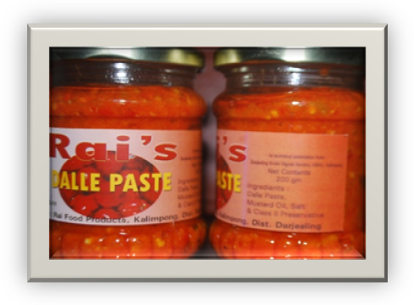

Food processing Industry in Darjeeling Hills is still underdeveloped. However, there are many traditional food items that are processed and produced which are specific to this region only. But unfortunately, even these specific items are not processed in commercial scale with scientific techniques. These regional items have good market both at home and abroad that needs immediate exploitation which has huge market potential in South East Asian countries. Under these circumstances, one Sri Ahok Rai, 43 years old from Sindaybong Busty near Kalimpong has come forward to take-up food processing as his profession. He was motivated after attending one of the training programme on Food Processing at Darjeeling Krishi Vigyan Kendra in 2009. He also took advice from Mr. S. P. Singh WBAS, Assistant Director of Horticulture, Department of Horticulture, Darjeeling Gorkha Hill Council, Kalimpong beside Krishi Vigyan Kendra and started his processing unit in a small scale taking technical help from Krishi Vigyan Kendra, Kalimpong in February 2010.

Source of Technology:
Darjeeling Krishi Vigyan Kendra and Department of Horticulture, Darjeeling Gorkha Hill Council, Kalimpong.

Production Capacity:
At present he is producing 1500 bottles of 250 grams each in every month.

Range of Products:
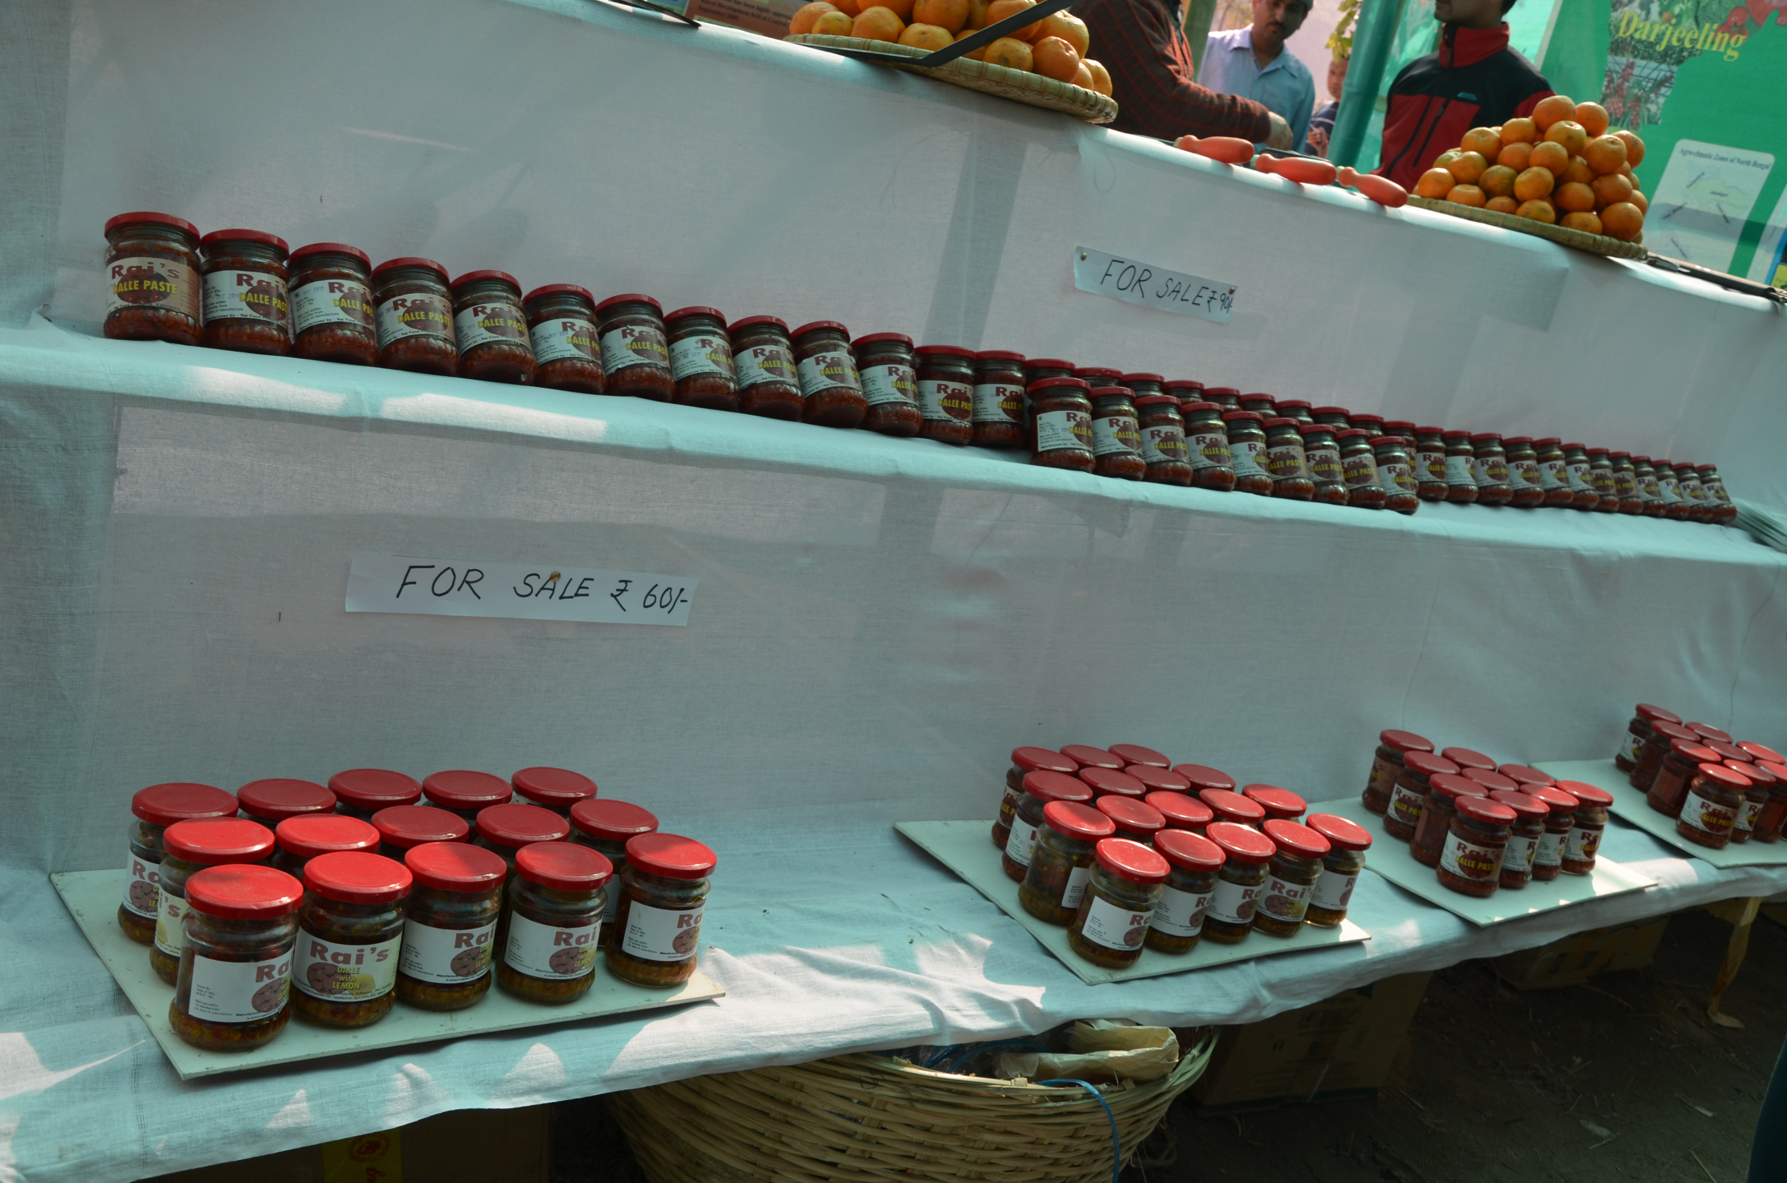
Sl.  No | Items | Rate for 250 gm bottle
1 | Dallay paste | ` 90
2 | Dallay paste with garlic and ginger | ` 90
3 | Dallay paste lemon | ` 70
4 | Dallay paste with bamboo shoot | ` 70
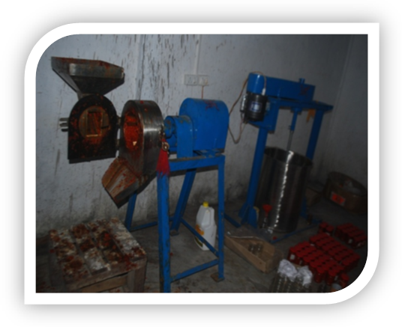
Machineries Procured:
He has procured the following machineries.
Fruit Miller
Mixing tank with stirrer
Manual capping machine
Citrus juice extractor

Market:
So far his products are sold only within the district of Darjeeling. However, it is also taken to Bhutan, Nepal and Sikkim by some people but in negligible quantity.
Distributer:
He has appointed only one distributor and is M/S Nilesh varieties Stores, Baghdhara Road, Kalimpong who distributes the product within Darjeeling District.

Area of the processing and Storage units:
Sri Rai has 25.00 sqr meter area for processing and the same areas for storage of the products.
Finance:
Sri Ashok Rai has taken loan of ` 3.5 lakh from Bank of India, Kalimpong Branch, Kalimpong while starting of the processing unit.

Finance:
Sri Rai has applied for the APO licence and expected to get shortly.
Employment Generated:
Sri Rai has not employed any permanent employee at the moment. He is handling all operations with the help of his family members. However, he is employing the seasonal labours on as and when required basis.

Problem:
Since his product is very good, some people are removing his label from the bottle and sticking their own and selling at higher rate in the market. Sri Rai is not able to take legal action to the culprits since he is still awaiting for APO licence.
Source of Inspiration:
Sri Ashok Rai is attracted to Food Processing Industry because of profitability and self sustainability of the industry.

Felicitation:
Very few farmers turn what is being said to them. Sri Ashok Rai was is one of them and Darjeeling Krishi Vigyan Kendra felicitated him on 11th January 2012 on the occasion of Krishi Paryatan Utsav 2012 held at Relli Tar, Kalimpong where is was honoured with khada by Sri Bimal Gurung, President, Gorkha Janmukti Morcha. He was presented the Letter of Recognition by Sri Anil Verma, Administrator, Darjeeling Gorkha Hill Council and a memento by Dr. Harka Bahadur Chettri, honourable MLA, Kalimpong.

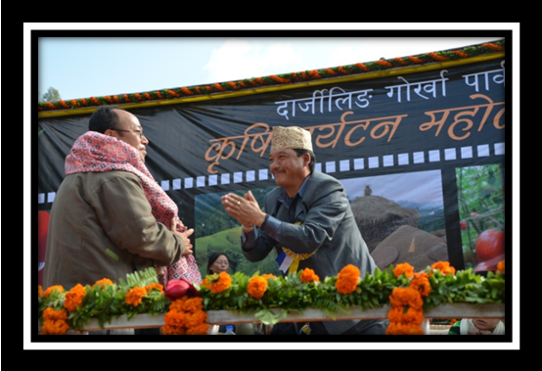

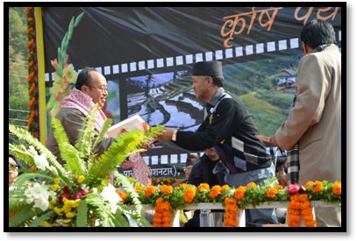
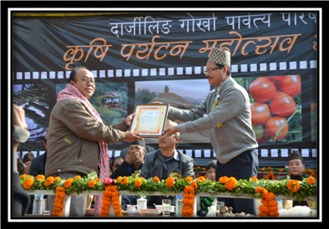

Message from Sri Ashok Rai

Shi Ashok Rai has a message to other fellow farmers -
Where there is Will, there is Way.

End

